December 2019

Welcome to CVC Practice News. In this newsletter we will outline any updates and changes to the Coordinated Veterans’ Care (CVC) Program, highlight the great work being done by practices and provide information on any upcoming events, workshops or training.

We invite you to send in comments, feedback and your own practice stories.

**In this Issue**

Survey Feedback

Claiming???

Christmas Shutdown

CVC Champions

**Survey Feedback**

Thank you to all of you who continue to provide feedback through the quarterly CVC provider surveys conducted by Bupa. The feedback you provide is invaluable and helps us to understand the needs of providers and informs CVC Program improvement activities.

**Care Collaboration**

The most recent survey asked you about Care Collaboration. The intent of this survey was to understand the extent of collaboration between the CVC GP and Practice Nurse, and other members of the Care Team.

Some interesting findings from the survey:

|  |  |
| --- | --- |
| Allied health professional are recognised as being most engaged in collaboration. | Care Plans are generally provided to most or all Care Team members. |
| Phone calls are recognised as the most frequent, and useful communication method in achieving coordinated care. | Time constraints are overwhelmingly considered to be the biggest barrier in achieving collaboration with other healthcare providers. |

Surveys are available on the CVC website and sent by email directly to providers. The contact information we use to send out surveys is from Medicare Australia. Make sure your information (email address) is up-to-date with Medicare to ensure you have the opportunity to provide feedback. Look out for more surveys in 2020 to help us continually improve the CVC Program.

**Claiming???**

Are you having trouble with your UP01 or UP03 claims? Constantly having claims rejected by Medicare? We find that the most common issue with rejected claims is the **date-of-service** being used when making a claim.

The [CVC Toolbox](http://healthprovidertoolbox.dva.gov.au/Home) is a great resource to assist you to work out the claiming dates for CVC participants.

The Claims Calculator Tool allows you to enter the date-of-service and then automatically calculates the next four claim dates.

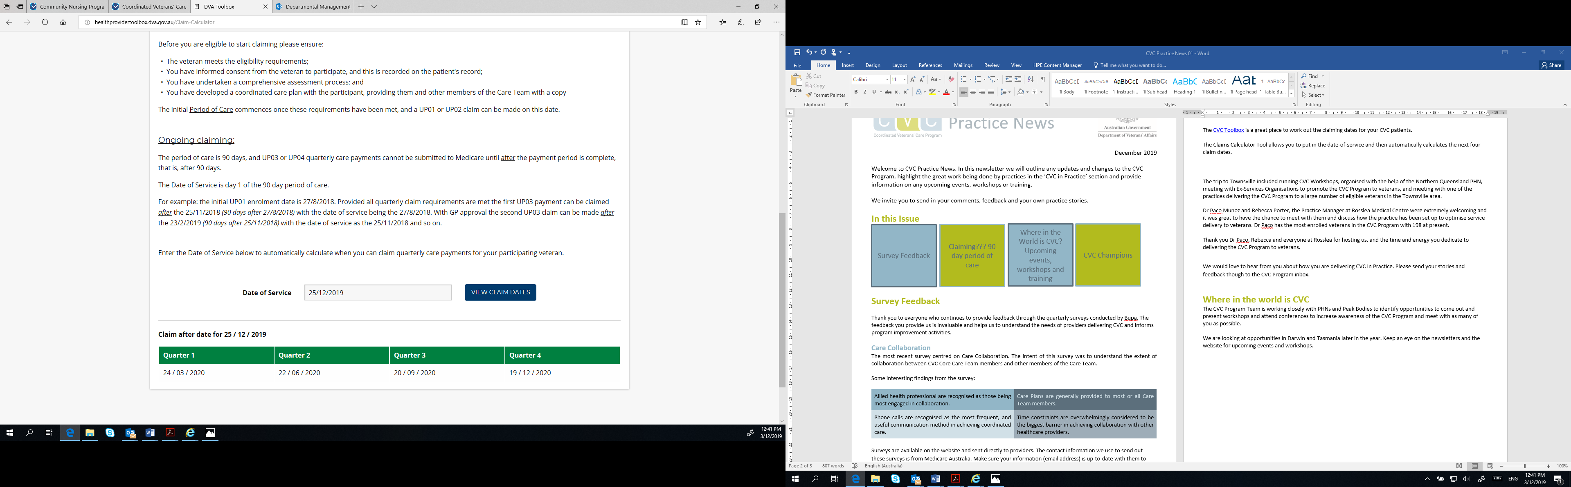

**Date-of-Service**

Remember when putting in your claims, that date-of-service is always the first day of the 90 day period of care. For example: initial date-of-service is 25/12/2019 – UP01 can be claimed on this day if a UP01 has not been previously claimed for this patient.

|  |  |  |  |
| --- | --- | --- | --- |
| Quarter 1 | Quarter 2 | Quarter 3 | Quarter 4 |
| Claim date – 24/03/2020  Date-of service for claim – 25/12/2019 | Claim date – 22/06/2020  Date-of service for claim – 24/03/2020 | Claim date – 20/09/2020  Date-of service for claim – 22/06/2020 | Claim date – 19/12/2020  Date-of service for claim – 20/09/2020 |

If you are still having difficulties with claiming please email the team at [cvcprogram@dva.gov.au](mailto:cvcprogram@dva.gov.au)

**Merry Christmas!**

DVA offices, including the CVC Program, will be closed from 5pm Tuesday 24 December 2019 and reopen at 8.30am Thursday 2 January 2020.

We wish you a safe and Merry Christmas. From the CVC team, thank you for the care you provide to veterans, and we look forward to working with you again in 2020.

**CVC Champions**

We are keen to work more closely with interested Nurses and GPs delivering the CVC Program and have started a key consultative group we call the CVC Champions.

We are looking to build our CVC Champions group – which is made up of individual CVC practitioners who have self-nominated to work with DVA to support the continuous improvement of the CVC Program. As a Champion we would look to you to provide feedback on new ideas or updated and reviewed resources, an occasional email, survey or phone call would be all that’s required so there’s minimal effort needed but to us, it’s highly valued input to inform the development of the program.

**Contact Us**

We are always happy to hear from you and to help with questions you might have about the CVC Program. Please feel free to contact us with your feedback, queries and compliments (of course). The best way to get in contact with the CVC team is via email.

We attempt to keep the information on the website up-to-date so it is always a good resource for you if you are looking for information on the Program. We look forward to hearing from you and hopefully meeting more of you throughout the year.

E | [cvcprogram@dva.gov.au](mailto:cvcprogram@dva.gov.au) W | [www.dva.gov.au/cvc](http://www.dva.gov.au/cvc) P | 1800 550 457