**TRANSITION AND WELLBEING RESEARCH PROGRAMME**

**MENTAL HEALTH AND WELLBEING TRANSITION STUDY**

Mental Health Prevalence and  
Pathways to Care

Summary Report

**2018**

978-0-6481608-4-7 (PDF)  
978-0-6481608-5-4 (Print)

© Commonwealth of Australia 2018

Unless otherwise noted, copyright (and other intellectual property rights, if any) in this publication is owned by the Commonwealth of Australia.

With the exception of the Coat of Arms and all photographs and graphics, this publication is licensed under a Creative Commons Attribution 3.0 Australia Licence. The Creative Commons 3.0 Australia Licence is a standard form licence agreement that allows you to copy, distribute, transmit and adapt this publication provided that you attribute the work.

The full licence terms are available from www.creativecommons.org/licenses/by/3.0/au/legalcode

Requests and enquiries concerning reproduction and rights should be addressed to:

The Department of Veterans’ Affairs  
GPO Box 9998  
Brisbane QLD 4001

or emailed to [publications@dva.gov.au](mailto:publications@dva.gov.au)

Suggested reference:

Van Hooff M, Forbes D, Lawrence-Wood E, Hodson S, Sadler N, Benassi H, Hansen C, Grace B, Avery J, Searle A, Iannos M, Abraham M, Baur J, Varker T, O’Donnell M, Phelps A, Frederickson J, Sharp M, McFarlane A, 2018, *Mental Health Prevalence and Pathways to Care Summary Report, Mental Health and Wellbeing Transition Study*, the Department of Defence and the Department of Veterans’ Affairs, Canberra.

This report is available from:

The Department of Defence  
<http://www.defence.gov.au/Health/DMH/ResearchSurveillancePlan.asp>

The Department of Veterans’ Affairs  
www.dva.gov.au/prevalence-pathways-summary-report

Published by the Department of Veterans’ Affairs, Canberra

Publication no: P03435

Contents

Acknowledgments v

Context 1

Key findings 3

Background 5

Methodology 9

How to interpret and discuss the findings in this report 15

Socio-demographic characteristics 17

Mental Health Prevalence Report findings 19

Pathways to Care among Transitioned ADF and 2015 Regular ADF 39

Glossary of terms 63

References 73

Tables

Table 1 Programme reports and objectives 6

Table 2 Survey response rates by Service for the Transitioned ADF and the 2015 Regular ADF 12

Table 3 Estimated prevalence of lifetime ICD-10 anxiety, affective, alcohol and any disorders in Transitioned ADF 23

Table 4 Estimated prevalence of 12-month ICD-10 anxiety, affective, alcohol, any disorder in Transitioned ADF 24

Table 5 Estimated prevalence n (%) of single and co-morbid affective, anxiety (excluding PTSD), PTSD and alcohol use disorders in the Transitioned ADF in the previous 12‑months using ICD-10 criteria 25

Table 6 Self-reported suicidal ideation, plans and attempts in the Transitioned ADF 25

Table 7 Estimated prevalence of 12-month ICD-10 disorders and suicidality in Transitioned ADF members, by transition status (Ex-Serving, Inactive Reservists and Active Reservists) 26

Table 8 Estimated prevalence of 12-month ICD-10 disorders and suicidality in Transitioned ADF members, by reason for discharge 27

Table 9 Estimated prevalence of 12-month ICD-10 disorders and suicidality in Transitioned ADF members, by DVA status 27

Table 10 Estimated prevalence of 12-month ICD-10 Disorder and suicidality in Transitioned ADF by Service at time of transition from Regular Service 28

Table 11 Estimated prevalence of 12-month ICD-10 Disorders and suicidality in Transitioned ADF by rank at time of transition from Regular Service 28

Table 12 Estimated prevalence of 12-month ICD-10 Disorders and suicidality in Transitioned ADF, by deployment status 29

Table 13 Estimated prevalence of 12-month ICD-10 disorders and suicidality in Transitioned ADF by sex 30

Table 14 Estimated proportions of Transitioned ADF and 2015 Regular ADF in each scoring band for the K10, PCL, AUDIT, PHQ-9, GAD-7 and the DAR-5 32

Table 15 Estimated prevalence in the Transitioned ADF compared to the Australian community K10 scoring bands for psychological distress 34

Table 16 Estimated proportions of maximum number of standard drinks on a single occasion in the last 12 months in Transitioned ADF compared to the Australian community 34

Table 17 Estimated proportions of the Frequency of Alcohol Consumption in Transitioned ADF compared to the Australian community in the last 12 months 34

Table 18 Estimated proportion of 2015 Regular ADF and Transitioned ADF who reported being concerned about their mental health in their lifetime, stratified by probable 30-day disorder 43

Table 19 Weighted estimate of 2015 Regular ADF and Transitioned ADF who reported being concerned about their mental health in their lifetime, and whether they ever had assistance for their mental health, stratified by probable 30-day disorder 44

Table 20 Estimated proportion of the Transitioned ADF and 2015 Regular ADF consulting each type of health professional, stratified by probable 30-day disorder 49

Table 21 Estimated proportion of Transitioned ADF and 2015 Regular ADF who used websites in the last 12 months to inform/assess mental health, stratified by probable 30-day disorder 53

Table 22 Preferred method for receiving health information in the Transitioned ADF and 2015 Regular ADF, stratified by probable 30-day disorder 54

Figures

Figure 1 Survey response rates for the Transitioned ADF and the 2015 Regular ADF 11

Figure 2 Flowchart of participation in Phase 2 of the Mental Health Prevalence and Transition Study for Transitioned ADF members 13

Figure 3 Estimated prevalence of 12-month ICD-10 disorders and suicidality in Transitioned ADF members, by years since transition 26

Figure 4 Estimated prevalence of 12-month ICD-10 Disorders and suicidality by years of Regular Service 29

Figure 5 Estimated prevalence of 12-month ICD-10 disorders and suicidality in Transitioned ADF members, by age 30

Figure 6 Estimated length of time between having a mental health concern and help-seeking among Transitioned ADF and 2015 Regular ADF stratified by probable 30‑day disorder 45

Figure 7 Who suggested help-seeking in Transitioned ADF and 2015 Regular ADF stratified by probable 30-day disorder (Note: all proportions are estimated) 46

Figure 8 Who assisted help-seeking in Transitioned ADF and 2015 Regular ADF stratified by probable 30-day disorder 47

Figure 9 Primary reason for seeking assistance for mental health among the Transitioned ADF and 2015 Regular ADF stratified by probable 30-day disorder 48

Figure 10 Aspects of service satisfaction in Transitioned ADF and 2015 Regular ADF, stratified by probable 30-day disorder 52

Figure 11 Estimated proportion of Transitioned ADF and 2015 Regular ADF endorsing each stigma item stratified by probable 30-day disorder 55

Figure 12 Number of stigmas endorsed in Transitioned ADF and 2015 Regular ADF stratified by probable 30-day disorder 56

Figure 13 Estimated proportion of Transitioned ADF and 2015 Regular ADF endorsing each barrier item stratified by probable 30-day disorder 57

Figure 14 Weighted estimate of reasons why help was not sought among those concerned with their mental health in the 2015 Regular ADF and Transitioned ADF, stratified by probable 30-day disorder 57

# Acknowledgments

Study participants

First and foremost, we acknowledge all current and ex-serving ADF personnel who generously gave their time to complete the study. This research was only made possible by their efforts and commitment to the study. Other key individuals include:

Principal Investigator

Dr Miranda Van Hooff (Co-lead), Director of Research, Centre for Traumatic Stress Studies, University of Adelaide.

Investigators

Professor David Forbes (Co-lead), Director, Phoenix Australia, Centre for Posttraumatic Mental Health, University of Melbourne.

Dr Ellie Lawrence-Wood, Senior Research Fellow, Centre for Traumatic Stress Studies, University of Adelaide.

Dr Stephanie Hodson, National Manager, Veterans and Veterans Families Counselling Service, Department of Veterans’ Affairs.

COL Nicole Sadler (Reservist), Senior Specialist, Military and High Risk Organisations, Phoenix Australia, Centre for Posttraumatic Mental Health, University of Melbourne.

Ms Helen Benassi, Mental Health, Rehabilitation and Psychology Branch, Joint Health Command, Department of Defence; PhD candidate, Australian National University.

Professor Alexander McFarlane, Professor of Psychiatry, Head of Centre for Traumatic Stress Studies, University of Adelaide.

Lead statistician

Dr Craig Hansen, Senior Statistician and Epidemiologist, Centre for Traumatic Stress Studies, University of Adelaide.

Statistician

Dr Blair Grace, Centre for Traumatic Stress Studies, University of Adelaide.

Transition and Wellbeing Research Programme Scientific Advisory Committee

RADM Jenny Firman (co-chair), Dr Ian Gardner (co-chair), Professor Ian Hickie, Professor Malcolm Battersby, Professor Mark Creamer, Professor Peter Butterworth, Professor Lyndall Strazdins, Dr Paul Jelfs, Dr Duncan Wallace, GPCAPT Lisa Jackson Pulver, Professor Tim Driscoll, Professor Kathy Griffiths, Professor Beverley Raphael, Dr Graeme Killer.

Centre for Traumatic Stress Studies, University of Adelaide

Mr Roger Glenny, Ms Maria Abraham, Ms Jenelle Baur, Ms Ashleigh Kenny, Ms Marie Iannos, Dr Jodie Avery, Dr Amelia Searle, Dr Elizabeth Saccone, Ms Jane Cocks, Mr Jeremy Hamlin, Ms Judy Bament, Ms Dianne Stewart.

Phoenix Australia, Centre for Posttraumatic Mental Health, University of Melbourne

Dr Tracey Varker, Professor Meaghan O’Donnell, Associate Professor Andrea Phelps, Dr Julia Frederickson, Dr Richard Cash, Dr John Cooper, Associate Professor Darryl Wade, Ms Loretta Watson.

Hunter Valley Foundation

Ms Shanti Ramanathan, Mr David Shellard, Dr Clare Hogue, Ms Phyllis Hartung, Mr Russ Redford and the team of CIDI interviewers.

Nexview Systems

Mr Trevor Moyle, Ms Hong Yan.

Australian Institute of Family Studies

Dr Galina Daraganova, Dr Jacquie Harvey.

Australian Institute of Health and Welfare

Mr Phil Anderson, Mr Nick Von Sanden, Mr Richard Solon, Mr Tenniel Guiver.

Australian Bureau of Statistics

Mr David Haynes, Ms Beatrix Forrest, Ms Michelle Ducat and staff from the Health and Disability Branch, Mr Barry Tynan and staff from the Communications and Dissemination Branch.

Transition and Wellbeing Research Programme Management Team

Ms Kyleigh Heggie, Ms Karen Barker, Dr Loretta Poerio, Ms Melissa Preston, Dr Carmel Anderson, Mr Tim Cummins, Ms Olivia Mahn, Ms Rachel McNab, Mr Christian Callisen, Department of Veterans’ Affairs.

COL Laura Sinclair, Ms Jess Styles, Ms Kanny Tait, Department of Defence.

For their assistance in developing the Study Roll: Mr Mark Watson and Ms Megan MacDonald, Department of Veterans’ Affairs, and Ms Carolina Casetta and Warrant Officer Class One Iain Lewington, Joint Health Command, Department of Defence.

Other key organisations

Australia Post.

# Context

In Australia, military service is held in high esteem with a recognition that it places high demands on those who serve, and can include exposure to extreme physical, psychological and mental stressors (Dobson et al., 2012; Forces in Mind Trust, 2013). Approximately 5,000 (9%) serving men and women transition out of the Regular Australian Defence Force (ADF) each year, either discharging completely (if involuntarily discharged, that is on medical or administrative grounds) or transferring into the Active or Inactive Reserves. This represents a significant number of Transitioned ADF members who are currently in the critical early stages of adjusting to civilian life and reintegrating into their community.

The period of transition from military to civilian life is quickly becoming recognised as one of the most significant and stressful transitions in the life course of military members world-wide owing to potential changes in identity, community and residence, social networks and status, family roles, occupation, finances, routines, responsibilities, supports and culture. Changes brought about by the transition process can lead to the development and/or exacerbation of existing service related mental and physical symptoms resulting in psycho-social adjustment issues ranging from employment difficulties and family/relationship conflict, to mental health and substance abuse problems.

Currently, there is very little systematic research about the mental health and wellbeing as well as the associated risk and protective factors and pathways to care in representative cohorts of transitioned military members. Most studies to date have focused on cohorts from specific deployments or those seeking treatment or compensation from the Department of Veterans’ Affairs (DVA) or the international equivalent, as these are the populations suggested to be most at risk. While international literature estimates 60–75% of transitioned military members report an easy adjustment to civilian life, it is likely others, particularly those who developed mental health symptoms or disorder prior to discharge, may struggle upon transition. The types of symptoms experienced by those who struggle and the factors that facilitate or inhibit these individuals from accessing care are essential to understand in order to ensure they receive appropriate mental health care in the civilian sector.

In Australia, only one in 10 ADF members who have recently transitioned out of the Defence Force choose to (or are able to) access veteran healthcare services therefore, administrative data alone cannot provide an accurate snapshot of the health of the population in the Australian context. Consequently, a population or cohort based approach is essential to establish accurate prevalence estimates of mental disorder in Transitioned ADF members. It is only through this understanding that targeted policy and programs can be developed that will meet the needs of individuals in this stage of the military career cycle.

This study builds on the findings of the 2010 Mental Health Prevalence and Wellbeing Study (McFarlane et al., 2011) which previously established the prevalence of mental disorder in the Regular ADF in 2010. It also examines the mental health and wellbeing and patterns of health service seeking and usage among ADF members in the first five years following transition from Regular ‘full-time’ ADF Service (January 2010-December 2014). The five-year window immediately post transition was chosen as this is a critical period to target for early intervention. Importantly, investigation of the differences in the mental health and wellbeing in current serving Regular ADF members, with Transitioned ADF members who are now in the Active and Inactive/Standby Reserves as well as Transitioned ADF members who have discharged completely into the community, provides critical information on the risk and protective factors throughout each stage of transition. Protective factors such as healthy worker or ‘healthy warrior’ effect have been seen for full-time regular serving ADF members but can lose strength as members transition out of the ADF.

Furthermore, a comparison of the self-reported psychological distress and alcohol consumption of the Transitioned ADF in 2015 with the contemporaneous data collected by the Australian Bureau of Statistics (ABS) in 2014–2015 as part of the National Health Survey was performed. This comparison situates the Transitioned ADF in the context of the civilian population using the most contemporary (and temporally equivalent) Australian data available. Mental health issues and disorder are not confined within the ADF. Nor are stigmas and barriers to care such as access, cost locality and stigmas. An understanding of how Transitioned ADF compare to the Australian community in this context provides a more thorough understanding of the role that military service plays in the amelioration or exacerbation of mental health symptoms as well as the factors that assist or limit access to care within these two populations.

The Transition and Wellbeing Research Programme is the most comprehensive study undertaken in Australia of the impact of military service on the mental, physical and social health of Transitioned and 2015 Regular Australian Defence Force (ADF) members and their families (the study populations). Utilising a robust two-phase design, the internationally acclaimed gold standard structured interview for assessing ICD-10 and DSM-IV mental disorder (Composite International Diagnostic Interview [CIDI]) (Kessler and Ustun, 2004)), and a two-stage statistical weighting methodology to correct for differential non-response and systematic response biases, this study provides the most thorough assessment of the mental health and wellbeing and patterns of help seeking in the Transitioned ADF compared to the current serving Regular ADF conducted to date.

This Report summarises the Mental Health and Wellbeing Transition Study methodology, describes the study populations and presents the key findings from the first two reports of the Transition and Wellbeing Research Programme: *Mental Health Prevalence* and *Pathways to Care*.

# Key findings

The Transition and Wellbeing Research Programme addresses key research priorities of both the DVA and the Department of Defence (Defence) over three studies: The Mental Health and Wellbeing Transition Study, the Impact of Combat Study and the Family Wellbeing Study. The findings from the first two reports form a fundamental component of the work under way by both DVA and Defence to enhance transition processes including enhancing mental health support services and suicide prevention initiatives (Commonwealth of Australia, 2017).

Results show ADF members transitioning from full-time military service represent a group at particular risk for mental disorder who would benefit from proactive strategies that aim to lessen the burden of mental illness and assist the transition process. An estimated 46% of ADF members who had transitioned from full-time service within the past five years, met 12-month diagnostic criteria for a mental disorder using a structured diagnostic interview. This level of 12-month disorder combined with the significantly greater severity of current self-reported symptoms of psychological distress, depression anxiety, anger, suicidality and alcohol use, particularly at subthreshold levels, in the Transitioned ADF compared to the 2015 Regular ADF places this population at significant risk of impairment and disability highlighting the challenges of transitioning out of full-time military service. Despite these levels of disorder, the levels of engagement in employment and socially connected roles among the Transitioned ADF is encouraging. For example, when the spectrum of roles, including studying, were taken into account, approximately 84% of the Transitioned ADF were either working or engaged in some purposeful activity, suggesting a degree of social engagement.

In regard to seeking care, the majority of the 2015 Regular ADF and Transitioned ADF populations with a mental health concern will take the initial steps in seeking care within the first 12 months, with a considerable number doing so within the first three months. This care is commonly provided not only by psychologists and General Practitioners (GPs) and Medical Officers (MOs), but also by psychiatrists and a range of other allied mental health providers. The majority of those with mental health concerns have engaged in care for these concerns, despite high rates of endorsement of stigma related beliefs.

While the rates of initial engagement and uptake of services are reasonably high, due to an accumulation of factors that occur at each phase of the help-seeking process, the findings suggest an under-engagement with evidence-based treatment for those with a current disorder. This is more evident in the Transitioned ADF than in the 2015 Regular ADF. Similarly, satisfaction with services is higher in the 2015 Regular ADF. Whilst effective treatment can and often should be episodic, these findings indicate that strategies need to be considered for improving engagement rates, retention and delivery of best practice care at each contact point.

The findings of the *Mental Health Prevalence Report* and the *Pathways to Care Report* and the subsequent reports will provide the foundation for evidence-based policy and programs to support those that have served our nation to successfully transition from full-time military service.

# Background

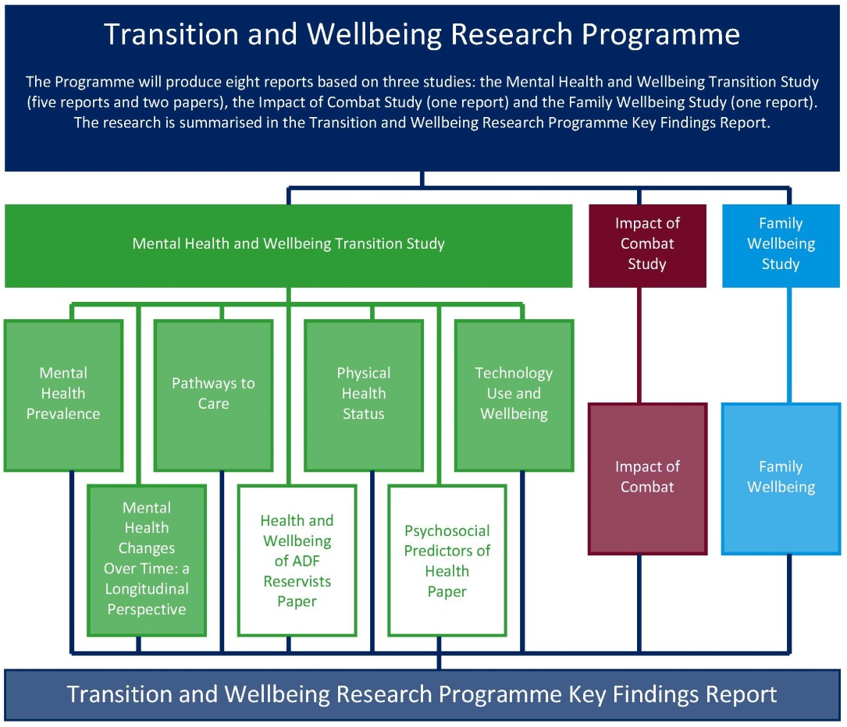

The Transition and Wellbeing Research Programme (Programme) is the most comprehensive study undertaken in Australia that examines the impact of military service on the mental, physical and social health of:

* serving and ex-serving Australian Defence Force (ADF) members including those who have been deployed in contemporary conflicts, and
* their families.

This research further extends and builds on the findings of the world-leading research conducted with current serving members of the ADF in the 2010 Military Health Outcomes Program (MilHOP).

This research, conducted in 2015, arises from the collaborative partnership between the Department of Veterans’ Affairs (DVA) and Department of Defence. It aims to implement the Government’s goal of ensuring that current and future policy, programs and services are responsive to the current and emerging health and wellbeing needs of serving and ex-serving ADF members and their families before, during and after transition from military life.

Ten objectives were developed to guide the Programme. The objectives are being realised through three studies comprising eight reports: the Mental Health and Wellbeing Transition Study (five reports and two papers), the Impact of Combat Study (one report), the Family Wellbeing Study (one report) and the Transition and Wellbeing Research Programme Key Findings Report, which summarises the research, as the diagram above shows.

The table below shows which reports deliver on the objectives. This publication, the *Mental Health Prevalence and Pathways to Care Summary Report*, addresses the first three objectives of the Programme, which are to:

1. Determine the prevalence of mental disorders amongst ADF members who have transitioned from Regular ADF service between 2010 and 2014.

2. Examine the self-reported mental health status of Transitioned ADF and the 2015 Regular ADF.

3. Assess pathways to care for Transitioned ADF and the 2015 Regular ADF, including those with a probable 30-day mental disorder.

Two eminent Australian research institutions, one specialising in trauma and the other in families, are leading the research programme. The Centre for Traumatic Stress Studies at the University of Adelaide is conducting the Mental Health and Wellbeing Transition Study and the Impact of Combat Study, and the Australian Institute of Family Studies is conducting the Family and Wellbeing Study.

Their research depth and expertise is enhanced through partner institutions from Monash University, University of New South Wales, Phoenix Australia – Centre for Posttraumatic Mental Health and InnoWell Pty Ltd, formerly the Young and Well Cooperative Research Centre.

Table 1 Programme reports and objectives

| Programme objectives | Corresponding reports and papers |
| --- | --- |
| 1. Determine the prevalence of mental disorders among ADF members who have transitioned from Regular ADF service between 2010 and 2014.  2. Examine self-reported mental health status of Transitioned ADF and the 2015 Regular ADF. | *Mental Health Prevalence Report* |
| 3. Assess pathways to care for Transitioned ADF and the 2015 Regular ADF, including those with a probable 30-day mental disorder. | *Pathways to Care Report* |
| 4. Examine the physical health status of Transitioned ADF and the 2015 Regular ADF. | *Physical Health Status Report* |
| 5. Investigate technology and its utility for health and mental health programmes including implications for future health service delivery. | *Technology Use and Wellbeing Report* |
| 6. Conduct predictive modelling of the trajectory of mental health symptoms/disorder of Transitioned ADF and the 2015 Regular ADF, removing the need to rely on estimated rates. | *Mental Health Changes Over Time: A Longitudinal Perspective Report* |
| 7. Investigate the mental health and wellbeing of currently serving 2015 Ab initio Reservists. | *The Health and Wellbeing of ADF Reservists paper* |
| 8. Examine the factors that contribute to the wellbeing of Transitioned ADF and the 2015 Regular ADF. | *Psychosocial Predictors of Health paper* |
| 9. Follow up on the mental, physical and neurocognitive health and wellbeing of participants who deployed to the Middle East Area of Operations between 2010 and 2012. | *Impact of Combat Report* |
| 10. Investigate the impact of ADF service on the health and wellbeing of the families of Transitioned ADF and the 2015 Regular ADF. | *Family Wellbeing Report* |
| All objectives | *Transition and Wellbeing Research Programme Key Findings Report* |

Through surveys and interviews, the researchers engaged with a range of ex-serving and current serving ADF members including:

* ADF members who transitioned from the Regular ADF between 2010 and 2014 (including Ex-Serving, Active and Inactive Reservists) known as Transitioned ADF
* a random sample of Regular ADF members serving in 2015 known as 2015 Regular ADF
* a sample of Ab initio Reservists serving in 2015 (who have never been full-time ADF members)
* 2015 Regular ADF and Transitioned ADF members who participated in MilHOP
* family members nominated by the above.

This report summarises the Mental Health and Wellbeing Transition Study methodology, describes the study populations, and presents the key findings from the first two reports of the Transition and Wellbeing Research Programme. This study is the first Australian study to establish the prevalence of mental disorder and pathways to care in a representative cohort of ADF members who have recently (2010–2014) transitioned out of Regular ADF service. It is also the first Australian study to map potential risk and protective factors associated with mental disorder in this Transitioned ADF population, and compare the self-reported mental health and wellbeing outcomes of this population with a contemporary sample of ADF members still in Regular military service in 2015, and the Australian community.

# Methodology

## Study design

Mental disorder prevalence estimates in the Transitioned ADF were obtained using a two-phase design. In the first phase, Transitioned ADF and 2015 Regular ADF members were screened for mental health problems, psychological distress, physical health problems, wellbeing factors, pathways to care and occupational exposures using a 60-minute self-report questionnaire which was tailored to their current ADF status. All analyses comparing the Transitioned ADF with the 2015 Regular ADF used the self-report data. The self-report measures of mental health were administered to *all* participants in the study and therefore allow comparisons between the mental health of the Transitioned ADF and a contemporary cohort of Regular ADF members to be made. Examination of self-reported symptoms has gained increasing consideration in mapping the emerging risks of mental disorder at a population level over time.

In the second phase, a sub-sample of Transitioned ADF members surveyed in Phase 1 were interviewed over the telephone using the World Health Organisation’s Composite International Diagnostic Interview (WMH-CIDI 3.0), with selection for this interview based on strata derived from rank, sex, Service and scores on measures of posttraumatic stress (PCL) and alco4hol consumption (AUDIT). Priority was given to Transitioned ADF members who were identified as being more likely to have a mental health problem based on their Phase 1 screening questionnaire, as well as groups accounting for the smallest proportion of the actual population (i.e. females). The CIDI was also used in the 2010 Mental Health Prevalence and Wellbeing Study (MHPWS) (McFarlane et al., 2011)

As the demographic and service characteristics of the Transitioned ADF and 2015 Regular ADF are known (i.e. sex, Service branch, rank and medical fitness, a dichotomous variable derived from Medical Employment Classification Status) it was possible to compare members who responded to the survey with members who did not. This allowed weighting of the data to provide estimates of mental disorder that are representative of the Transitioned ADF and self-reported mental health symptoms that are representative of each of the study populations: Transitioned ADF and 2015 Regular ADF.

## Study population

In this report, Transitioned ADF refers to the population of ADF members who transitioned from full-time ADF service between 2010 and 2014, including those who transitioned into the Active and Inactive Reserves and those who had discharged completely (Ex-Serving). The 2015 Regular ADF refers to ADF members who were serving full-time in the ADF in 2015.

This Report summarises findings on the Transitioned ADF and the 2015 Regular ADF, and provides self-report comparisons with the Australian Community (2014–2015: Socio-demographically matched data drawn from the 2014–2015 ABS National Health Survey (NHS) data) wherever possible (Australian Bureau of Statistics, 2015).

The limited comparison of the mental health of the Transitioned ADF with an Australian community sample from the ABS, matched on age, sex and employment status, was included in this study, to situate the Transitioned ADF in the context of the civilian population. Two mental health outcomes were available to be compared between these groups: psychological distress and self-reported alcohol consumption.

## Response rates

Of the Transitioned ADF population of 24,932, 96% (N = 23,974) were invited to participate in Phase 1 of the study. Those not invited represented those individuals who may have opted out of the study or did not have any usable contact information. Thirty-eight per cent (N = 20,031) of the 2015 Regular ADF population (N = 52,500) were invited to participate in Phase 1 of the study. The sample of 2015 Regular ADF invited to participate included a stratified random sample of 5040 regular ADF members in 2015 as well as those who had participated in the MilHOP between 2010 and 2012, and who were still serving in 2015.

### Phase 1 responders

Of those invited, 18% (N = 4326) of the Transitioned ADF population and 42.3% (N = 8480) of the 2015 ADF population completed the Phase 1 survey. Figure 1 shows the overall response rates for each sample.

Phase 1 responders in both the Transitioned and 2015 Regular ADF were predominantly Army (followed by Air Force and Navy), male and higher in rank (see Table 2), with the mean age of responders in both groups being approximately 41 years old. Transitioned females were more likely to respond than Transitioned males, while 2015 Regular ADF females were less likely to respond than their male counterparts. Not unexpectedly, Transitioned ADF were more likely to be unfit on transition from Regular ADF (31.1%) compared to the 2015 Regular ADF population (16.1%).

Figure 1 Survey response rates for the Transitioned ADF and the 2015 Regular ADF

Total ADF cohort   
n = 77,432

Non-responder  
n = 31,119 (70.9%)

Invited  
n = 44,005 (56.8%)

Responder  
n = 12,806 (29.1%)

Transitioned ADF  
n = 24,932

Non-responder  
n = 19,648 (82.0%)

Invited  
n = 23,974 (96.2%)

Responder  
n = 4326 (18.0%)

2015 Regular ADF  
n = 52,500

Non-responder  
n = 11,551 (57.7%)

Invited  
n = 20,031 (38.2%)

Responder  
n = 8480 (42.3%)

Table 2 Survey response rates by Service for the Transitioned ADF and the 2015 Regular ADF

|  | Transitioned ADF N = 24,932 | | | | 2015 Regular ADF N = 52,500 | | | |
| --- | --- | --- | --- | --- | --- | --- | --- | --- |
|  | Population | Invited | Responders | Response rate (%) | Population | Invited | Responders | Response rate (%) |
| **Service** |  |  |  |  |  |  |  |  |
| Navy | 5671 | 5495 | 863 | 15.7 | 13,282 | 5113 | 2040 | 39.9 |
| Army | 15,038 | 14,465 | 2463 | 17.0 | 25,798 | 8067 | 3500 | 43.4 |
| Air Force | 4223 | 4014 | 1000 | 24.9 | 13,420 | 6851 | 2940 | 42.9 |
| **Sex** |  |  |  |  |  |  |  |  |
| Male | 21,671 | 20,713 | 3646 | 17.6 | 47,645 | 15,176 | 6693 | 44.1 |
| Female | 3261 | 3261 | 380 | 20.9 | 4855 | 4855 | 1787 | 36.8 |
| **Rank** |  |  |  |  |  |  |  |  |
| OFFR | 4063 | 3939 | 1259 | 32.0 | 13,444 | 7847 | 3538 | 45.1 |
| NCO | 7866 | 7393 | 2097 | 28.4 | 17,491 | 9117 | 4336 | 47.6 |
| Other Ranks | 13,003 | 12,642 | 970 | 7.7 | 21,565 | 3067 | 606 | 19.7 |
| **Medical fitness** |  |  |  |  |  |  |  |  |
| Fit | 18,273 | 17,525 | 2981 | 17.0 | 46,022 | 17,097 | 7116 | 41.6 |
| Unfit | 6659 | 6449 | 1345 | 20.9 | 6478 | 2934 | 1364 | 46.5 |
| **Total** | 24,932 | 23,974 | 4326 | 18.0 | 52,500 | 20,031 | 8480 | 42.3 |

Notes:  
Unweighted data

95%CI: 95% Confidence Interval

Response rates presented in the table above are calculated as the proportion of those invited to participate in the study

OFFR: Officer, NCO: Non-Commissioned Officer

### Phase 2 responders

In Phase 2, 1807 Transitioned ADF members were selected for a CIDI diagnostic interview, and 1049 completed the interview.

## Ethics

The study protocol was approved by the DVA Human Research Ethics Committee (E014/018) and was recognised under expedited review processes by Defence and the University of Adelaide Human Research Ethics Committee. The study protocol was also submitted to AIHW Ethics Committee, which granted approval (EO 2015/1/163). This study was conducted in accordance with the Australian Code for the Responsible Conduct of Research (<https://www.nhmrc.gov.au/guidelines-publications/r39>).

Figure 2 Flowchart of participation in Phase 2 of the Mental Health Prevalence and Transition Study for Transitioned ADF members

Transitioned ADF Population N=24932

Invited Transitioned ADF Population N=23974 (96.2%)

Responders N = 4326 (18.0%)

Phase 1: Self Report Survey

Non-Responders N = 19,648 (82.0%)

Phase 2 (CIDI) Selected =1807 (41.8%)

Phase 2 (CIDI) Not Selected   
N = 2519 (58.2%)

Phase 2: CIDI Telephone Interview

Phase 2 (CIDI) Responders  
N = 1049 (58.1%)

Phase 2 (CIDI) Non-Responders  
N = 758 (41.9%)

# How to interpret and discuss the findings in this report

## Prevalence estimates

* Where the report refers to prevalence estimates of mental disorder and symptoms, these are the *estimated* rates of a particular outcome within an entire population (i.e. entire Transitioned ADF, entire 2015 Regular ADF or Transitioned ADF with Probable Disorder, 2015 Regular ADF with Probable Disorder). It is important to understand that these are estimates. These estimates represent the proportion of cases we would predict to observe in the entire population, based on the proportion of actual cases detected in the subpopulation who completed the outcome measure (the CIDI interview for mental disorder estimates, the self-report survey for estimates of mental health symptoms).
* When considering prevalence estimates, the estimated proportions are more informative than the estimated numbers.
* While results in this report were weighted to be representative of the total population, this weighting was performed on the basis of four key variables: **sex, rank, Service (Navy, Army or Air Force)** and **medical fitness**. This assumes a general consistency across individuals with each combination of these characteristics (strata), and does not account for individual differences, or other factors that may influence the outcomes of interest.
* Weighted estimates of mental health outcomes for the Australian community were standardised on the basis of sex, employment status and age. These standardised rates are not the true rates in the Australian Bureau of Statistics (ABS) population, but hypothetical rates that would have been observed if the Australian community population had the same age, sex and employment distribution as the ADF Transition population. This standardised rate takes into account any differences in the age, sex and employment structure of the two populations. Thus, when comparing the two populations using standardised rates, any remaining differences between them cannot be attributed to confounding by these three demographic factors.
* The relatively low response rates observed in the study mean that the weighted estimates presented may have a lower level of accuracy, with estimates more highly dependent on the characteristics used for weighting.
* The estimates for subpopulations (strata) with higher response rates can be considered more accurately representative of those subpopulations than those with lower response rates.
* In the case of diagnosable mental disorder:
* In this report, all lifetime and 12-month mental disorder prevalence rates were calculated using diagnostic criteria obtained from the World Health Organization International Classification of Diseases (10th revision) (World Health Organisation, 1994) and as such provide a more inclusive measure of mental disorder than the Diagnostic and Statistical Manual of Mental Disorder (DSM 5) (American Psychiatric Association, 2013).
* Where mental disorder cases were detected among a proportion of study participants who completed the CIDI, the characteristics of this subpopulation were used as a basis for estimating the likelihood of disorder caseness in the broader study population who share those characteristics (through statistical weighting).
* A two-phase weighting process was used to derive the prevalence estimates of diagnosable mental disorder. Stage 1 weighting accounted for the non-representativeness of the sample invited to complete a diagnostic interview, while Stage 2 weighting adjusted the weights to be representative of the characteristics of the total population.
* To interpret the precision or imprecision of a given estimate, readers might consider additional information supplied with the estimates, such as confidence intervals.

**Confidence intervals:** confidence intervals represent the possible range of values within which the presented estimate falls. Where the value of interest is a prevalence estimate, the confidence intervals show the range of error of the estimate. In general, confidence intervals that are very close to the estimate value reflect the precision of the estimate, while confidence intervals that are very wide reflect estimate imprecision. Where there are wide confidence intervals, associated estimates should be interpreted cautiously, with the upper and lower limits considered the top and bottom range of possible precise values.

**Significance**: Where a between group difference is discussed as significant in the text, this means that the difference between groups was statistically tested, adjusting for sex, age and Service, and the associated confidence intervals had no overlap between groups.

**Populations used in this report:** The primary populations of interest used in this report were ADF members who transitioned from the Regular ADF between 2010 and 2014 (Transitioned ADF) and the 2015 Regular ADF population. Of note: the ***Pathways to Care Report*** focused on three specific sub-populations of Transitioned and Regular ADF members: (1) those who reported ever having a concern about their mental health (2) those who reported having had assistance for their mental health, (3) those who scored above (probable 30-day mental disorder) and below (no probable 30-day mental disorder) the epidemiological cut-off on the screens for anxiety and depression (K10) and posttraumatic stress (PCL).

**Caveats:** (1)The overall response rate was low, particularly for the Transitioned ADF, with a rate of 18% (n = 4326). This was largely due to the limited contact information available for this group which may not have been updated for several years; (2) Consistent with previous research (Dobson et al., 2012; McFarlane et al., 2011), responders in this study were more likely to be females, Officers, Non-Commissioned Officers and Air Force members. Individuals classified as medically unfit were also more likely to respond. The current study addressed this response bias by statistically weighting the results based on four key variables – sex, rank, Service (Navy, Army or Air Force) – known to impact response rates and the prevalence of mental disorder more broadly, and medical fitness. The lower the number of responders, the less accurate the resulting weighted population estimates are likely to be. This is highly relevant to rank, with Officers and Non-Commissioned Officers over-represented among responders, while Other Ranks were highly under-represented, despite Other Ranks accounting for the largest proportion of the total population. As such, estimates stratified by rank should be interpreted with caution; (3) A large proportion of this study is based on self-report measures, which are subject to potential biases, including recall bias and other response biases. This response bias must be acknowledged in the interpretation of the findings presented; (4) This study reported ICD-10 rates of mental disorder which is likely to affect prevalence estimates for PTSD because ICD-10 PTSD has a lower threshold for severity of symptoms to achieve a diagnosis (Peters et al., 2006) than the DSM diagnostic system. However, given the literature regarding the morbidity associated with sub-syndromal DSM PTSD, the population defined in this study is clinically relevant (McFarlane, 2010); (5) All data used to examine help-seeking and pathways to care (for example categories of providers accessed, the types of services they received from these providers and the sources of funding for each) are based on participant self-report. Although descriptors were included in the survey to help participants discriminate between types of mental health services provided, in reality this can be quite difficult for veterans and the lay community to identify; (6) Finally, this study only investigates the initial stages of transition (the first five years), and only includes ADF members who transitioned from ADF service between 2010 and 2014. Further study of this cohort should be an important priority to map the ongoing course of mental disorder following ADF service. This is particularly important in light of evidence about the emergence of disorders among veterans many years after active service in conflicts such as Vietnam (Johnston et al., 2016).

# Socio-demographic characteristics

In order to fully understand how Transitioned ADF members are functioning in their civilian lives it is important to consider their current socio-demographic profile, as well as the circumstances surrounding their transition. There are known risk factors for social disadvantage in the literature that can contribute to mental health issues (Australian Bureau of Statistics, 2010) including unemployment, incarceration, housing instability including homelessness, and being in receipt of disability payments. Understanding the extent to which Transitioned ADF members are exposed to these factors can provide valuable insight into the overall mental, physical and social health of this population.

Overall, approximately 84% of the Transitioned ADF were either working or engaged in some purposeful activity (62.8% employed) with the most commonly reported areas of employment being government administration and Defence (16.8%), mining (9.9%), construction (8.8%) and transport and storage (8.6%). Just over 5.5% of the Transitioned ADF had retired.

Similar to the 2015 Regular ADF, the majority of the Transitioned ADF were aged 28–47 years (56.2%), were male (86.9%), were in a significant relationship (74.7%), were of lower rank (52.2%) and were Army (60.3%). Just over one third of Transitioned ADF had served 4–7.9 years in the Regular ADF (36.2%), followed by 23.2% who had served for 20+ years. Compared to the 2015 Regular ADF, Transitioned ADF were *more likely* to be: aged over 58 years, female, lower in rank, from the Army, classified as medically unfit, and to have under eight years of service with the ADF. In contrast, Transitioned ADF were *less likely* than 2015 Regular ADF to be in a relationship where they are not living with their partner.

Just under half (43.3%) of the Transitioned ADF were Ex-Serving (discharged) at the time of survey completion and therefore no longer remained engaged with Defence in a Reservist role. A quarter of the Transitioned ADF had remained in an Active Reservist role (25.7%) and therefore continued to be engaged in service for a specified number of days per year; 30.1% were Inactive Reservists and therefore their contact with Defence would be variable and for some there would be no ongoing contact.

The most common type of discharge/resignation reported was ‘own request’ (53.7%) with over 60% of these voluntarily discharging or discharging due to the end of a fixed period of service. Just over 20% of the Transitioned ADF were estimated to have been medically discharged, with their employment terminated by the ADF on the grounds of being permanently or at least in the long-term not fit to serve, or not fit for deployment to operational (warlike) service. The most common reasons for transition were ‘impact of service life on family’ (10.2%), ‘better employment prospects in civilian life’ (7.2%), ‘mental health problems’ (6.5%) and ‘physical health problems’ (4.3%).

In relation to the Transitioned ADF, potentially at greatest risk were a small subset (5.2%) who reported being unemployed at the time of the survey. In addition, just under half of Transitioned ADF members reported being unemployed for a period of three months or more after transitioning from Regular ADF service. There were also a very small proportion who reported having been arrested, convicted or incarcerated since transition (an estimated 5.1%), and approximately 3.4% who reported that they had not been living in stable housing in the two months prior to completing the survey.

One final group of particular interest, and who may be at significant risk due to the fact they have a known/diagnosed physical or mental health conditions, were the 8.9% who were on some form of disability support pension, as well as those discharged from the ADF on a medical discharge but who have not yet engaged with DVA. While over 43% of the Transitioned ADF reported currently accessing DVA funded treatment, there is likely a proportion of those who had medically discharged who were not.

# Mental Health Prevalence Report findings

## Key findings

### Definitions of key terms used in this report

**Transitioned ADF members** -Population of ADF members who transitioned from full-time ADF service between 2010 and 2014, including those who transitioned into the Active and Inactive Reserves and those who had discharged completely (Ex-Serving).

**2015 Regular ADF** – ADF members who were serving full-time in the ADF in 2015

**Lifetime prevalence** – A prevalence that meets diagnostic criteria for a mental disorder at any point in the respondent’s lifetime.

**12-month prevalence** – Meeting the diagnostic criteria for a lifetime ICD-10 mental disorder and having reported symptoms in the 12 months before the interview.

Refer to the Glossary of terms for definitions of other key terms in this section.

Demographics

* More than half of Transitioned ADF members remained in the ADF as Reservists (55.8%). Of these, 25.7% were Active Reservists.
* Approximately, 84% of the Transitioned ADF were either working or engaged in some purposeful activity with 62.8% being employed. Just over 5.5% of the Transitioned ADF had retired.
* More than 43% of Transitioned ADF members reported accessing DVA-funded treatment through either a DVA White Card (39.4%) or DVA Gold Card (4.2%).
* Just over one-fifth of the Transitioned ADF were estimated to have been medically discharged.
* The most commonly reported reasons for transition were ‘impact of service life on family’ (10.2%), ‘better employment prospects in civilian life’ (7.2%), ‘mental health problems’ (6.5%) and ‘physical health problems’ (4.3%).
* There were no significant differences in housing stability between the Transitioned ADF and the 2015 Regular ADF, with more than 93% estimated to have been in stable housing in the previous two months.
* Just over 40% of the Transitioned ADF and 36% of the 2015 Regular ADF reported having a diploma or university qualification.
* Twice as many members of the Transitioned ADF were classified as medically unfit compared to the 2015 Regular ADF.

Estimated prevalence of lifetime mental disorder in Transitioned ADF

* Almost three in four Transitioned ADF members are estimated to have met criteria for a mental disorder at some stage in their lifetime that is either, prior to, during or after their military career.
* Anxiety and (46.1%) Alcohol disorders (47.5%) were the most common classes of lifetime disorder.
* One quarter of Transitioned ADF members were estimated to have met criteria for posttraumatic stress disorder (PTSD) in their lifetime (24.9%).

Estimated prevalence of 12-month mental disorder in Transitioned ADF

* Just over half of the Transitioned ADF had not experienced a mental disorder in the previous 12 months.
* 46.4% of Transitioned ADF members are estimated to have experienced a mental disorder in the previous 12 months.

Anxiety disorders

* Anxiety disorders were the most common type of 12-month mental disorder among the Transitioned ADF with over one in three (37.0%) experiencing an anxiety disorder in the last 12 months.
* PTSD (17.7%), panic attacks (17.0%), agoraphobia (11.9%) and social phobia (11.0%) were the most common types of anxiety disorders in the Transitioned ADF.

Affective disorders

* One in five (23.1%) Transitioned ADF are estimated to have experienced an affective disorder in the last 12 months.
* The most common affective disorder type in Transitioned ADF was depressive episodes (11.2%).

Alcohol disorders

* 12.9% of the Transitioned ADF met criteria for an alcohol disorder in the last 12 months.

Occurrence of more than one disorder at the same time (comorbidity) in Transitioned ADF

* Of the Transitioned ADF with a 12-month mental disorder more than half (55.2%) had at least one comorbid or co-existing mental disorder.

Estimated prevalence of suicidality (ideation, planning, attempting) in Transitioned ADF

* Just over 20 per cent of Transitioned ADF experienced suicidal ideation, plans or attempts in the last 12 months.
* 28.9% of Transitioned ADF had felt that their life was not worth living.
* 21.2% had felt so low that they thought about taking their own life.
* 7.9% of Transitioned ADF had made a suicide plan.
* 2.0% of Transitioned ADF reported having attempted suicide.

Transition factors associated with 12-month mental disorder and suicidality in Transitioned ADF

Transition status

* Transitioned ADF, who were Ex-Serving, had significantly greater rates of anxiety disorders, affective disorders, alcohol disorders and suicidality compared to both Inactive and Active Reservists indicating poorer mental health outcomes for those who are most disengaged with Defence.

Years since transition

* The estimated rates of 12-month mental disorder were lowest in Transitioned ADF who had transitioned less than one year ago, increasing at one year or more post-transition. This may inform the timing of possible mental health surveillance activities.

Reason for discharge

* Transitioned ADF who had been medically discharged had significantly higher rates of affective, anxiety and alcohol disorders and suicidality than those who discharged for other reasons.

DVA Status

* Affective, anxiety and alcohol disorders and suicidality were more commonly observed in those Transitioned ADF who were in contact with or receiving services from DVA. This is expected given DVA is the primary conduit to care and assistance for ex-serving members.

Self-reported mental health in Transitioned ADF compared to the 2015 Regular ADF

* Compared to 2015 Regular ADF, the Transitioned ADF reported significantly higher current mental health symptoms across all domains measured.

Psychological distress

* Compared to 2015 Regular ADF, nearly twice as many Transitioned ADF had high to very high psychological distress (33.1% vs 18.7%).

Posttraumatic stress symptoms

* Compared to 2015 Regular ADF, nearly three times as many Transitioned ADF had high to very high posttraumatic stress symptoms (24.3% vs 8.7%).

Alcohol use

* Compared to 2015 Regular ADF, nearly four times as many Transitioned ADF reported alcohol use at levels which suggest the need for further assessment.
* Compared to the 2015 Regular ADF, the Transitioned ADF were significantly more likely to report higher alcohol consumption and problems with drinking.

Depressive symptoms

* Compared to 2015 Regular ADF, nearly three times as many Transitioned ADF had moderately severe to severe depressive symptoms (19.5% vs 7.4%).

Anxiety symptoms

* Compared to 2015 Regular ADF, more than twice as many Transitioned ADF had moderate to severe general anxiety disorder symptoms (22.3% vs 9.6%).

Suicidality

* The Transitioned ADF had significantly higher rates of suicidal ideation, plans and attempts compared to 2015 Regular ADF.

Anger

* Transitioned ADF members experienced significantly greater levels of anger than the 2015 Regular ADF.

Self-reported trauma exposure

* An estimated 85% or more of the entire Transitioned ADF and 2015 Regular ADF have experienced a potentially adverse deployment exposure.
* Exposure to toxins were the most common deployment exposure type with over 50% of Transitioned ADF and 2015 Regular ADF reporting potentially toxic/environmental exposures (smoke, fumes, chemicals, and local food and water).

Self-reported mental health in the Transitioned ADF compared to the Australian Community

Psychological distress

* Levels of psychological distress in the Transitioned ADF were significantly higher than the Australian Community, with almost three times more Transitioned ADF reporting high to very high psychological distress (33.1%) compared to the Australian Community (12.8%).
* Patterns of psychological distress were similar in the Australian community and the Transitioned ADF for males and females and consistent across all age bands.

Alcohol use

* Overall, the Australian Community drank more standard drinks on a single occasion in the last 12 months than the Transitioned ADF.
* Frequency of alcohol consumption in the last 12 months was similar for the Transitioned ADF compared to the Australian Community, but results varied by age and sex.
* A significantly higher proportion of Transitioned ADF females reported drinking daily, weekly and monthly compared to Australian Community females.
* There were no differences between the Transitioned ADF and the Australian Community in the frequency of alcohol consumed in the last 12 months in the 18–27-year age group.

## Prevalence of mental disorder in Transitioned ADF

The key objective of the Mental Health and Wellbeing Transition Study, Mental Health Prevalence Report was to document the mental health and wellbeing of 24,932 ADF members who had recently (between 2010–2014) transitioned from Regular military service. Providing this evidence base is a fundamental component of the work under way within both DVA and Defence to enhance transition processes in addition to describing the characteristics of the population.

International research suggests that there are a number of distinct risk and protective factors that may influence the likelihood of mental health problems during and following transition from military service. These include factors specific to transition such as whether someone is still in reserve service or has left the military completely, the length of time that has passed since transition, whether someone was medically discharged or left for another reason, and whether someone is engaged with services such as DVA. Service specific factors such as Service branch, rank, whether someone has deployed or not, and how long someone has served for are also important. Finally, there is evidence that demographic factors like sex and age may also be relevant. In addition to presenting the lifetime and 12- month prevalence of a range of common mental disorders in Transitioned ADF, the Mental Health Prevalence Report also examined them in relation to each of these factors.

### Estimated lifetime prevalence of mental disorder in Transitioned ADF

Consistent with the 2010 MHPWS report, this study examined three classes of common mental disorder anxiety, affective and alcohol disorder. Almost three quarters of the Transitioned ADF were estimated to have met ICD-10 criteria for any lifetime mental disorder, with the most common of these being alcohol disorders (Table 3). Forty-six per cent of the Transitioned ADF were estimated to have met criteria for a lifetime anxiety disorder, and one quarter were estimated to have met criteria for PTSD specifically in their lifetime. Just under 40% were estimated to have met criteria for a lifetime affective disorder.

Table 3 Estimated prevalence of lifetime ICD-10 anxiety, affective, alcohol and any disorders in Transitioned ADF

|  | Transitioned ADF (n = 24,932) | | |
| --- | --- | --- | --- |
| Lifetime ICD-10 Disorder | Weighted n | % | 95% CI |
| Anxiety disorder (including PTSD) | 11,378 | 46.1 | 41.4, 50.9 |
| Anxiety disorder (excluding PTSD) | 7976 | 31.9 | 27.7,36.6 |
| Anxiety disorder (ABS) | 10,421 | 41.8 | 37.1,46.6 |
| Affective disorder | 9769 | 39.6 | 35.0, 44.4 |
| Alcohol disorder | 11,714 | 47.5 | 42.8, 52.2 |
| PTSD | 6134 | 24.9 | 20.9, 29.3 |
| Any disorder | 18,435 | 74.7 | 70.5, 78.5 |

Note: 95%CI: 95% Confidence Interval

## Estimated 12-month prevalence of mental disorder, comorbidity and suicidality in the Transitioned ADF

### 12-month ICD-10 mental disorder

In the past 12 months, it is estimated that nearly half of the Transitioned ADF met criteria for an ICD-10 mental disorder (Table 4). The most common class of 12-month mental disorder among the Transitioned ADF was anxiety, with more than one in three estimated to have met criteria for an anxiety disorder in the past 12 months. Posttraumatic stress disorder, panic attacks, agoraphobia and social phobia were the most common individual disorders, with 17.7% of the Transitioned ADF estimated to have met criteria for PTSD in the previous 12 months. An estimated 19.3% met criteria for an anxiety disorder other than PTSD. One in five Transitioned ADF members were estimated to have experienced an affective disorder in the past 12 months, with the most common type being depressive episodes. Alcohol disorders were the least prevalent 12-month mental disorders among the Transitioned ADF with an estimated 12.9% meeting ICD-10 criteria for a 12-month diagnosis.

Table 4 Estimated prevalence of 12-month ICD-10 anxiety, affective, alcohol, any disorder in Transitioned ADF

|  | Transitioned ADF (n = 24,932) | | |
| --- | --- | --- | --- |
| 12-month ICD-10 Disorder | Weighted n | % | 95% CI |
| Any anxiety disorder | 9232 | 37.0 | 32.6, 41.7 |
| Panic attack | 4244 | 17.0 | 13.8, 20.8 |
| Panic disorder | 1344 | 5.4 | 3.6, 8.0 |
| Agoraphobia | 2975 | 11.9 | 9.1, 15.5 |
| Social phobia | 2738 | 11.0 | 8.4, 14.3 |
| Specific phobia | 1936 | 7.8 | 5.8, 10.3 |
| Generalised anxiety disorder | 917 | 3.7 | 2.2, 6.0 |
| Obsessive compulsive disorder | 1029 | 4.1 | 2.6, 6.6 |
| Posttraumatic stress disorder | 4408 | 17.7 | 14.5, 21.3 |
| Any affective disorder | 5755 | 23.1 | 19.2, 27.5 |
| Depressive episodes | 2783 | 11.2 | 8.6, 14.3 |
| Dysthymia | 1140 | 4.6 | 3.1, 6.7 |
| Bipolar affective disorder | 2443 | 9.8 | 7.0, 13.5 |
| Any alcohol disorder | 3219 | 12.9 | 9.8, 16.9 |
| Alcohol harmful use | 948 | 3.8 | 2.3, 6.3 |
| Alcohol dependence | 2271 | 9.1 | 6.4, 12.8 |
| Any disorder | 11,558 | 46.4 | 41.7, 51.1 |

Note: 95%CI: 95% Confidence Interval

### 12-month ICD-10 mental disorder comorbidity

The issue of mental disorder comorbidity is important as it is a marker of the severity of disorder and associated impairment in functioning and presents a significant challenge in obtaining optimal treatment outcomes (Hruska et al., 2014).

Mental disorder comorbidity among the Transitioned ADF was high. In the Transitioned ADF, just over half of those with a mental disorder had a least one comorbid disorder, with one in four Transitioned ADF meeting criteria for two or more mental disorder classes (Table 5: two classes:15.1%, three classes:8.2%, four classes: 1.9%). Alcohol disorders were the most common comorbid condition, with approximately 95% of those meeting 12-month criteria for an alcohol disorder also having another mental disorder. In relation to PTSD specifically, over 80% meeting 12-month criteria had another comorbid mental disorder.

Table 5 Estimated prevalence n (%) of single and co-morbid affective, anxiety (excluding PTSD), PTSD and alcohol use disorders in the Transitioned ADF in the previous 12‑months using ICD-10 criteria

|  | Total (n = 24,932) | | |
| --- | --- | --- | --- |
| ICD-10 mental disorder group | Weighted n | % | 95% CI |
| No mental disorder | 13,374 | 54.2 | 49.5, 58.9 |
| Any alcohol disorder only | 501 | 2.0 | 1.0, 3.9 |
| Any anxiety disorder only (excl. PTSD) | 2084 | 8.4 | 6.5, 10.9 |
| PTSD only | 873 | 3.5 | 2.3, 5.4 |
| Any affective disorder only | 1601 | 6.5 | 4.4, 9.4 |
| One mental disorder class | 5059 | 20.4 | 17.1, 24.3 |
| Any anxiety disorder (excl. PTSD) and any alcohol disorder | 596 | 2.4 | 1.2, 4.8 |
| Any affective disorder and any alcohol disorder | 224 | 0.9 | 0.3, 2.7 |
| PTSD and any alcohol disorder | 317 | 1.3 | 0.5, 3.4 |
| Any anxiety disorder (excl. PTSD) and any affective disorder | 1412 | 5.7 | 3.8, 8.6 |
| Any anxiety disorder (excl. PTSD) and PTSD | 814 | 3.3 | 2.1, 5.1 |
| Any affective disorder and PTSD | 381 | 1.5 | 0.7, 3.3 |
| Two mental disorder classes | 3744 | 15.1 | 12.0, 19.1 |
| Any anxiety disorder (excl. PTSD) and any alcohol disorder and PTSD | 356 | 1.4 | 0.6, 3.7 |
| Any anxiety disorder (excl. PTSD) and any alcohol disorder and any affective disorder | 731 | 3.0 | 1.5, 5.7 |
| Any alcohol disorder and PTSD and any affective disorder | 26 | 0.1 | 0.0, 0.4 |
| Any anxiety disorder (excl. PTSD) and PTSD and any affective disorder | 912 | 3.7 | 2.3, 5.9 |
| Three mental disorder classes | 2025 | 8.2 | 5.7, 11.6 |
| Four mental disorder classes | 468 | 1.9 | 0.9, 4.0 |

Note: 95%CI: 95% Confidence Interval

### 12-month suicidality

Suicide and suicidality are issues of major concern in military populations. In this study, 21.7% of the Transitioned ADF reported some form of suicidal ideation, plans or attempts in the last 12 months with more than one quarter reporting they felt their life was not worth living and an estimated 21.2% reporting they had felt so low that they thought about death by suicide (Table 6). Overall, an estimated 7.9% of the Transitioned ADF reported making a suicide plan and 2.0% had attempted suicide.

Table 6 Self-reported suicidal ideation, plans and attempts in the Transitioned ADF

| Suicide | | | |
| --- | --- | --- | --- |
| n (%) represent those answering yes to these items | | | |
|  | Transitioned ADF 2015 (n = 24,935) | | |
|  | Weighted n | % | 95% CI |
| Felt life not worth living | 7208 | 28.9 | (27.3, 30.6) |
| Felt so low thought about committing suicide | 5294 | 21.2 | (19.8, 22.8) |
| Made a suicide plan | 1965 | 7.9 | (7.0, 8.9) |
| Attempted suicide | 505 | 2.0 | (1.6, 2.6) |
| Any suicidality* | 5342 | 21.7 | 20.2, 23.3 |

* Calculated as yes to either felt so low thought about committing suicide, made a suicide plan, or attempted suicide

Note: 95%CI: 95% Confidence Interval

Note: This terminology in this table reflects the standardized survey item used in this study, however it should be noted that this is no longer considered an appropriate description, and the term ‘committing suicide’ should be replaced with ‘thought about taking their own life’

## Transition factors and 12-month mental disorder and suicidality in Transitioned ADF

It was the transition specific factors including the type of transition, years since transition, reason for discharge that were most associated with mental disorder and suicidality prevalence. DVA status and 12-month mental disorder were also strongly associated.

### Transitioned status

Overall, mental health outcomes were poorer for those Transitioned ADF who were most disengaged with Defence. Specifically, those who had fully discharged at the time of completing the study (Ex-Serving) recorded the highest rates of 12-month mental disorder across the various disorder categories (Table 7), and had significantly higher estimated rates of suicidality. This is also consistent with the finding of the 2017 Australian Institute of Health and Welfare (AIHW) suicide study (Australian Institute of Health and Welfare, 2017). In contrast, those Transitioned ADF who were Inactive and Active Reservists had substantially lower rates of 12-month mental disorder and suicidality, however rates of diagnosable disorder, representing one in three, still remain a concern within this group.

### Years Since Transition

Length of time since transition was also associated with various mental health outcomes. Overall, estimated rates of 12-month mental disorder were lowest in those who had transitioned less than one year ago, increasing at one year or more post-transition. This was not a linear association, and varied according to mental health outcome. This is a particularly important finding as it suggests that the most critical time for mental health surveillance may occur a significant time after transition from Regular ADF service. Furthermore, it may be indicative of the first 12 months following transition being a critical risk period for future disorder emergence.

Table 7 Estimated prevalence of 12-month ICD-10 disorders and suicidality in Transitioned ADF members, by transition status (Ex-Serving, Inactive Reservists and Active Reservists)

| 12-month ICD-10 Disorder and Suicidality | Transition status | | | | | | | | |
| --- | --- | --- | --- | --- | --- | --- | --- | --- | --- |
| Ex-serving (n = 11,440) | | | Inactive Reservists (n = 6447) | | | Active Reservists (n = 6968) | | |
| Weighted n | % | 95% CI | Weighted n | % | 95% CI | Weighted n | % | 95% CI |
| Any anxiety disorder (incl. PTSD) | 5102 | 44.6 | 37.2, 52.2 | 1902 | 29.5 | 22.5, 37.5 | 2223 | 31.9 | 24.9, 39.9 |
| Posttraumatic stress disorder | 2437 | 21.3 | 16.0, 27.8 | 1006 | 15.6 | 11.1, 21.5 | 948 | 13.6 | 8.7, 20.6 |
| Any affective disorder | 3764 | 32.9 | 26.0, 40.5 | 1096 | 17.0 | 11.2, 24.9 | 871 | 12.5 | 7.9, 19.2 |
| Any alcohol disorder | 2139 | 18.7 | 13.2, 25.9 | 561 | 8.7 | 4.8, 15.4 | 509 | 7.3 | 3.4, 15.0 |
| Any suicidality* | 3598 | 31.5 | 28.8, 34.2 | 1010 | 15.7 | 13.3, 18.4 | 866 | 12.4 | 10.3, 14.9 |

* Calculated as yes to either felt so low thought about committing suicide, made a suicide plan, or attempted suicide

Figure 3 Estimated prevalence of 12-month ICD-10 disorders and suicidality in Transitioned ADF members, by years since transition

### Reason for discharge

Those with a medical discharge had significantly greater estimated rates of affective, anxiety, and alcohol disorder, and greater suicidality than those who transitioned for another reason (Table 8). These findings are not unexpected, as individuals with a medical versus other type of discharge would be expected to have greater rates of mental (and other) disorders.

Table 8 Estimated prevalence of 12-month ICD-10 disorders and suicidality in Transitioned ADF members, by reason for discharge

| 12-month ICD-10 Disorder and Suicidality | Reason for discharge | | | | | |
| --- | --- | --- | --- | --- | --- | --- |
| Medical (n = 5082) | | | Other (n = 19,154) | | |
| Weighted n | % | 95% CI | Weighted n | % | 95% CI |
| Any anxiety disorder (incl. PTSD) | 2608 | 51.3 | 41.4, 61.2 | 5800 | 30.3 | 25.4, 35.7 |
| Posttraumatic stress disorder | 1171 | 23.0 | 16.3, 31.6 | 2800 | 14.6 | 11.1, 19.0 |
| Any affective disorder | 2008 | 39.5 | 30.2, 49.6 | 3324 | 17.4 | 13.2, 22.3 |
| Any alcohol disorder | 1030 | 20.3 | 13.0, 30.2 | 1997 | 10.4 | 7.1, 15.0 |
| Any suicidality* | 2165 | 42.6 | 38.9, 46.4 | 3065 | 16.0 | 14.4, 17.7 |

* Calculated as yes to either felt so low thought about committing suicide, made a suicide plan, or attempted suicide

### DVA Status

Among the Transitioned ADF, those who were a DVA client had significantly greater estimated rates of affective, anxiety, and alcohol disorder, and greater suicidality than those who were not a DVA client (Table 9). Similar to the results for medical discharge these findings are not unexpected. As DVA is the primary conduit to care and assistance for ex-serving members, higher rates of mental disorder among DVA clients suggests that many of those Transitioned ADF who require assistance are already seeking it through DVA.

Of concern, however is the remaining, relatively large proportion (i.e. 40% of those with 12-month PTSD, 51% of those with a 12-month Affective Disorder) of Transitioned ADF who met criteria for a 12-month ICD-10 mental disorder but are not recorded as a DVA client. This highlights that many transitioned members who have a mental disorder in the first five years following discharge from military service are *not DVA clients*, and therefore are *not* receiving support through DVA.

Table 9 Estimated prevalence of 12-month ICD-10 disorders and suicidality in Transitioned ADF members, by DVA status

|  | DVA Client | | | | | |
| --- | --- | --- | --- | --- | --- | --- |
| 12-month ICD-10 Disorder and Suicidality | No (n = 15,605) | | | Yes (n = 8774) | | |
| Weighted n | % | 95% CI | Weighted n | % | 95% CI |
| Any anxiety disorder (incl. PTSD) | 3480 | 22.3 | 16.4, 29.5 | 3975 | 45.3 | 39.4, 51.3 |
| Posttraumatic stress disorder | 1326 | 8.5 | 5.0, 14.1 | 1983 | 22.6 | 18.0, 28.0 |
| Any affective disorder | 2590 | 16.6 | 11.1, 24.0 | 2492 | 28.4 | 23.1, 24.4 |
| Any alcohol disorder | 1248 | 8.0 | 4.5, 13.9 | 1395 | 15.9 | 11.5, 21.6 |
| Any suicidality* | 2497 | 16 | 13.8, 18.5 | 2393 | 27.3 | 25.1, 29.6 |

* Calculated as yes to either felt so low thought about committing suicide, made a suicide plan, or attempted suicide

## ADF service factors and 12-month mental disorder and suicidality In Transitioned ADF

Service specific factors such as Service branch, rank, deployment, and years of service had mixed associations with mental disorder and suicidality prevalence among the Transitioned ADF. Service branch at time of transition had some association with rates of PTSD, alcohol disorder and suicidality, and rank at time of transition from Regular service had some association with 12-month mental disorder more generally. Transitioned ADF who had ever deployed were more likely to meet criteria for an anxiety disorder than those who had not, and overall, years of Regular ADF service was negatively associated with estimated rates of 12-month ICD-10 mental disorders, though this was not a linear relationship, and varied by disorder category.

### Service

The estimated prevalence of 12-month PTSD was greater in the Army and Air Force compared to Navy; Army and Navy had higher estimated alcohol disorder prevalence compared to Air Force; and estimated suicidality was highest amongst Transitioned ADF from the Army (Table 10).

Table 10 Estimated prevalence of 12-month ICD-10 Disorder and suicidality in Transitioned ADF by Service at time of transition from Regular Service

| 12-month ICD-10 Disorder and Suicidality | Service at Transition | | | | | | | | |
| --- | --- | --- | --- | --- | --- | --- | --- | --- | --- |
| Navy (n = 5671) | | | Army (n = 15,038) | | | Air Force (n = 4223) | | |
| Weighted n | % | 95% CI | Weighted n | % | 95% CI | Weighted n | % | 95% CI |
| Any anxiety disorder (incl. PTSD) | 1856 | 32.7 | 24.3, 42.5 | 5755 | 38.3 | 32.1, 44.8 | 1621 | 38.4 | 31.3, 46.0 |
| Posttraumatic stress disorder | 532 | 9.4 | 6.6, 13.1 | 3022 | 20.1 | 15.3, 25.9 | 854 | 20.2 | 15.3, 26.3 |
| Any affective disorder | 1309 | 23.1 | 15.5, 32.9 | 3577 | 23.8 | 18.5, 30.0 | 869 | 20.6 | 14.4, 28.6 |
| Any alcohol disorder | 760 | 13.4 | 7.5, 22.8 | 2173 | 14.4 | 10.2, 20.1 | 286 | 6.8 | 3.0, 14.8 |
| Any suicidality* | 1207 | 21.7 | 18.5, 25.3 | 3367 | 22.7 | 20.7, 24.8 | 768 | 18.4 | 15.8, 21.5 |

* Calculated as yes to either felt so low thought about committing suicide, made a suicide plan, or attempted suicide

### Rank

Estimated rates of 12-month ICD-10 affective disorders, alcohol disorders, and rates of self-reported suicidality were higher among Other Ranks, while anxiety disorders were higher among Non-Commissioned Officers compared to Officers (Table 11).

Table 11 Estimated prevalence of 12-month ICD-10 Disorders and suicidality in Transitioned ADF by rank at time of transition from Regular Service

| 12-month ICD-10 Disorder and Suicidality | Rank at Transition | | | | | | | | |
| --- | --- | --- | --- | --- | --- | --- | --- | --- | --- |
| OFFR (n = 4063) | | | NCO (n = 7866) | | | Other Ranks (n = 13,003) | | |
| Weighted n | % | 95% CI | Weighted n | % | 95% CI | Weighted n | % | 95% CI |
| Any anxiety disorder (incl. PTSD) | 1203 | 29.6 | 25.0, 34.6 | 3181 | 40.5 | 36.3, 44.8 | 4848 | 37.3 | 29.5,45.8 |
| Posttraumatic stress disorder | 608 | 15.0 | 11.6, 19.1 | 1559 | 19.8 | 16.6, 23.5 | 2242 | 17.2 | 12.0,24.2 |
| Any affective disorder | 531 | 13.1 | 9.9, 17.1 | 1582 | 20.1 | 16.8, 23.9 | 3642 | 28.0 | 21.1, 36.2 |
| Any alcohol disorder | 263 | 6.5 | 4.3, 9.7 | 571 | 7.3 | 5.3, 9.8 | 2385 | 18.3 | 12.6, 25.9 |
| Any suicidality* | 533 | 13.2 | 11.7, 14.8 | 1687 | 21.8 | 0.3, 23.4 | 3122 | 24.4 | 21.7, 27.2 |

*Calculated as yes to either felt so low thought about committing suicide, made a suicide plan, or attempted suicide

### Deployment

Transitioned ADF who had been on an operational deployment were more likely to meet criteria for an anxiety disorder (in particular Obsessive-Compulsive Disorder and PTSD) compared to those who had never deployed (Table 12). This is in direct contrast with the findings from the 2010 MHPWS report, and suggests that those ADF members who have been on an operational deployment and who have a mental disorder may be more inclined to transition out of Defence. Notably, an estimated 1 in 4 Transitioned ADF members who have never deployed still meet criteria for a 12-month disorder, despite never having been on an operational deployment.

Table 12 Estimated prevalence of 12-month ICD-10 Disorders and suicidality in Transitioned ADF, by deployment status

|  | Deployment Status | | | | | |
| --- | --- | --- | --- | --- | --- | --- |
| 12-month ICD-10 Disorder and Suicidality | Ever Deployed (N = 20,087) | | | Never Deployed (N = 4885) | | |
| Weighted n | % | 95% CI | Weighted n | % | 95% CI |
| Any anxiety disorder (incl. PTSD) | 7370 | 39.1 | 34.2, 44.3 | 1405 | 25.1 | 15.7, 37.7 |
| Posttraumatic stress disorder | 3782 | 20.1 | 16.2, 24.5 | 196 | 3.5 | 1.3, 9.0 |
| Any affective disorder | 4436 | 23.6 | 19.3, 28.5 | 1251 | 22.4 | 13.2, 35.3 |
| Any alcohol disorder | 2560 | 13.6 | 10.0, 18.2 | 602 | 10.8 | 4.7, 22.6 |
| Any suicidality* | 4301 | 22.3 | 20.7, 24.0 | 1041 | 18.5 | 15.4, 22.0 |

* Calculated as yes to either felt so low thought about committing suicide, made a suicide plan, or attempted suicide

### Years of service

In general, rates of affective disorder were highest among those serving between 1 and 12 years in the ADF. Alcohol disorders and suicidality showed a general decrease with increasing years of service. Anxiety disorders overall were highest in those serving 3 months – 3.9 years and 8–11.9 years and lowest in those serving 12–15.9 years. Finally, for PTSD specifically, while estimated 12-month prevalence was reasonably evenly distributed among the different lengths of service (as can be seen in Figure 4) it was highest among those who had served between 4 and 7.9 years (21.2%, 95% CI 14.2, 30.4).

Figure 4 Estimated prevalence of 12-month ICD-10 Disorders and suicidality by years of Regular Service

## Demographic factors and 12-month mental disorder and suicidality in Transitioned ADF

Overall, sex and age had little association with estimated rates of 12-month ICD-10 mental disorder among the Transitioned ADF.

### Sex

There were no significant sex related differences in affective, anxiety or alcohol disorders, or self-reported suicidality (Table 13).

Table 13 Estimated prevalence of 12-month ICD-10 disorders and suicidality in Transitioned ADF by sex

| 12-month ICD-10 Disorder and Suicidality | Sex | | | | | |
| --- | --- | --- | --- | --- | --- | --- |
| Male (n = 21,671) | | | Female (n = 3261) | | |
| Weighted N | % | 95% CI | Weighted N | % | 95% CI |
| Any anxiety disorder (incl. PTSD) | 7865 | 36.3 | 31.5, 41.4 | 1367 | 41.9 | 32.3, 52.2 |
| Posttraumatic stress disorder | 3598 | 16.6 | 13.2, 20.7 | 810 | 24.8 | 18.2, 32.8 |
| Any affective disorder | 5005 | 23.1 | 18.8, 28.0 | 750 | 23.0 | 14.7, 34.1 |
| Any alcohol disorder | 2848 | 13.1 | 9.7, 17.5 | 371 | 11.4 | 5.3, 22.7 |
| Any suicidality* | 4643 | 21.7 | 20.1, 23.4 | 699 | 21.7 | 18.4, 25.4 |

*Calculated as yes to either felt so low thought about committing suicide, made a suicide plan, or attempted suicide

### Age

There were some age-related trends, with 12-month affective disorders and suicidality showing a similar pattern of prevalence across age groups and lowest in Transitioned ADF aged 58+ (Figure 5). Alcohol disorders were most commonly observed among the younger Transitioned ADF, aged 18–47. Anxiety disorder was relatively stable across age groups.

Figure 5 Estimated prevalence of 12-month ICD-10 disorders and suicidality in Transitioned ADF members, by age

## Transitioned ADF compared to 2015 Regular ADF

### Current self-reported mental health

Currently, little is known about the similarities and differences in the mental health of recently transitioned and current serving Regular ADF members, and how symptoms change and develop in ADF members once they transition. Self-report measures of mental health can provide valuable additional information on the severity and nature of current symptomatology and in this report, mental health symptoms were compared between the Transitioned ADF and the 2015 Regular ADF. A range of symptoms were compared: psychological distress, posttraumatic stress, alcohol use, depression, anger, suicidality, and anxiety, and self-reported lifetime and service related trauma exposures, and these are reported in Table 14.

### Psychological distress (measured by K10)

Psychological distress was higher among the Transitioned ADF than in the 2015 Regular ADF with 33.0% scoring in the high to very high band compared to 18.7% of the 2015 Regular ADF. In general, the level of psychological distress was high among the Transitioned ADF and over 40.6% scored equal to or above the screening cut-off of 19. Importantly, a further 17.8% of the Transitioned ADF had a moderate level of symptomatology reflecting subthreshold anxiety or depressive disorders: these are a group at risk of developing a diagnosable disorder in the future.

### Posttraumatic stress symptoms (measured by PCL)

Similar to findings for psychological distress, the severity of posttraumatic stress symptoms was significantly greater in the Transitioned ADF compared to the 2015 Regular ADF, highlighting the strength of the relationship between poor mental health and transition. Approximately 38% of the Transitioned ADF had moderate to very high posttraumatic stress symptoms and almost one quarter scored in the high to very high-risk categories. This compared to 20.2% and 8.7% of the Regular ADF respectively. Almost 40% of the Transitioned ADF scored equal to or above the ADF screening cut-off of 29 (McFarlane et al., 2011). Importantly, these individuals represent the group who could be considered to have subthreshold PTSD symptoms and should be a target for early intervention.

### Alcohol use (measured by AUDIT)

Overall, self-reported alcohol use and problem drinking were significantly greater in the Transitioned ADF compared to the 2015 Regular ADF. Compared to the 2015 Regular ADF, the Transitioned ADF reported significantly higher AUDIT total scores, more frequent drinking, and drinking more standard drinks on a typical day. They were also more likely to report a problem with drinking and to anticipate problems cutting down or stopping drinking if they tried, a pattern of drinking consistent with psychological dependence. Just over 11% of the Transitioned ADF scored in Band 3 or above in the Transitioned ADF, indicating a need for referral and/or brief counselling, compared to 3.3% of the 2015 Regular ADF.

### Depressive symptoms (measured by PHQ)

The severity of self-reported depressive symptoms was significantly higher in the Transitioned ADF compared to the Regular ADF, with 19.5% of the Transitioned ADF reporting moderately severe (scoring range 15–19) to severe depressive symptoms (scoring range 20–27), compared to 7.4% of the Regular ADF. A further 11.1% of the Transitioned ADF had symptoms of depression in the moderate range (scoring range 10–14), highlighting the prevalence of subthreshold depression which is a significant risk in terms of future morbidity (Pine et al., 1999). As with posttraumatic stress symptoms and symptoms of psychological distress, the higher rates of self-reported depressive symptoms in the Transitioned ADF further underscores the role that symptoms may play in influencing the decision to leave the military, as well as the impact of transition on mood more generally.

### Anxiety symptoms (measured by GAD-7)

The severity of self-reported symptoms of generalised anxiety in the Transitioned ADF was high with 22.3% reporting moderate to severe symptoms. In contrast, a significantly lower proportion of the 2015 Regular ADF (9.6%) reported moderate to severe symptoms.

### Suicidal ideation and behaviour

The Transitioned ADF were significantly more likely to report suicidal ideation, plans and attempts than the 2015 Regular ADF. This is consistent with the recent AIHW report into the incidence of suicide among serving and Ex-Serving ADF members (Australian Institute of Health and Welfare, 2017) which found rates of completed suicide were lower than the general population among those still serving in the ADF (Regular and Reserve) but higher in those who were Ex-Serving. The consistency of the self-reported suicidality observed in the current study with data regarding completed suicide is of high importance, as it strongly indicates that the Ex-Serving Transitioned ADF are at increased risk of suicidal ideation escalating to suicidal behaviour.

### Anger (measured by DAR-5)

Self-reported anger was measured in this study for a range of reasons, notably because it is an important symptom of PTSD. In particular, as reported in the scientific literature, the associated impairments and impacts on interpersonal relationships and social functioning in relation to anger are significant. Overall, self-reported anger followed the same patterns as for other psychological symptoms and for diagnosable mental disorder with Transitioned ADF members reported significantly greater levels of anger than the 2015 Regular ADF.

Table 14 Estimated proportions of Transitioned ADF and 2015 Regular ADF in each scoring band for the K10, PCL, AUDIT, PHQ-9, GAD-7 and the DAR-5

|  | Transitioned ADF 2015  (n = 24,932) | | | 2015 Regular ADF  (n = 52,500) | | |
| --- | --- | --- | --- | --- | --- | --- |
|  | Weighted N | % | 95% CI | Weighted N | % | 95% CI |
| Psychological Distress (K10) |  |  |  |  |  |  |
| Low (10–15) | 11,904 | 47.7 | 45.9, 49.6 | 33,015 | 62.9 | 59.3, 66.4 |
| Moderate (16–21) | 4438 | 17.8 | 16.4, 19.3 | 8278 | 15.8 | 13.5, 18.4 |
| High (22–29) | 3371 | 13.5 | 12.3, 14.8 | 4179 | 7.9 | 6.4, 9.9 |
| Very High (30-50) | 4884 | 19.6 | 18.2, 21.1 | 5644 | 10.8 | 8.4, 13.7 |
| Posttraumatic Stress (PCL) |  |  |  |  |  |  |
| Low (17–29) | 14,879 | 59.7 | 57.9, 61.5 | 41,432 | 78.9 | 75.6, 81.9 |
| Moderate (30–39) | 3426 | 13.7 | 12.5, 15.1 | 6013 | 11.5 | 9.3, 14.1 |
| High (40–49) | 2032 | 8.2 | 7.2, 9.2 | 2605 | 5.0 | 3.4, 7.3 |
| Very High (50–85) | 4003 | 16.1 | 14.8, 17.5 | 1957 | 3.7 | 2.6, 5.4 |
| Alcohol Use (AUDIT) |  |  |  |  |  |  |
| Band I (0–7) | 16,236 | 65.1 | 63.2, 66.9 | 41,430 | 78.9 | 75.6, 81.9 |
| Band 2 (8–15) | 5574 | 22.4 | 20.8, 24.1 | 9151 | 17.4 | 14.7, 20.5 |
| Band 3 (16–19) | 1169 | 4.7 | 3.9, 5.6 | 988 | 1.9 | 1.1, 3.3 |
| Band 4 (20 to 40) | 1616 | 6.5 | 5.6, 7.5 | 726 | 1.4 | 0.6, 3.1 |
| Depression (PHQ-9) |  |  |  |  |  |  |
| Minimal (0–4) | 11,342 | 45.5 | 43.7, 47.3 | 29,505 | 56.2 | 52.6, 59.7 |
| Mild (5–9) | 5788 | 23.2 | 21.7, 24.8 | 13,391 | 25.5 | 22.4, 28.9 |
| Moderate (10–14) | 2764 | 11.1 | 9.9, 12.3 | 5228 | 9.9 | 7.9, 12.5 |
| Moderately Severe (15–19) | 2250 | 9.0 | 8.0, 10.2 | 2374 | 4.5 | 3.1, 6.5 |
| Severe (20–27) | 2622 | 10.5 | 9.5, 11.7 | 1562 | 2.9 | 1.7, 5.1 |
| General Anxiety (GAD-7) |  |  |  |  |  |  |
| Minimal (0–4) | 13,545 | 54.3 | 52.5, 56.1 | 36,907 | 70.3 | 66.8, 73.6 |
| Mild (5–9) | 5523 | 22.2 | 20.7, 23.7 | 10,049 | 19.1 | 16.4, 22.2 |
| Moderate (10–14) | 2734 | 10.9 | 9.9, 12.2 | 2671 | 5.1 | 3.7, 6.94 |
| Severe (15–21) | 2850 | 11.4 | 10.3, 12.6 | 2384 | 4.5 | 2.9, 6.9 |
| Suicidality |  |  |  |  |  |  |
| Felt life not worth living | 7208 | 28.9 | 27.3, 30.6 | 6927 | 13.2 | 10.7, 16.2 |
| Felt so low thought about committing suicide | 5294 | 21.2 | 19.8, 22.8 | 4493 | 8.6 | 6.4, 11.3 |
| Made a suicide plan | 1965 | 7.9 | 6.9, 8.9 | 950 | 1.8 | 1.0, 3.3 |
| Attempted suicide | 505 | 2.0 | 1.6, 2.6 | 311 | 0.6 | 0.2, 1.6 |
| Any suicidality† | 5342 | 21.7 | 20.2, 23.3 | 4533 | 8.8 | 6.7, 11.6 |
|  | **M** | **SE** | **95% CI** | **M** | **SE** | **95% CI** |
| Anger (DAR-5) |  |  |  |  |  |  |
| Anger frequency | 2.4 | 0.02 | 2.4, 2.5 | 2.2 | 0.04 | 2.1, 2.2 |
| Anger intensity | 2.0 | 0.02 | 1.9, 2.0 | 1.7 | 0.04 | 1.6, 1.7 |
| Anger duration | 1.9 | 0.02 | 1.8,1.9 | 1.5 | 0.04 | 1.5, 1.6 |
| Antagonism towards others | 1.7 | 0.02 | 1.7, 1.8 | 1.4 | 0.04 | 1.3, 1.5 |
| Social relations | 1.8 | 0.02 | 1.8, 1.8 | 1.5 | 0.04 | 1.4, 1.6 |
| DAR-5 total | 9.8 | 0.1 | 9.6, 10.0 | 8.2 | 0.5 | 7.9 8.5 |

### Deployment exposures and lifetime trauma exposure

The consistent findings of elevated rates of psychological symptoms and mental disorder among the Transitioned ADF need to be considered in the context of the reported deployment and non-deployment traumatic stress exposures experienced by this population.

Results of this study suggest that those who have transitioned from the ADF have had substantially higher levels of deployment related traumas in contrast to those who remain within the ADF in 2015. For example, in the Transitioned ADF, 38.3% reported they had gone on combat patrols in contrast to 29.9% of the 2015 Regular ADF. Similarly, among the Transitioned ADF, 37.4% had either handled or seen dead bodies in contrast to 30.2% of the 2015 Regular ADF.

Additionally, Transitioned ADF reported significantly higher rates of lifetime trauma (including both military and non-military trauma) compared to the 2015 Regular ADF with 77.0% of the Transitioned ADF and 69.3% of the 2015 Regular ADF reporting being exposed to a traumatic event in their lifetime. Transitioned ADF also reported being exposed to a greater number of different lifetime traumatic events compared to 2015 Regular ADF.

While it is important not to minimise the significant exposures of those who remain within Regular ADF service, these findings suggest that those who transition have on average endured a slightly greater history of a range of traumatic exposures both on deployment and in their lifetime compared to the 2015 Regular ADF.

## An Australian Community comparison: psychological distress and alcohol use in Transitioned ADF compared to the Australian community

### Psychological distress (measured by K10)

National and International research has demonstrated that military service places high demands on those who serve. The 2010 MHPWS showed that ADF members experienced a significantly higher prevalence of lifetime trauma (both deployment related and pre-enlistment trauma) compared with a socio-demographically matched Australian community (ABS). The 2010 MHPWS study also showed that the 2010 Regular ADF had a significantly higher prevalence of 12-month depressive episodes and posttraumatic stress compared to the Australian community. The increased risk of lifetime trauma exposure and mental disorder in ADF members, combined with transition related stressors places Transitioned ADF members at particular risk as they assimilate back into civilian society which has clear implications for service provision and support.

In this section key measures of mental health are compared between Transitioned ADF members and a stratified sample of the general Australian community, in order to place the mental health of Transitioned members within the civilian context (please see methodology section for details on how estimates from the Australian community were calculated). Comparisons between the Transitioned ADF and the Australian community were made using contemporaneous data obtained from the 2014–2015 ABS National Health Survey (NHS): in particular the K10 and number of Alcohol Use questions taken from the NHS.

In general, psychological distress was higher among the Transitioned ADF compared to the Australian community (Table 15). Almost three times more Transitioned ADF scored in the high to very high psychological distress bands (33.1%) compared to the Australian community (12.8%). Further analyses comparing the two populations by age and sex (not listed in table) showed that the largest difference between the Transitioned ADF and the Australian community, across the various sex and age groups, was in the very high scoring band on the K10 for psychological distress where nearly one in five Transitioned ADF scored in this band compared with just under 5% of the Australian community. Psychological distress was also found to decrease overall with age in the Transitioned ADF, while in the Australian community it remained relatively stable across age groups.

Table 15 Estimated prevalence in the Transitioned ADF compared to the Australian community K10 scoring bands for psychological distress

|  | Transitioned ADF (n = 24,932) | | | Australian Community | | | Difference | | |
| --- | --- | --- | --- | --- | --- | --- | --- | --- | --- |
|  | % | SE | 95% CI | % | SE | 95% CI | % | SE | 95% CI |
| Low (10–15) | 47.7 | 0.9 | 45.9, 49.6 | 66.3 | 0.9 | 64.5, 68.2 | -18.6 | 1.3 | -21.2, -15.9 |
| Moderate (16–21) | 17.8 | 0.7 | 16.4, 19.3 | 20.1 | 0.8 | 18.6 21.6 | -2.3 | 1.0 | -4.3, -0.2 |
| High (22–29) | 13.5 | 0.7 | 12.3, 14.8 | 8.3 | 0.6 | 7.1, 9.4 | 5.3 | 0.9 | 3.5, 6.9 |
| Very High (30–50) | 19.6 | 0.7 | 18.2, 21.1 | 4.5 | 0.5 | 3.5, 5.5 | 15.1 | 0.9 | 13.3, 16.9 |

Note: 95%CI: 95% Confidence Interval

### Alcohol use

A quite different pattern of results was found when comparing patterns of alcohol use between the Transitioned ADF and the Australian community. Overall, the Australian community drank more standard drinks on a single occasion in the last 12 months than the Transitioned ADF, with a significantly higher proportion of the Australian community (48.3%) drinking more than seven or more standard drinks on a single occasion compared to the Transitioned ADF (33.2%), this pattern was particularly salient in Australian community males (Table 16). Overall, however, there were fewer observed differences in the rates of alcohol consumption between the two samples, particularly in the lower age groups (not presented in Table 16).

The majority of Transitioned ADF and the Australian community consumed alcohol weekly (approximately 45% – 48%), followed by monthly and less than monthly. A significantly higher proportion of the Transitioned ADF than the Australian Community reported drinking monthly. (Table 17). This pattern was mostly accounted for by ADF males. There were female specific differences in rates of problem drinking between the Transitioned ADF and the community (not presented in Table 17), with a significantly higher proportion of Transitioned ADF females reporting drinking daily, weekly and monthly compared to Australian community females.

Table 16 Estimated proportions of maximum number of standard drinks on a single occasion in the last 12 months in Transitioned ADF compared to the Australian community

|  | Transitioned ADF (n = 24,932) | | | Australian Community | | | Difference | | |
| --- | --- | --- | --- | --- | --- | --- | --- | --- | --- |
|  | % | SE | 95% CI | % | SE | 95% CI | % | SE | 95% CI |
| 11 + | 21.6 | 0.9 | 19.9, 23.3 | 34.2 | 1.0 | 32.3, 36.1 | -12.6 | 1.3 | -15.2, -10.1 |
| 7–10 | 11.6 | 0.6 | 10.4, 12.9 | 14.1 | 0.7 | 12.7, 15.4 | -2.4 | 0.9 | -4.3, -0.6 |
| 5 or 6 | 12.8 | 0.6 | 11.6, 14.7 | 10.5 | 0.6 | 9.4, 11.6 | 2.3 | 0.8 | 0.6, 3.9 |
| 3 or 4 | 11.3 | 0.6 | 10.2, 12.5 | 12.0 | 0.7 | 10.6, 12.5 | -0.7 | 0.9 | -2.6, 1.1 |
| 1 or 2 | 10.7 | 0.6 | 9.7, 11.8 | 13.7 | 0.6 | 12.5, 14.9 | -3.0 | 0.8 | -4.7, -1.4 |

Note: 95%CI: 95% Confidence Interval

Table 17 Estimated proportions of the Frequency of Alcohol Consumption in Transitioned ADF compared to the Australian community in the last 12 months

|  | Transitioned ADF (n = 24,932) | | | Australian Community | | | Difference | | |
| --- | --- | --- | --- | --- | --- | --- | --- | --- | --- |
|  | % | SE | 95% CI | % | SE | 95% CI | % | SE | 95% CI |
| Daily | 4.3 | 0.4 | 3.6, 5.0 | 5.1 | 0.4 | 4.4, 5.8 | -0.8 | 0.5 | -1.8, 0.23 |
| Weekly | 47.6 | 0.1 | 45.6, 49.5 | 45.4 | 1.0 | 43.5, 47.3 | 2.2 | 1.4 | -0.5, 4.8 |
| Monthly | 26.1 | 0.9 | 24.4, 27.9 | 20.1 | 0.9 | 18.4, 21.8 | 6.0 | 1.3 | 3.5, 8.5 |
| Less than monthly | 14.1 | 0.7 | 12.8, 15.6 | 13.0 | 0.6 | 11.8, 14.3 | 1.1 | 0.9 | -0.8, 2.9 |

Note: 95%CI: 95% Confidence Interval

## Implications and future directions: Mental Health Prevalence

The rates of mental disorder identified in ADF members in the first five years following transition in this study is a matter of concern that warrants attention with nearly half estimated to have a 12-month mental disorder. This level of 12-month disorder combined with the significantly greater severity of current self-reported symptoms of psychological distress, depression anxiety, anger, suicidality and alcohol use in the Transitioned ADF compared to the 2015 Regular ADF highlights the challenges of transitioning out of full-time military service.

Consistent with the findings of the 2017 AIHW report on suicide incidence among serving and ex-serving members, those discharging medically are one of the most high-risk groups identified in this report and should be a priority for further evaluation and follow-up (Australian Institute of Health and Welfare, 2017). Importantly however, there is also a large proportion of Transitioned ADF who were not medically discharged but who met criteria for a mental disorder in the last 12 months (i.e. 62.3% of those with a 12-month affective disorder – 70.5% of those with 12-month PTSD). Thus, many of these individuals may not have been referred to the appropriate mental health providers at the point of transition. This raises important questions as to whether these disorders emerged following discharge or failed to be declared or identified during the discharge medical. It also raises questions as to whether there should be a more systematic mental health assessment during military service and/or the discharge process using structured diagnostic interviews. Furthermore, as has been planned by Defence, referral of discharging members to a primary health care provider should increasingly become a priority as this is likely to significantly assist in both the diagnosis of emerging disorders as well as referral to treatment networks.

Similarly, a large proportion of Transitioned ADF who met criteria for a 12-month mental disorder, were not recorded as a DVA client (i.e. 40% of those with 12-month PTSD, 51% of those with a 12-month Affective Disorder). Taken together these findings suggest a need to address how ADF members are screened, assessed and monitored for mental health conditions both pre-and post-transition. The data also reinforces the importance of a range of initiatives currently being implemented by DVA and Defence to enhance early identification and intervention, including through the transition process.

One example highlighted in the 2017 Government response to the National Mental Health Commission Review is the Early Engagement Model. The goal is for DVA to establish a relationship with serving members as early in their career as practical. This will include Defence notifying DVA at agreed events during a member’s career including events such as enlistment, involvement in a serious incident, medical discharge or retirement (Commonwealth of Australia, 2017). Defence is also reforming the ADF Transition Support Service to offer coaching and mentoring with a focus on developing an individual post separation plan, including employment support. This new model is aimed at all ADF members who are transitioning. This new model will also see Transition Officers contacting each member one month after separation to check on the success of the post separation plan and whether any new issues have arisen.

Over recent years, Defence has been trialling and implementing an enhanced mental health screening program which builds upon the comprehensive program of screening which already occurs post-deployment and post-exposure to critical incidents. Key components include standardising mental health screening measures across screening events, introducing periodic mental health screening for all ADF members (regardless of whether they have deployed) within primary health care settings, Command requested screening for high-risk groups, and updates to the health examination conducted as part of the discharge process (O’Donnell et al., 2014). This Mental Health Screening Continuum also includes the development of an online self-assessment website which will allow ADF members to anonymously assess their own mental health.

Meanwhile, the Veterans and Veterans Counselling Service (VVCS) is working towards development of a VVCS online system to increase help-seeking, early intervention and self-management. Through participatory design, VVCS intends to establish a range of digital options for care, including a Mental Health eClinic that offers immediate online assessment resulting in a dashboard of results as well as support via apps and eTools where real-time data (i.e. physical activity, mood, sleep) can be displayed progressively. This initiative will see a wide variety of information, co-designed with members and their families that enhances awareness of the challenges experienced by transitioning members and offers information and tools to manage these experiences. Increased tailoring of online tools will not mitigate the need for some members of the community to access more direct clinical support, but will increase the likelihood that all discharging ADF members and their families are aware of, and understand the services available to them through the VVCS. As part of this offering VVCS would seek to make available a self-administered, online mental health check that connects the client to appropriate tools, resources and supports depending on individual need. In addition to these initiatives, it is suggested Defence and DVA consider the integration of screening processes pre-and post-transition and online resources to enable continuity throughout the transition process.

The findings in this report also strongly support an important DVA initiative to increase access to care: the DVA non-liability health care program. This program pays for mental health treatment for serving and ex-serving ADF members without needing to establish that the condition was caused by their ADF service. This treatment is delivered through the provision of a DVA White Card and allows ex-serving ADF members to access GPs, psychologists, psychiatrists, medication, public or private hospital care, and VVCS counselling services. Originally this was just for five common mental health conditions: PTSD, depressive disorder, anxiety disorder, and alcohol and substance use disorders with a set period of service. This has been now extended to anyone who has ever served at least one day in the full-time ADF and all mental health conditions.

The data in the report also highlights the importance of ensuring that whenever individuals access care they obtain a comprehensive assessment by military aware clinicians who are cognisant of the need for effective differential diagnosis when developing treatment plans. In the Transitioned ADF, just over half of those with a mental disorder had a least one comorbid disorder, with one in four Transitioned ADF meeting criteria for two or more mental disorder classes. The issue of mental disorder comorbidity is important as it is a marker of the severity of disorder and presents a significant challenge in obtaining optimal treatment outcomes, particularly when the co-morbid disorder(s) are not clearly defined from the outset (Hruska et al., 2014). These findings have important implications from a clinical perspective including the need to upskill both military and civilian clinicians on the specific criteria of a broad range of disorders beyond depression and PTSD. The relatively high rates of some individual disorders such as bipolar disorder in Transitioned ADF members found in this study, are matters of considerable concern, particularly due to the behavioural disinhibition, including greater suicidal risk, associated with bipolar disorder (Raja and Azzoni, 2004). Further longitudinal research should be conducted to examine the potential risk factors for this disorder and other high prevalence disorders in military populations, such as epigenetic consequences of PTSD and related stress exposures, in order to clearly identify subpopulations who maybe at particular risk.

A qualitative study of Transitioned ADF members who have been identified as having particular mental disorders would assist in better understanding the issues which cannot be captured by the structured diagnostic interview and questionnaires used in this study. This strategy would assist in better understanding the nuances and difficulties experienced by ADF members as they navigate the civilian healthcare system upon transition for the first time. This would also build on the quantitative information in the *Pathways to Care Report* including the nature of the interventions that have been offered once contact is made with the mental health system. It needs to be recognised that there are many limitations within the civilian health care sector and these are potentially impacting on Transitioned ADF members who do not have DVA entitlements.

The Mental Health Prevalence report examined both diagnosable mental disorders as well as self-reported subthreshold mental health symptoms. This latter group represent those at significant risk of the later emergence of disorder: a predictable outcome given the international evidence which has shown an association between increasing age/time and increasing rates of some disorders such as PTSD (Mota et al., 2016; Smid et al., 2013). This is in keeping with the importance of the introduction in Australia of the ability for GPs to conduct a comprehensive ADF Post Discharge Health Assessment (Reed et al., 2016) and further supports the Departments considering further options for ongoing surveillance of this population including those who have transitioned to the Active and Inactive Reserves.

The current study focuses on ADF members who transitioned from Regular ADF service between 2010 and 2014. This includes ADF members who transitioned into the Active and Inactive Reserves. What this study does not address is the mental health of Reservists who have never served in the Regular ADF (Ab Initio Reservists). Given data was collected on a sample of Ab Initio Reservists as part of this Programme, future planned analyses will compare the impacts of military service in these three Reservist groups.

More generally this study highlights the value of ongoing health surveillance of longitudinal cohorts. In the case of longitudinal surveillance, it is possible to make causal associations particularly where exposures have been measured in close proximity to their occurrence. Two planned future reports: *Impact of Combat Report and Mental Health Changes Over Time: a Longitudinal Perspective Report* will provide some examples of the power of these prospective cohort studies to assist with the identification of risk and protective factors for good and poor health outcomes over time, and how these can directly inform risk mitigation and resilience building strategies to protect future cohorts.

Finally, the relationship between deployment exposures and the levels of psychological symptoms and mental disorder in both the Transitioned and Regular ADF require further exploration. This is particularly important longitudinally given recent research highlighting the role of sensitisation following deployment as a risk factor for the development of delayed onset PTSD and other mental disorders (McEwen, 2003; Smid et al., 2013).

### Areas for future research

This study examined the prevalence of mental disorder in Transitioned ADF members and compared self-reported mental health symptoms among Transitioned and 2015 Regular ADF members. Substantially more information exists within the dataset collected however and is yet to be analysed. It is critical that the value of this information is understood and that ongoing strategies for further analyses are developed in the light of the findings that emerge. Following are a number of suggested areas for further examination of this data that emerge from the findings of the first report:

* Examination of the relationship between aspects of social disadvantage (i.e. homelessness, unemployment) and mental health in Transitioned ADF.
* Examination of the association between mental disorder and functioning, social integration and impairment and how this differ between those with a co-morbid alcohol disorder and those without.
* Examination of the impact of alcohol use without problem drinking on the severity of disorder and functioning.
* Examination of the predictors of comorbid mental disorder and the impacts of comorbidity on functioning and impairment.
* Examination of the predictors (in relation to mental disorder and the difficulties associated with transition into civilian roles) of the increasing suicidality since transition.
* Examination of the impact of deployment location and deployment exposures on the mental health of those who have transitioned. What are the patterns of social integration, help seeking and treatment efficacy in these populations?
* Examination of the nature and prevalence of the physical comorbidities in Transitioned ADF with mental disorders. How does the presence of physical comorbidities impact on the help-seeking and treatment effectiveness for mental disorders?
* Examination of the risk factors for PTSD in deployed and non-deployed ADF members who have transitioned compared to those who remain in Regular ADF service.
* Examination of the predictors of who becomes a DVA client versus who does not and the effect this has on employment and other domains of social adjustment in those with a mental disorder.
* Examination of the relationship between anger and mental disorder in Transitioned and 2015 Regular ADF and the impact of anger on levels of impairment and current levels of distress.
* Examination of the impact of anger with and without mental disorder on criminal acts and related social integration.
* Examination of predictors of suicidal ideation and behaviour of transitioned ADF members compared with the civilian community.

# Pathways to Care among Transitioned ADF and 2015 Regular ADF

## Key findings

### Definitions of key terms used in this report

**Transitioned ADF members** -population of ADF members who transitioned from full-time ADF service between 2010 and 2014, including those who transitioned into the Active and Inactive Reserves and those who had discharged completely (Ex-Serving).

**2015 Regular ADF** – ADF members who were serving full-time in the ADF in 2015

**Mental health concern** – having ever had any level of concern about their mental health.

**Probable mental disorder** – Where probable rates of mental disorder are presented, these are based on self-reported epidemiological cut-offs.

Refer to the Glossary of terms for definitions of other key terms in this section.

Demographics

* More than half of Transitioned ADF members remained in the ADF as Reservists (55.8%). Of these, 25.7% were Active Reservists.
* Approximately, 84% of the Transitioned ADF were either working or engaged in some purposeful activity with 62.8% being employed. Just over 5.5% of the Transitioned ADF had retired.
* More than 43% of Transitioned ADF members reported accessing DVA-funded treatment through either a DVA White Card (39.4%) or DVA Gold Card (4.2%).
* Just over one-fifth of the Transitioned ADF were estimated to have been medically discharged.
* The most commonly reported reasons for transition were ‘impact of service life on family’ (10.2%), ‘better employment prospects in civilian life’ (7.2%), ‘mental health problems’ (6.5%) and ‘physical health problems’ (4.3%).
* There were no significant differences in housing stability between the Transitioned ADF and the 2015 Regular ADF, with more than 93% estimated to have been in stable housing in the previous two months.
* Just over 40% of the Transitioned ADF and 36% of the 2015 Regular ADF reported having a diploma or university qualification.
* Twice as many members of the Transitioned ADF were classified as medically unfit compared to the 2015 Regular ADF.

Self-reported concerns for mental health

* Over half the Transitioned ADF (64.4%) and 2015 Regular ADF (52.1%) have been concerned about their mental health during their lifetime.
* Prevalence of mental health concerns were significantly higher for the Ex-Serving group (70.9%) compared with the Inactive (61.0%) and the Active (57.6%) Reserve groups.

Help-seeking in the Transitioned ADF and 2015 Regular ADF

* Approximately, 3 in 4 Transitioned ADF and 2015 Regular ADF have received assistance for their mental health in their lifetime. Of these, about 41% of Transitioned ADF and 46% of 2015 Regular ADF report receiving assistance currently or within the last 12 months.
* Approximately, half of Transitioned ADF and 2015 Regular ADF sought help for their mental health within three months of becoming concerned about it.

Support from others in seeking care

* For around 60% of Transitioned ADF and 2015 Regular ADF, who were concerned about their mental health and sought assistance, someone else had suggested they seek care for their mental health, usually a partner or friend.
* Only about 30% received assistance in engaging with mental health care. For Transitioned ADF this was most commonly a doctor (either a General Practitioner or Medical Officer), partners or supervisors and, for Regular 2015 ADF, this was most commonly supervisors, General Practitioners or Medical Officers.

Primary reasons for seeking care

* In both the Transitioned and Regular ADF the most common reasons for seeking assistance were depression, anxiety, relationship problems and anger.

Help-seeking among Transitioned ADF and 2015 Regular ADF with a probable current mental disorder

* Of the Transitioned ADF and 2015 Regular ADF with a probable current mental disorder, who have expressed a concern about their mental health and sought care, 75% had done so currently or within the last 12 months.
* Of those with probable disorder, 2015 Regular ADF were more likely than Transitioned ADF to seek care within the first three months.

Attrition in help seeking

* Self-reported rates of help seeking for a mental health problem are reasonably high, but due to attrition at each help seeking stage and variability in the treatment services delivered, approximately a quarter of those with a probable current mental disorder were estimated to have received evidence-based care in the last 12 months.

Mental health service use

In Transitioned ADF and 2015 Regular ADF with a mental health concern

* Transitioned ADF and 2015 Regular ADF with a mental health concern reported very high rates of consulting a General Practitioner/Medical Officer, psychologist and/or a psychiatrist at some stage in their lifetime.
* There were high rates of satisfaction with the services delivered by these health professionals.

In Transitioned ADF and 2015 Regular ADF with a probable current mental disorder

* While the majority of Transitioned ADF and 2015 Regular ADF with a probable current mental disorder had reported consulting a psychologist in the self-report survey, only half of these had done so in the last 12 months.
* Approximately 60% of Transitioned ADF and 2015 Regular ADF with a probable current mental disorder reported consulting a psychiatrist in the self-report survey, and over half of these had done so in the last 12 months.

Satisfaction with health service factors

* 2015 Regular ADF were more likely to be satisfied than Transitioned ADF in the accessibility, location, effectiveness, competence, friendliness, convenience and confidentiality of health services. Those with probable current mental disorders reported lower satisfaction across all health service factors.

Mental health services funding

* Defence was the main funder of mental health services for the 2015 Regular ADF, followed by DVA, including Veterans and Veterans Families Counselling Service (VVCS).
* DVA was the main funder of mental health services for Transitioned ADF, followed by Medicare and self-funding.

Methods used to inform or assess mental health among the Transitioned ADF and 2015 Regular ADF

Websites

* Around one quarter of Transitioned ADF and 2015 Regular ADF used websites to inform or assess their mental health, and were most likely to access websites designed by DVA or Defence. While satisfaction with the DVA and Defence websites were at reasonable levels, the proportion accessing them was low.

Smart phone apps

* Use of all smart apps were low in both Transitioned and 2015 Regular ADF members, but doubled in those with a probable current mental disorder.

Helplines

* About 10% of both Transitioned and 2015 Regular ADF members used a veteran or military helpline, and these rates doubled in those with a probable current mental disorder. VVCS Vetline was the most highly used helpline with very high satisfaction rates.

Ex-service organisations (ESOs)

* Less than 10% of Transitioned and 2015 Regular ADF members used ESOs to inform or assess their mental health. This doubled for those with a probable current mental disorder.
* Rates of satisfaction with ESO services were high.

Receiving health information

* Both Transitioned and 2015 Regular ADF members preferred receiving mental health information face-to-face rather than by the internet or by telephone. This effect was much stronger in those with a probable current disorder.

Stigma

* In both Transitioned 2015 and Regular ADF members, the highest rated stigmas were concerns others would lose confidence in them, that they would be seen as weak, that they would be treated differently, that they would feel worse due to being unable to solve their own problems, that they would feel embarrassed. Those with probable current mental disorder were more likely to endorse each stigma item.
* The most common reasons for not seeking assistance in both Transitioned and 2015 Regular ADF members were a perceived preference to self-manage, ability to function effectively and feeling afraid to ask.
* Over half the Transitioned ADF and around 40% of the 2015 Regular ADF with probable current mental disorder held four or more stigma-related beliefs. However, the vast majority of those with mental health concerns still engaged in care.

Barriers to seeking help

* The most common barriers to seeking help for 2015 Regular ADF were concerns about the impact on deployability or career and for Transitioned ADF were concerns about the impact on career and expense.

## Pathways to Care Report objectives

The *Pathways to Care Report* investigated self-reported pathways to care in transitioned and currently serving ADF members with mental health care needs, to ensure they have access to and receive appropriate mental health care. It specifically sought to identify:

* What proportion of Transitioned ADF and 2015 Regular ADF sought professional care for their mental health concerns?
* What are the patterns of latency between onset of a mental health concern and seeking care?
* For those who sought care, what problems were driving their decision to seek care, did someone else suggest they seek care and if so, who was that and did someone else assist them in actually getting to care?
* What types of professionals did they consult, what type of services did they report the professionals provided and how satisfied were they with what was provided?
* What other self-management strategies did they use to address their mental health concerns and what were their levels of satisfaction with those strategies?
* What were common attitudes and beliefs about mental health and seeking care focusing initially on the entire cohort and then those with mental health concerns who did not seek care?

Self-reported patterns of service engagement were considered from both within the respective Transitioned ADF and 2015 Regular ADF populations and with comparisons between them, with further examination of the differences between the Transitioned ADF sub-groupings (Ex-Serving, Active Reservists, Inactive Reservists). The study also compared these patterns between those who did and did not meet criteria for current probable 30-day mental disorder, as defined by meeting the epidemiological cut-offs on the screens for anxiety and depression (K10) and posttraumatic stress (PCL).

## Self-reported concern for mental health

Over half of the Transitioned ADF (64.4%) and the 2015 Regular ADF (52.1%) had experienced concerns about their mental health in their lifetime (Table 18). Within the Transitioned ADF, concerns about mental health were most prevalent in the Ex-Serving group (70.9%), and this was significantly different compared to both the Inactive (61.0%) and the Active (57.6%) Reserve groups.

Of note, a small but important minority of those with probable 30-day disorder (11.2% of the Transitioned ADF and 27.3% of the 2015 Regular ADF) *did not* express concern about their mental health.

Table 18 Estimated proportion of 2015 Regular ADF and Transitioned ADF who reported being concerned about their mental health in their lifetime, stratified by probable 30-day disorder

|  | Transitioned ADF n = 24,932 | | | 2015 Regular ADF n = 52,500 | | |
| --- | --- | --- | --- | --- | --- | --- |
|  | n | Weighted n | % (95% CI) | n | Weighted n | % (95% CI) |
| No | 1294 | 8880 | 35.6 (33.7,37.6) | 3362 | 25,128 | 47.9 (44.0, 51.8) |
| Yes | 2485 | 16,052 | 64.4 (62.4,66.3) | 4339 | 27,372 | 52.1 (48.3, 56.0) |
| Probable 30-day disorder (by concerned about mental health) | | | | | | |
| No, Not Concerned | 107 | 789 | 11.2 (9.0,14.0) | 239 | 2069 | 27.3 (19.1, 37.5) |
| Yes, Concerned | 920 | 6234 | 88.8 (86.0,91.0) | 727 | 5506 | 72.7 (62.5, 90.0) |
| No probable 30-day disorder (by concerned about mental health) | | | | | | |
| No, Not Concerned | 1187 | 8091 | 45.2 (42.8,47.6) | 3123 | 23,059 | 51.3 (47.2, 55.4) |
| Yes, Concerned | 1565 | 9818 | 54.8 (52.4,57.2) | 3612 | 21,866 | 48.7 (44.6, 52.8) |

Denominator: Entire cohort

Notes:  
Probable 30-day disorder = PCL ≥ 53 or K10 ≥ 25; No probable 30-day disorder = PCL < 53 and K10 < 25.

95%CI: 95% Confidence Interval

## Help-seeking among those with a mental health concern

Of those with a concern about their mental health, approximately three in four Transitioned ADF and 2015 Regular ADF reported having ever received assistance for their mental health (Table 19). Approximately 41% of Transitioned ADF and 46% of 2015 Regular ADF reported receiving assistance for their mental health *currently or within the last 12 months*.

Within the Transitioned groups, the Ex-Serving were more likely to seek assistance for their mental health concerns (82.2%) or currently be receiving treatment (38.2%), than the Inactive Reservists (68.3%, 18.4%), or Active Reservists (67.7%, 15.2%) (table/figure not shown in report).

Of those with a probable 30-day disorder, the majority of Transitioned ADF (84.0%) and 2015 Regular ADF (81.4%) reported receiving assistance for their mental health in their lifetime, with 75% of these reporting receiving care currently or within the last 12 months. This equates to approximately 63% of Transitioned ADF and 61% of 2015 Regular ADF with a probable 30-day disorder being currently or recently in care.

Table 19 Weighted estimate of 2015 Regular ADF and Transitioned ADF who reported being concerned about their mental health in their lifetime, and whether they ever had assistance for their mental health, stratified by probable 30-day disorder

|  | **Transitioned ADF n = 16,052** | | | **2015 Regular ADF n = 27,372** | | |
| --- | --- | --- | --- | --- | --- | --- |
|  | **n** | **Weighted n** | **% (95%CI)** | **n** | **Weighted n** | **% (95%CI)** |
| **All** |  |  |  |  |  |  |
| No, never received assistance | 562 | 3922 | 24.4 (22.3,26.7) | 965 | 6546 | 23.9 (19.6,28.9) |
| Yes, Currently | 714 | 4374 | 27.3 (25.2,29.4) | 972 | 6433 | 23.5 (19.0,28.7) |
| Yes, In the Last 12 months | 342 | 2199 | 13.7 (12.1,15.5) | 815 | 6183 | 22.6 (18.2,27.7) |
| Yes, more than 12 months ago | 852 | 5449 | 33.9 (31.7,36.3) | 1571 | 8124 | 29.7 (25.6,34.1) |
| Dichotomised grouping |  |  |  |  |  |  |
| No, Never | 562 | 3922 | 24.4 (22.3,26.7) | 965 | 6546 | 23.9 (19.6,28.9) |
| Yes, Ever | 1908 | 12,022 | 74.9 (72.6,77.0) | 3358 | 20,740 | 75.8 (70.8,80.1) |
| **Probable 30-day disorder** | **n = 6234** | | | **n = 5506** | | |
| No, never received assistance | 119 | 960 | 15.4 (12.55,18.76) | 94 | 1006 | 18.3 (9.7,31.8) |
| Yes, Currently | 496 | 3141 | 50.4 (46.4,54.3) | 359 | 2752 | 50.0 (37.1,62.8) |
| Yes, In the Last 12 months | 114 | 760 | 12.2 (9.9,15.0) | 112 | 599 | 10.9 (7.8,14.9) |
| Yes, more than 12 months ago | 186 | 1334 | 21.4 (18.3,24.9) | 159 | 1131 | 20.6 (11.8, 33.4) |
| Dichotomised grouping |  |  |  |  |  |  |
| No, Never | 119 | 960 | 15.4 (12.6,18.8) | 94 | 1006 | 18.3 (9.7,31. 8) |
| Yes, Ever | 796 | 5236 | 84.0 (80.6,86.9) | 630 | 4482 | 81.4 (68.0,90.0) |
| **No probable 30-day disorder** | **n = 9818** | | | **n = 21,866** | | |
| No, never received assistance | 443 | 2962 | 30. 27 (27.3,33.2) | 871 | 5540 | 25.3 (20.6,30.8) |
| Yes, Currently | 218 | 1233 | 12.6 (10.7,14.6) | 613 | 3682 | 16.8 (12.8,21.9) |
| Yes, In the Last 12 months | 228 | 1438 | 14.7 (12.6,17.0) | 703 | 5584 | 25.5 (20.4,31.5) |
| Yes, more than 12 months ago | 666 | 4114 | 41.9 (38.9,45.0) | 1412 | 6993 | 32.0 (27.6,36.8) |
| Dichotomised grouping |  |  |  |  |  |  |
| No, Never | 443 | 2962 | 30.2 (27.3,33.2) | 871 | 5540 | 25.3 (20.6,30.8) |
| Yes, Ever | 1112 | 6786 | 69.1 (66.1,72.0) | 2728 | 16,258 | 74.4 (68.9,79.1) |

Denominator: those who were concerned about their mental health

Notes:  
194 (weighted) participants (2015 Regular ADF=86 (0.31%); Transitioned ADF=108 (0.67%)) had a missing value and are not included. However, distributions are calculated by including those with a missing value to allow for correct weighted totals.

Probable 30-day disorder = PCL ≥ 53 or K10 ≥ 25; No probable 30-day disorder = PCL < 53 and K10 < 25.

95%CI: 95% Confidence Interval

### Help-seeking latency

Most Transitioned ADF members sought assistance for a mental health concern within one year of concern onset, with 45.4% of Transitioned ADF members seeking care within three months and another 24.7% between three months and a year (Figure 6). For those with a probable 30-day disorder, only 37.5% sought care within three months of being concerned and 17.7% waited three or more years.

Rates of early treatment seeking were significantly higher in the 2015 Regular ADF, with 55.9% seeking care within the first three months of concern onset, including 50.5% of those with a probable 30-day disorder.

Of note, is the significant minority of Transitioned ADF (14*.*4%) and 2015 Regular ADF (7.6%)who waited more than three years to seek care.

Figure 6 Estimated length of time between having a mental health concern and help-seeking among Transitioned ADF and 2015 Regular ADF stratified by probable 30‑day disorder

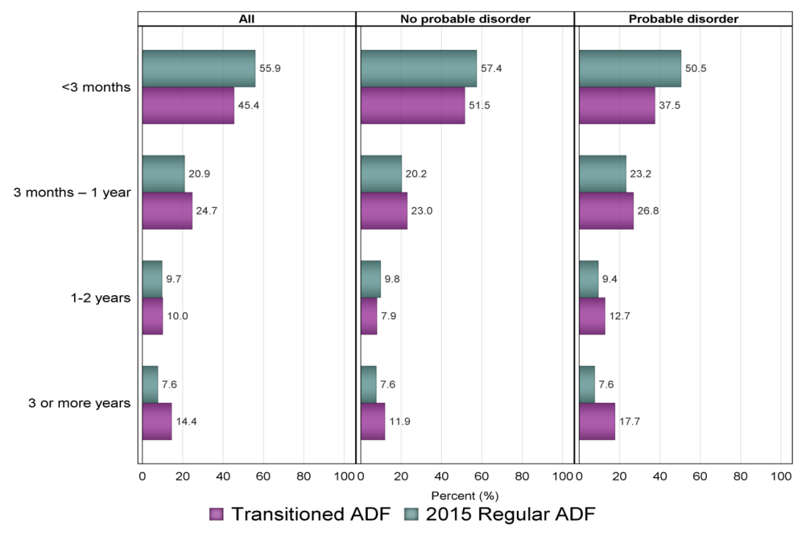

## Support from others in seeking care

### Who suggested they seek help?

In order to better understand patterns of service engagement, it is important to identify the most common pathways into care. For the majority of Transitioned ADF (62.5%) and 2015 Regular ADF (57.5%) who were concerned about their mental health and had ever sought assistance, engagement with professional care was suggested by another. These rates were similar for those with a probable 30-day disorder (68.6% and 55.5% respectively) (Figure 7).

Partners were most likely to suggest Transitioned ADF (47.2%) and 2015 Regular ADF (43.0%) seek assistance for their mental health, followed by friends (28.8% and 29.1%), supervisors (22.1% and 27.6%) and General Practitioners (GPs)/Medical Officers (MOs) (combined 31.1% and 25.3%).

Figure 7 Who suggested help-seeking in Transitioned ADF and 2015 Regular ADF stratified by probable 30-day disorder (Note: all proportions are estimated)

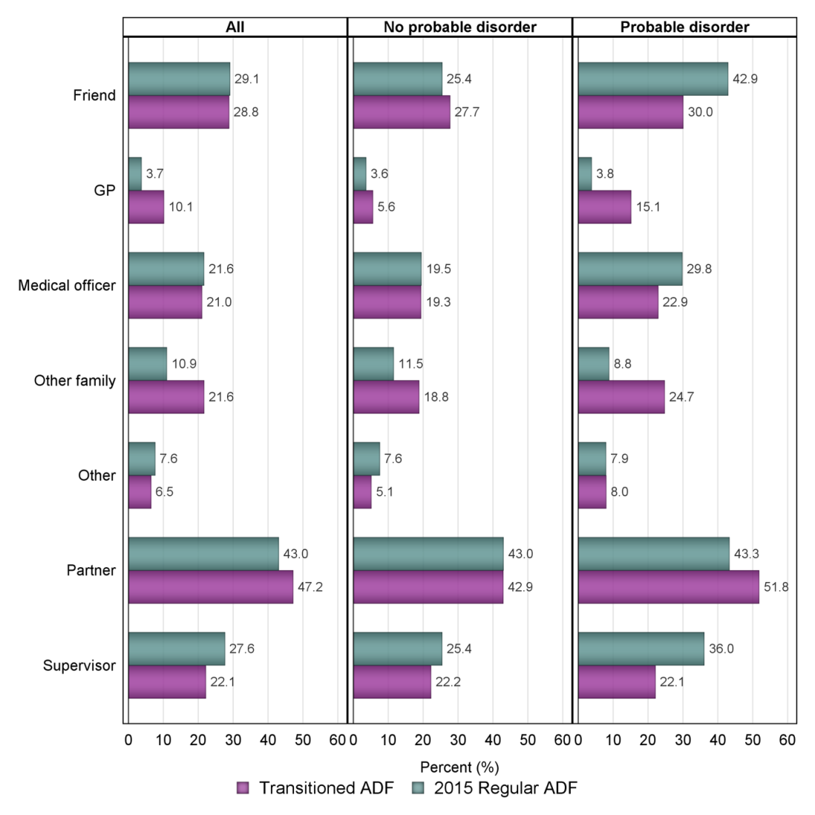

### Who assisted them to seek help?

While the majority of Transitioned ADF and 2015 Regular ADF who sought care had it suggested by someone else, only a minority of those were actively assisted in accessing this care. For 32.6% of Transitioned ADF, someone else assisted them to engage with care, and this was most commonly a GP/MO (combined 41.4%), partner (28.0%), or supervisor (24.9%) (Figure 8). For the 28.5% of 2015 Regular ADF who received assistance with engaging with care, this was most commonly provided by supervisors (32.6%), then GP/MOs (combined 36.2%), friends (16.5%), and partners (12.0%).

Figure 8 Who assisted help-seeking in Transitioned ADF and 2015 Regular ADF stratified by probable 30-day disorder

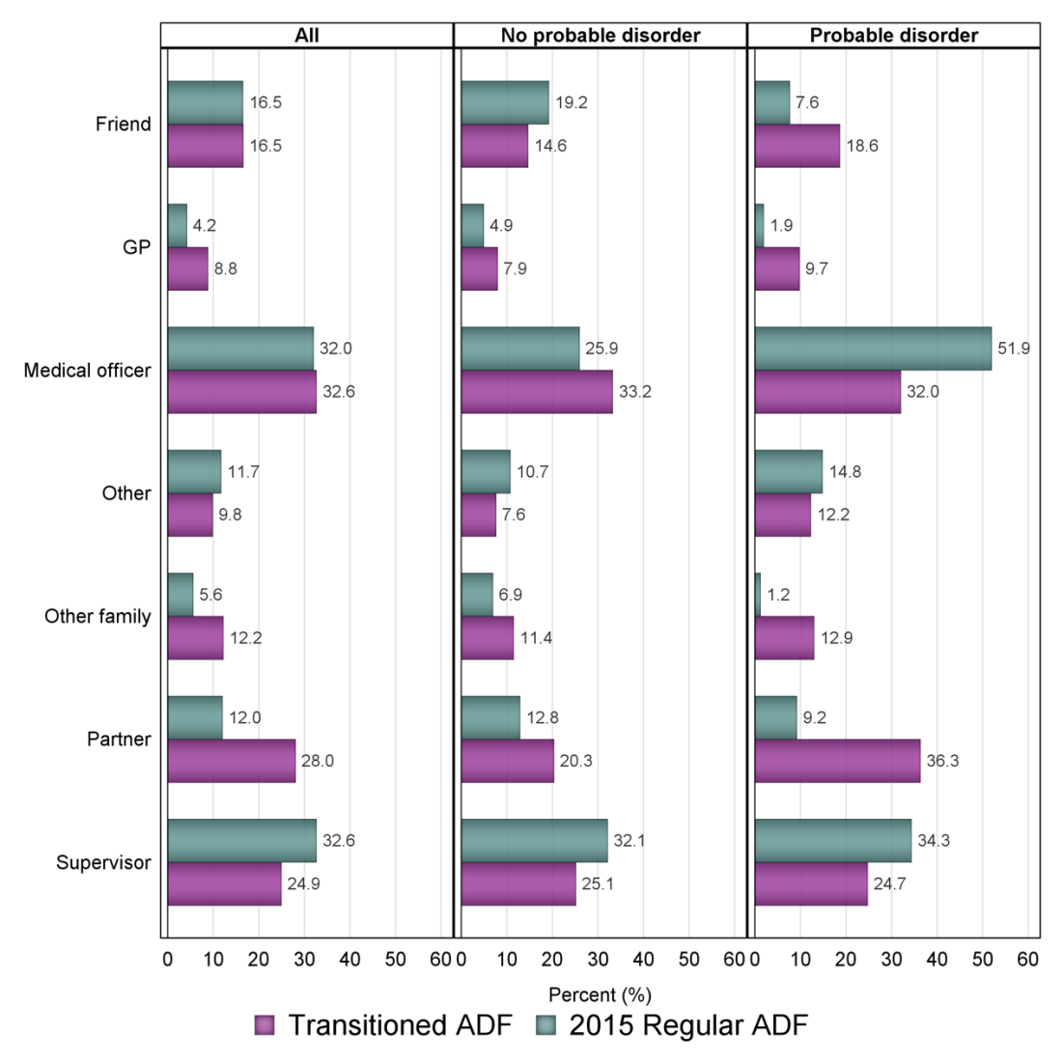

## Primary reasons for seeking care

There was considerable consistency in the Transitioned ADF and 2015 Regular ADF in the primary reasons for seeking mental health care, with the most common reasons being depression (27.2% and 21.0%), anxiety (17.8% and 19.6%), relationship problems (11.1% and 18.7%), and anger (12.4% and 13.0%) (Figure 9). This pattern of primacy of depression, anxiety and anger was consistent for those with and without probable 30-day disorder, however Transitioned ADF with a probable disorder were most likely to seek care for depression whereas 2015 Regular ADF with a probable disorder were most likely to seek help for anxiety.

Figure 9 Primary reason for seeking assistance for mental health among the Transitioned ADF and 2015 Regular ADF stratified by probable 30-day disorder

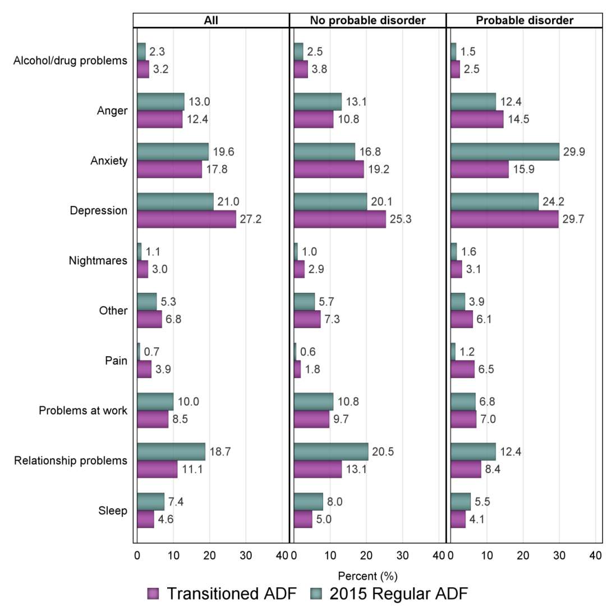

## Mental health service use

### Who was consulted?

The Transitioned ADF and 2015 Regular ADF with a mental health concern reported high rates of engagement with health and mental health professionals for mental health care during their lifetime, with most reporting consulting a GP/MO (80.9% and 77.6%), a psychologist (81.3% and 87.6%) and/or a psychiatrist (49.9% and 38.9%) (Table 20).

Table 20 Estimated proportion of the Transitioned ADF and 2015 Regular ADF consulting each type of health professional, stratified by probable 30-day disorder

|  | **Transitioned ADF n = 12,022** | | | **2015 Regular ADF n = 20,740** | | |
| --- | --- | --- | --- | --- | --- | --- |
|  | **n** | **Weighted n** | **% (95%CI)** | **n** | **Weighted n** | **% (95%CI)** |
| **General Practitioner/Medical Officer** | | | | | | |
| Ever | 1550 | 9720 | 80.9 (78.5,83.0) | 2524 | 16,103 | 77.6 (72.8,81.8) |
| < 12 months ago | 729 | 4616 | 38.4 (35.6,41.1) | 1182 | 7868 | 37.9 (32.0,44.2) |
| > 12 months ago | 1009 | 6330 | 52.7 (49.9,55.4) | 1605 | 9474 | 45.7 (39.7,51.8) |
| *Probable 30-day disorder* |  |  |  |  |  |  |
| Ever | 707 | 4574 | 87.4 (84.1,90.1) | 533 | 4051 | 90.4 (86.5,93.3) |
| < 12 months ago | 462 | 2987 | 57.1 (52.8,61.2) | 377 | 2483 | 55.4 (40.9,69.0) |
| > 12 months ago | 363 | 2402 | 45.9 (41.7,50.1) | 244 | 1917 | 42. 8 (29.3,57. 5) |
| *No probable 30-day disorder* |  |  |  |  |  |  |
| Ever | 843 | 5146 | 75.8 (72.5,78.9) | 1991 | 12,052 | 74.1 (68.3,79.2) |
| < 12 months ago | 267 | 1629 | 24.0 (21.0,27.3) | 805 | 5385 | 33.1 (26.7,40.2) |
| > 12 months ago | 646 | 3929 | 57.9 (54.2,61.5) | 1361 | 7557 | 46.5 (39.9,53.2) |
| **Psychologist** | | | | | | |
| Ever | 1604 | 9772 | 81.3 (78.8,83.5) | 2902 | 18,171 | 87.6 (83.7,90.7) |
| < 12 months ago | 646 | 3878 | 32.3 (29.8,34.9) | 1327 | 9148 | 44.1 (38.0,50.4) |
| > 12 months ago | 1109 | 6864 | 57.1 (54.3,59.8) | 1871 | 10,796 | 52.1 (45.9,58.2) |
| *Probable 30-day disorder* |  |  |  |  |  |  |
| Ever | 703 | 4413 | 84.3 (80.4,87.5) | 576 | 4189 | 93.5 (90.1,95.7) |
| < 12 months ago | 390 | 2342 | 44.7 (40.6,48.9) | 381 | 2464 | 55.0 (40.6,68.6) |
| > 12 months ago | 396 | 2596 | 49.6 (45.4,53.8) | 280 | 2336 | 52.1 (38.2,65.7) |
| *No probable 30-day disorder* |  |  |  |  |  |  |
| Ever | 901 | 5360 | 79.0 (75.6,82.0) | 2326 | 13,982 | 86.0 (81.2,89.8) |
| < 12 months ago | 256 | 1536 | 22.6 (19.7,25.9) | 946 | 6684 | 41.1 (34.4,48.2) |
| > 12 months ago | 713 | 4267 | 62.9 (59.2,66.4) | 1591 | 8460 | 52.0 (45.3,58.7) |
| **Psychiatrist** | | | | | | |
| Ever | 989 | 6003 | 49.9 (47.2,52.6) | 1160 | 8068 | 38.9 (33.0,45.2) |
| < 12 months ago | 477 | 2818 | 23.4 (21.3,25.7) | 470 | 3201 | 15.4 (11.3,20.8) |
| > 12 months ago | 613 | 3840 | 31.9 (29. 5,34.5) | 761 | 5137 | 24.8 (19.5,30.9) |
| *Probable 30-day disorder* |  |  |  |  |  |  |
| Ever | 574 | 3485 | 66.5 (62.3,70.6) | 342 | 2696 | 60.2 (46.4,72.4) |
| < 12 months ago | 364 | 2123 | 40.6 (36.6,44.6) | 212 | 1426 | 31.8 (20.2,46.2) |
| > 12 months ago | 287 | 1847 | 35.3 (31.4,39.3) | 602 | 3744 | 23.0 (17.5,29.6) |
| *No probable 30-day disorder* |  |  |  |  |  |  |
| Ever | 415 | 2518 | 37.1 (33.6,40.7) | 818 | 5372 | 33.0 (26.7,40.0) |
| < 12 months ago | 113 | 694 | 10.2 (8.2,12.7) | 258 | 1775 | 10.9 (7.0,16.6) |
| > 12 months ago | 326 | 1993 | 29.4 (26.1,32.8) | 159 | 1393 | 31.1 (18.9,46.7) |
| **Other mental health professional** | | | | | | |
| Ever | 567 | 3662 | 30.5 (28.0,33.1) | 1010 | 6945 | 33.5 (27.7,39.9) |
| < 12 months ago | 196 | 1177 | 9.8 (8.3,11.5) | 369 | 2058 | 9.9 (7.2,13.6) |
| > 12 months ago | 414 | 2785 | 23.2 (20.9,25.7) | 689 | 5050 | 24.4 (17.0,30.7) |
| *Probable 30-day disorder* |  |  |  |  |  |  |
| Ever | 274 | 1745 | 33.3 (29.6,37.3) | 218 | 1474 | 32.9 (21.2,47.2) |
| < 12 months ago | 136 | 786 | 15.0 (12.4,18.0) | 132 | 743 | 16.6 (9.8,26.7) |
| > 12 months ago | 166 | 1173 | 22.4 (19.0,26.2) | 102 | 788 | 17.6 (8.6,32.7) |
| *No probable 30-day disorder* |  |  |  |  |  |  |
| Ever | 293 | 1917 | 28.3 (25.0,31.8) | 792 | 5470 | 33.7 (27.2,40.8) |
| < 12 months ago | 60 | 391 | 5.8 (4.2,7.8) | 237 | 1315 | 8.1 (5.3,12.2) |
| > 12 months ago | 248 | 1612 | 23.8 (20.7,27.1) | 587 | 4262 | 26.2 (20.1,33.4) |

Denominator: Those who were concerned about their mental health and sought assistance.

Notes:  
95%CI: 95% Confidence Interval

These are not mutually exclusive groups and therefore do not sum to 100%.

Probable 30-day disorder = PCL ≥ 53 or K10 ≥ 25; No probable 30-day disorder = PCL < 53 and K10 < 25.

For those with a probable 30-day disorder who had sought assistance, 84.3% and 93.5% of Transitioned ADF and 2015 Regular ADF respectively had consulted a psychologist. Of those, 55.5% of Transitioned ADF and 66.1% of 2015 Regular ADF had done so in the last 12 months. Approximately 60% of both the Transitioned ADF and the 2015 Regular ADF with a probable 30-day disorder had consulted a psychiatrist.

### What services were provided and what were the levels of satisfaction with these services?

Among the Transitioned ADF, overall satisfaction ratings for core services for each of GP/MOs, psychologists, psychiatrists, and other mental health professionals were in the 60% to70% range. Satisfaction reported by 2015 Regular ADF was considerably higher across MOs, psychologists and psychiatrists, with rates of between 70% and 90%.

#### GPs/MOs

The services most commonly provided by GPs/MOs to Transitioned ADF (73.4%) and 2015 Regular ADF (83.9%) was referral to another service. Other services provided, included information (50.2% and 46.7%), prescribing medicine (68.5% and 35.2%) and support (42.7% and 38.9%).

The GP/MO services with which Transitioned ADF were most satisfied included referrals (74.7%), information (66.1%), medicine (66.9%) and support (61.6%). The GP/MO services with which the 2015 Regular ADF were most satisfied included trauma-focused cognitive behavioural therapy (CBT) and CBT (87.4% and 81.2%), referral (82.3%), and psychotherapy (78.3%).

#### Psychologists

The service most commonly provided by psychologists to Transitioned ADF (80.6%) and 2015 Regular ADF (85.7%) was supportive counselling. Other services included CBT (63.7% and 63.9%) and information (55.9% and 51.9%).

The psychology services with which Transitioned ADF were most satisfied included referrals (72.6%), information (68.6%), supportive counselling (62.5%) and CBT (59.9% including trauma-focused CBT 59.9%). The psychology services 2015 Regular ADF were most satisfied with included CBT (83.9%, including trauma focused CBT 85.5%), information (82.0%) and referrals (84.7%).

Of note, within this study the use of CBT is the best proxy for the delivery of evidence-based psychological treatment for the most common veteran and military mental health problems, and both the Transitioned ADF and the 2015 Regular ADF are reporting high rates of psychologists delivering CBT (63%).

#### Psychiatrists

The services most commonly provided by psychiatrists to Transitioned ADF (77.9%) and 2015 Regular ADF (54.5%) were prescribing medicine, followed by supportive counselling (63.4% and 45.0%) and information (60.1% and 53.8%).

The psychiatry services the Transitioned ADF were most satisfied with included information (69.5%), medicine (66.7%) and CBT (63.0%). The psychiatry services the 2015 Regular ADF were most satisfied with included information (85.2%), medicine (78.3%), supportive counselling (66.8%) and CBT (61.5%).

#### Other mental health providers

The services sought from other mental health professionals such as social workers, occupational therapists and mental health nurses to address mental health concerns were also examined. The most commonly delivered services reported by the Transitioned ADF and 2015 Regular ADF were supportive counselling (69% and 63%) followed by information provision (60% and 39%).

### Attrition in help seeking

While the findings indicate high rates of engagement with mental health care, the attrition at each stage of engagement must also be taken into consideration.

Using the Transitioned ADF as an example:

* 84% of those with a lifetime mental health concern and who had a probable 30-day disorder sought care in their lifetime.
* Of these, 81% had consulted a psychologist for these concerns.
* This equates to 68% of those with a mental health concern at some stage in their lives and who had probable 30-day disorder having sought care from a psychologist. Of this 68%, 55% have seen their psychologist in the last 12 months, i.e., 38% of the total of those with a lifetime mental health concern and current probable 30-day disorder.
* Of the 38% of Transitioned ADF with a probable 30-day disorder seeing a psychologist in the last 12 months, 63% of these received CBT (the best proxy for receiving evidence-based care), (i.e. approximately 24% with a mental health concern and probable 30-day disorder received CBT from a psychologist in the past 12 months).

Therefore, whilst the rates of engagement and uptake at each time point are reasonably high, and exceed community and international standards in veteran and military mental health, a minority of Transitioned ADF with a probable 30-day disorder reported receiving CBT (24%), which would be considered the most evidence-supported treatment for the most prevalent conditions in this population.

### Satisfaction with health service factors

Satisfaction with the accessibility, cost, location, effectiveness, competence, friendliness, convenience and confidentiality of health services are presented in Figure 10. 2015 Regular ADF were more likely to be satisfied than Transitioned ADF in all service factors, with the exception of cost, where there was no significant difference. In both Transitioned ADF and 2015 Regular ADF, those with probable 30‑day disorders reported lower satisfaction in all service factors.

Of the key health service factors, Transitioned ADF were most satisfied with friendliness (71.6%), and confidentiality (70.3%) and 2015 Regular ADF were most satisfied with friendliness (90.9%), location (87.3%), and competence (85.7%).

Figure 10 Aspects of service satisfaction in Transitioned ADF and 2015 Regular ADF, stratified by probable 30-day disorder

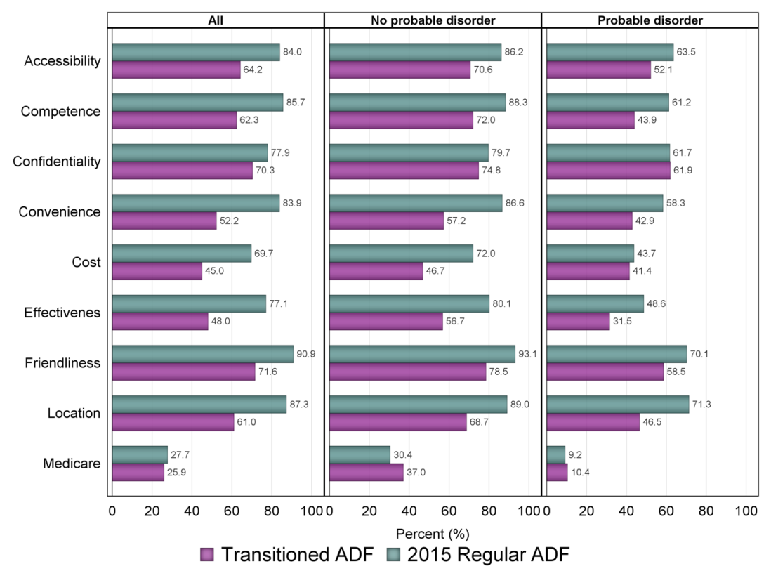

### Who is funding the treatment?

As would be expected, Defence was reported to be the dominant funder of mental health related care for the 2015 Regular ADF, and DVA was reported to be the dominant funder of care for the Transitioned ADF (table/figure not shown in report).

For the Transitioned ADF, 57.1% reported receiving GP/MO services funded by DVA, followed by Medicare (40.6%), self-funded (22.1%), and Defence funded (14.9%). With respect to psychology services, 47.4% reported receiving services funded by DVA, followed by VVCS self-referral (25.8% with an additional 5.9% of Defence funded VVCS services), and Medicare (20.8%).

Within the 2015 Regular ADF, 93.0% reported receiving MO/GP services funded by Defence and 10.8% reported receiving these services funded through DVA. Approximately 85% reported receiving psychology services funded by Defence, followed by VVCS self-referral (17.1% with an additional 5.1% of Defence funded VVCS services).

### Self-help strategies for informing and assessing mental health

#### Websites

Overall, 30.3% of Transitioned ADF and 25.0% of the 2015 Regular ADF reporting using a website to inform or assess their mental health (Table 21). In the Transitioned ADF, 18.6% reported using the DVA website with an additional 10.0% using the ADF website. For 2015 Regular ADF, 14.5% reported using the ADF website followed by 10.5% using the DVA website. The Beyondblue website was the next most common website utilised by both groups (8.0% Transitioned ADF, 6.4% 2015 Regular ADF). Less than 2% reported using the At Ease website.

While satisfaction with the DVA and ADF websites are at reasonable levels, and both the Transitioned ADF and 2015 Regular ADF populations were most likely to access websites designed specifically for serving and ex-serving ADF members by either DVA or Defence, the proportion accessing them is low.

Table 21 Estimated proportion of Transitioned ADF and 2015 Regular ADF who used websites in the last 12 months to inform/assess mental health, stratified by probable 30-day disorder

|  | **Transitioned ADF n = 24,932** | | | **2015 Regular ADF n = 52,500** | | |
| --- | --- | --- | --- | --- | --- | --- |
|  | **n** | **Weighted n** | **% (95%CI)** | **n** | **Weighted n** | **% (95%CI)** |
| **ADF website** | 401 | 2505 | 10.0 (8.9,11.3) | 1285 | 7577 | 14.4 (12.1,17.2) |
| *Helpful?* | 234 | 1407 | 56.2 (50.1,62.1) | 948 | 5320 | 70.2 (60.9,78.1) |
| With probable 30-day disorder | 143 | 838 | 11.9 (9.9,14.4) | 227 | 1540 | 20.3 (13.7,29.2) |
| *Helpful?* | 58 | 325 | 38.8 (29.8,48.7) | 132 | 755 | 49.0 (29.9,68.5) |
| **DVA website** | 815 | 4644 | 18.6 (17.3,20.1) | 1005 | 5535 | 10.5 (8.8,12.6) |
| *Helpful?* | 510 | 2694 | 58.0 (53.8,62.1) | 795 | 3863 | 69.8 (59.8,78.2) |
| With probable 30-day disorder | 386 | 2190 | 31.2 (28.1,34.5) | 232 | 1374 | 18.1 (12.3,25.9) |
| *Helpful?* | 206 | 1071 | 48.9 (43.1,54.8) | 168 | 679 | 49.4 (31.4,67.6) |
| **At Ease website** | 84 | 437 | 1.8 (1.4,2.3) | 107 | 818 | 1.6 (0.8,2.9) |
| *Helpful?* | 39 | 187 | 42.8 (31.1,55.5) | 58 | 196 | 23.9 (11.6,42.9) |
| With probable 30-day disorder | 40 | 225 | 3.2 (2.2,4.6) | 23 | 270 | 3.6 (0.9,12.7) |
| *Helpful?* | 16 | 93 | 41.2 (24.4,60.4) | 11 | 30 | 11.3 (2.5,38.5) |
| **Beyond Blue** | 302 | 1998 | 8.0 (7.0,9.2) | 531 | 3381 | 6.4 (4.7,8.8) |
| *Helpful?* | 208 | 1292 | 64.7 (57.4,71.3) | 444 | 2647 | 78.3 (61.9,88.9) |
| With probable 30-day disorder | 160 | 1109 | 15.8 (13.2,18.8) | 129 | 1043 | 13.8 (7.3,24.6) |
| *Helpful?* | 101 | 658 | 59.4 (49.5,68.5) | 105 | 791 | 75.9 (38.2,94.1) |
| **Any Health websites** | 1230 | 7549 | 30.3 (28.6,32.1) | 2126 | 13,113 | 25.0 (21.8,28.5) |
| With probable 30-day disorder | 535 | 3294 | 46.9 (43.2,50.6) | 419 | 3021 | 40.0 (29.8,50.9) |

Denominator: Entire cohort

Notes:  
Probable 30-day disorder = PCL ≥ 53 or K10 ≥ 25; No probable 30-day disorder = PCL < 53 and K10 < 25.

95%CI: 95% Confidence Interval

These are not mutually exclusive groups and therefore do not sum to 100%.

#### Internet treatments

Internet treatments such as MoodGYM, and e-couch were only used by approximately 2% of both the Transitioned ADF and 2015 Regular ADF. This rate was slightly higher for those with probable 30-day disorder.

#### Smartphone apps

Similarly, rates of uptake of smartphone applications remained quite low with only approximately 6% of Transitioned ADF and 2015 Regular ADF using these applications, although these rates doubled to 14% in both groups in those with a probable 30-day disorder. The most commonly used app was PTSD Coach used by 9.1% and 9.8% in the Transitioned ADF and the 2015 Regular ADF respectively.

#### Other internet

Approximately 20% of the Transitioned and 10% of 2015 Regular ADF reported using some form of additional internet usage to inform or assess their mental health. Of these, the most common form of additional internet use was social media, with 18.1% and 9.9% of Transitioned ADF and 2015 Regular ADF respectively using social media to inform or assess their mental health and approximately 55% of those finding it helpful. Considering this across the transitioned groups, the Ex-Serving group reported considerably higher social media usage of 22% compared with 17% and 13% in Inactive and Active Reservists respectively.

#### Telephone helplines

Approximately 9% of Transitioned ADF and 12% of 2015 Regular ADF used a veteran or military helpline, with rates of 17% and 19% respectively in those with a probable 30-day disorder. The VVCS Vetline was the most highly used helpline in both groups (approximately 8%) followed by 1800 IMSick in the 2015 Regular ADF (4.3%). Approximately 16% of Transitioned ADF and the 2015 Regular ADF with a probable 30-day disorder reported using VVCS Vetline, with very high satisfaction rates of 75–85% in all users and 75% in those with a probable 30-day disorder.

Other telephone helplines which were not military specific, i.e., Lifeline, Mensline, Sane Australia were barely utilised across all groups (less than 2%), with the exception of 2015 Regular ADF members with a probable 30-day disorder, where 6% of this group reported use of the Relationships Australia helpline.

#### Ex-Service Organisations

Contact with ex-service organisations (ESOs) to inform or assess their mental health was reported by 9.2% of Transitioned ADF and 2.9% of 2015 Regular ADF. This figure doubled (18%) for those with a probable 30-day disorder. Rates of satisfaction with ESO services were also high, reinforcing the important role of these organisations within the broader veterans’ service framework.

### Preference for receiving mental health information

With respect to receiving health information, for both the Transitioned ADF and the 2015 Regular ADF there was a stronger preference for receiving this information face-to-face rather than by the internet or by telephone, which was the least preferred of the three options (Table 22). This effect was much stronger in those with a probable 30-day disorder, where 59.7% of Transitioned ADF and 52.2% of 2015 Regular ADF preferred to receive information face-to-face compared to the internet (26.8% and 29.5% respectively).

Table 22 Preferred method for receiving health information in the Transitioned ADF and 2015 Regular ADF, stratified by probable 30-day disorder

|  | **Transitioned ADF n = 24,932** | | | **2015 Regular ADF n = 52,500** | | |
| --- | --- | --- | --- | --- | --- | --- |
|  | **n** | **Weighted n** | **% (95%CI)** | **n** | **Weighted n** | **% (95%CI)** |
| **All** |  |  |  |  |  |  |
| Face-to-face | 1902 | 12,325 | 49.4 (47.4,51.4) | 4484 | 29,335 | 55.9 (52.0,59.7) |
| Telephone | 151 | 1219 | 4.9 (4.0,5.6) | 178 | 1106 | 2.1 (1.2,3.6) |
| Internet | 1182 | 7825 | 31.4 (29.6,33.3) | 2199 | 14,975 | 28.5 (25.2,32.2) |
| **Probable 30-day disorder** | **n = 7023** | | | **n = 7575** | | |
| Face-to-face | 637 | 4191 | 59.7 (55.9,63.3) | 630 | 3952 | 52.2 (41.3,62.8) |
| Telephone | 45 | 350 | 5.0 (3.5,7.1) | 33 | 429 | 5.7 (1.6,17.8) |
| Internet | 261 | 1881 | 26.8 (23.6,30.3) | 209 | 2235 | 29.5 (20.0,41.2) |
| **No probable 30-day disorder** | **n = 17,909** | | | **n = 44,925** | | |
| Face-to-face | 1265 | 8135 | 45.4 (43.1,47.8) | 3854 | 25,383 | 56.5 (52.4,60.6) |
| Telephone | 106 | 869 | 4.9 (3.8,6.1) | 145 | 677 | 1.5 (1.0,2.2) |
| Internet | 921 | 5944 | 33.2 (31.0,35.5) | 1990 | 12,740 | 28.4 (24.8,32.9) |

Denominator: Entire cohort

Notes:  
Based on weighted counts, 7085 (13.49%) of 2015 Regular ADF, and 3562 (14.29%) Transitioned ADF had missing values for this question. However, distributions are calculated by including those with a missing value to allow for correct weighted totals.

Probable 30-day disorder = PCL ≥ 53 or K10 ≥ 25; No probable 30-day disorder = PCL < 53 and K10 < 25.

95%CI: 95% Confidence Interval

## Stigma and barriers to care

### Stigma

This study examined the degree to which negative beliefs and attitudes to seeking care were evident amongst the Transitioned ADF and 2015 Regular ADF (Figure 11). This included the prevalence of negative beliefs relating to what help-seeking would mean about them and their expectation of themselves and how others would perceive them (self-stigma and anticipated public stigma), as well as beliefs about barriers to accessing care.

The most common negative attitudes and beliefs about help-seeking were consistent across both the Transitioned ADF and the 2015 Regular ADF, and included perceptions that others would lose confidence in them (40.0% and 44.6%), they would be seen as weak (28.8% and 31.3%), be treated differently (32.5% and 36.3%), feel worse due to being unable to solve their own problems (35.5% and 27.2%) and feel embarrassed (31.7% and 24.8%). Both the Transitioned ADF and the 2015 Regular ADF with probable 30-day disorder were more likely to endorse most stigma items.

Figure 11 Estimated proportion of Transitioned ADF and 2015 Regular ADF endorsing each stigma item stratified by probable 30-day disorder

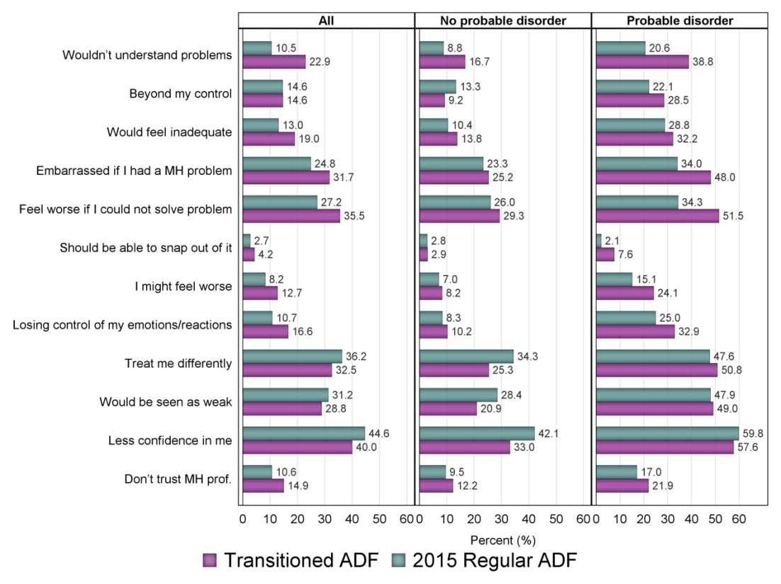

While 35.0% of the Transitioned ADF and 37.4% of the 2015 Regular ADF groups did not report any stigmas, 33.6% and 30.0% respectively held four or more (Figure 12). In Transitioned ADF and 2015 Regular ADF with probable 30-day disorder, 56.2% and 43.8% respectively held four or more stigma related beliefs. Closer examination of this data indicated that care-seeking remained largely proportional to group size in the five stigma endorsement groupings, including for the group who endorsed four or more stigma-related beliefs.

Figure 12 Number of stigmas endorsed in Transitioned ADF and 2015 Regular ADF stratified by probable 30-day disorder

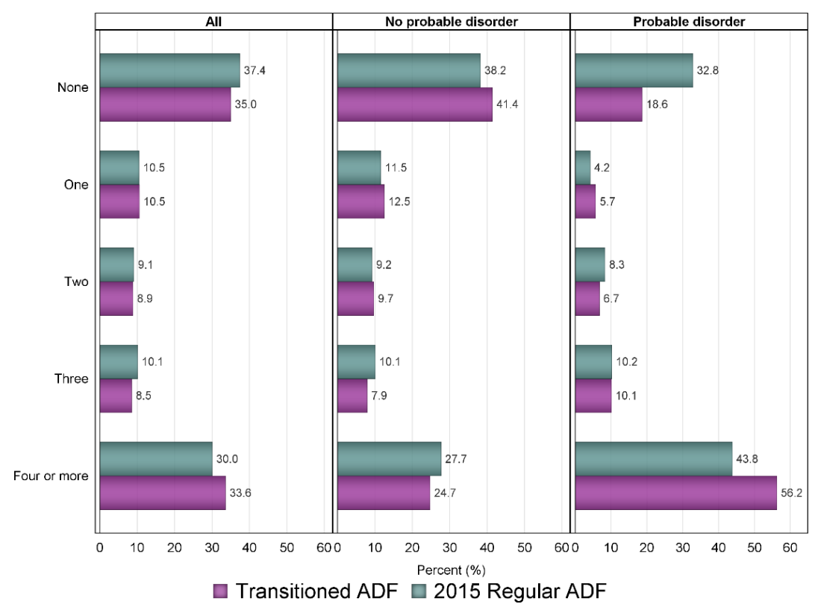

### Barriers

The most common self-reported barrier to seeking care for a mental health problem in the Transitioned ADF was ‘harm my career/career prospects’ (30.3%), and for the 2015 Regular ADF was ‘stop me from being deployed’ (47.4%) (Figure 13). The next most commonly cited barriers for Transitioned ADF were ‘too expensive’ (30.0%) and ‘difficulty getting time off work’ (20.6%). For 2015 Regular ADF these were ‘harm my career/career prospects’ (38.7%) and ‘difficulty getting time off work’ (19.9%).

Similar results were found in those respondents with a probable 30-day disorder. For Transitioned ADF, the most commonly held barrier was ‘too expensive’ (42.2%), ‘harm my career/career prospects’ (41.9%) and ‘difficulty getting time off work’ (29.7%). For 2015 Regular ADF, these were ‘stop me from being deployed’ (47.2%), ‘harm my career/career prospects’ (46.0%) and ‘difficulty getting time off work’ (26.9%).

### Reasons for not seeking assistance

The most common reasons for not seeking assistance for a mental health concern among the Transitioned ADF and 2015 Regular ADF were ‘I can still function’ (80.6% and 82.4%), ‘prefer to manage myself’ (76.7% and 80.1%), and ‘afraid to ask’ (42.6% and 44.9%) (Figure 14).

Figure 13 Estimated proportion of Transitioned ADF and 2015 Regular ADF endorsing each barrier item stratified by probable 30-day disorder

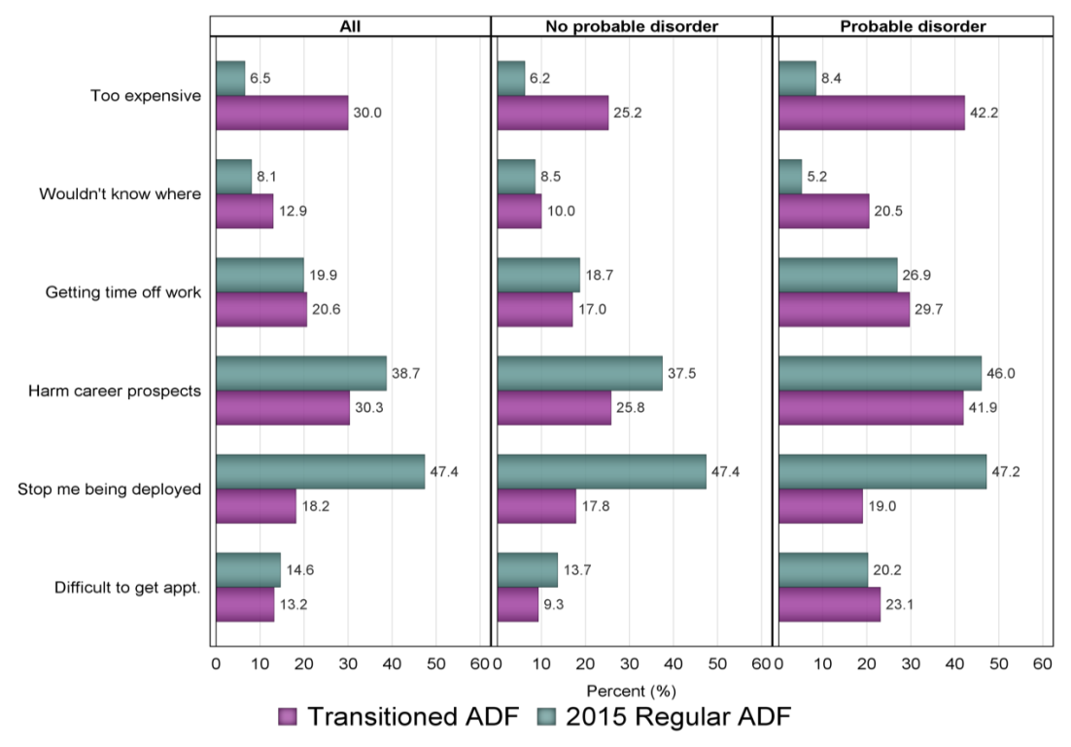

Figure 14 Weighted estimate of reasons why help was not sought among those concerned with their mental health in the 2015 Regular ADF and Transitioned ADF, stratified by probable 30-day disorder

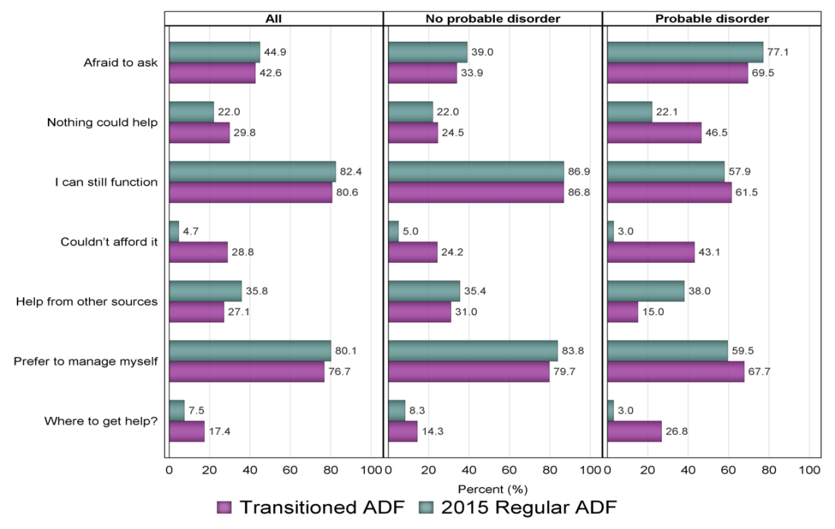

## Implications and future directions: Pathways to Care

The majority of the 2015 Regular ADF and the Transitioned ADF populations with a mental health concern will take the initial steps in seeking care within the first 12 months, with a considerable number doing so within the first three months. This care is commonly provided not only by psychologists, General Practitioners (GPs) and Medical Officers (MOs), but also by psychiatrists and a range of other allied mental health providers.

While the rates of initial engagement and uptake of services are reasonably high, due to an accumulation of factors that occur at each phase of the help-seeking process, the findings also suggest an under-engagement with evidence-based treatment for those with a current disorder. This is more evident in the Transitioned ADF than in the 2015 Regular ADF. Similarly, satisfaction with services is higher in the 2015 Regular ADF. Whilst effective treatment can and often should be episodic, these findings indicate that strategies need to be considered for improving engagement rates, retention and delivery of best practice care at each contact point.

### Integration and coordination of services

There is currently a disparity between the available health service systems for Transitioned ADF and Regular ADF. One of the points of difference is the inherently more interconnected nature of the Defence health services for Regular ADF compared with the broader and more disparate range of services and service providers operating for Transitioned ADF. Currently there is little systematic coordination between the levels of care and providers of care for the Transitioned ADF, and therefore the risks of individuals falling out of care or into the gaps between services is considerable. Improving the organisation and coordination of health services across levels and types of care, and better supporting veterans in their navigation of services, will not only increase the potential for care to be delivered at the right level and intensity according to veterans’ need, but will also place the veteran at the centre of the process and aid the ease with which they can assume agency in facilitating their own care. Aiding this coordination would be the future development and integration of a more proactive, outreach-focused and responsive health and non-health service capability.

### Expertise in military culture and clinical presentations

With the exception of VVCS and the facilities providing accredited PTSD programs for veterans, services for Transitioned ADF are largely provided by a broad array of community practitioners and hospital-based services (National Mental Health Commission, 2017), many of which may not have sufficient exposure to military mental health issues. As such the military cultural competence and knowledge and skills in the treatment of veterans’ common mental health problems may be quite variable. When satisfaction is examined more closely for specialised services such as the PTSD programs, satisfaction ratings are high and very high in currently serving ADF members. These systems have clear specifications to guide services delivered and identified quality assurance and evaluation processes around them specifically. In bolstering engagement and the satisfaction ratings for the competence and effectiveness domains identified in the *Pathways to Care Report* consideration needs to be given to the above features and factors in redressing these issues. One possibility to improve the quality and relevance of the services is to consider establishing networks of excellence (National Mental Health Commission, 2017) whereby services and practitioners with a cultural understanding of veterans and the experience, skill and competence in addressing veterans’ mental health problems are identified and utilised. The network would also promote high levels of connectedness between services within the network, enabling closer communication between practitioners and allowing veterans to make informed decisions in the navigation of their own care.

While the focus is frequently on addressing more serious mental disorder, high quality services must also be provided for a broad range of presenting concerns in those without disorder. Such services serve a critical role of not only ameliorating current subclinical or broader psychosocial issues of concern but also in the prevention of further deterioration in mental health and the maintenance of wellbeing and functioning.

### Bolstering effectiveness of treatment

Beyond the engagement in care, an issue for consideration is the degree to which Transitioned ADF and 2015 Regular ADF experience evidence-based treatments and an ‘adequate dose’ of such treatments (Rosen et al., 2011). The low reported rates of receiving CBT, the best proxy for evidence-based treatment within this study for common mental health problems, indicates the requirement for strategies to improve the extent to which evidence-based care is delivered and also the degree to which individuals remain in this care long enough to receive an effective intervention.

It is acknowledged that even the most evidence-based best practice interventions have limited effectiveness for a considerable proportion of veterans. Therefore, there is also a current DVA commitment reflected in the newly established DVA funded Centenary of Anzac Centre to continue to explore new and innovative biological, medical, social and psychological interventions to improve clinical outcomes for those who fail to benefit currently and adjunctive interventions in order to further enhance quality of life more broadly.

### Bolstering support networks

For the majority of Transitioned and Regular ADF members in 2015, care had been suggested by others, particularly partners and friends. This reinforces the benefit of targeting mental health awareness and treatment information initiatives to the broader support network of Transitioned and Regular ADF members, including partners, family, peers, and commanders or supervisors. This has the potential to not only enhance treatment seeking rates but also direct current and ex-serving ADF members to the most appropriate source of mental health care.

Although the reported rates of contact with ESOs for mental health information and assistance were relatively low, rates of satisfaction with ESO services were high. This highlights the importance of DVA and Defence continuing to collaborate with the ESO community as they have the potential to act as a referral and access point to the evidence-based care provided by the broader veteran and ADF mental health care systems.

### Bolstering the use of self-help strategies

While satisfaction with the DVA and ADF websites are at reasonable levels, and both the Transitioned ADF and 2015 Regular ADF populations were most likely to access websites designed specifically for ADF members by either DVA or Defence, the proportion accessing them is low. The reported use of mobile phone applications was even lower. Currently considerable effort and resources are being dedicated to the use of e-health options. There is much promise in these technologies, however, a better understanding of the reasons for the low uptake rates for current available resources is required. The awareness of and preferences for use of these technologies across information provision and e-interventions will be considered in more detail in the *Technology Use and Wellbeing Report*.

The overall use of social media was not high, but a quarter of Transitioned ADF with a probable 30-day disorder reported using social media as a resource for assessing or informing their mental health, with about half of those reporting it to be useful. Therefore, the potential use of social media in the promotion and dissemination of important health related information should be considered, and this could include consideration of online support groups to promote recovery. It will be however, important to better understand the manner in which social media is being used to leverage off this finding.

Both the 2015 Regular ADF and the Transitioned ADF were most likely to utilise a veteran or military helpline to inform or assess their mental health. The VVCS Vetline service, in particular, had a strong market presence and perceived satisfaction with this service was high. It appears to be a strong brand that can be built upon and integrated further into the service offerings of the health system.

As there was a stronger preference for receiving health information face-to-face than by internet or by telephone, particularly in those with a probable 30-day disorder, consideration should be given to delivery of health-related information face-to-face where possible. One of the most likely and frequent points of face-to-face contact in the 2015 Regular ADF or Transitioned ADF members’ mental health is the GP/MO. Hence, continuing to focus on building the capacity of GP/MOs to deliver clear and targeted mental health awareness, self-management and treatment information is important. These findings also support the current ADF approach of conducting face-to-face mental health screening at high risk points in the service member’s career, including the post deployment mental health screening which includes a significant face-to-face psycho-educational component.

### Stigma, beliefs about mental health treatment and barriers to care

There is evidence of significant self-stigma and anticipated public stigma in up to 50% of Transitioned and 2015 Regular ADF with probable 30-day disorders. While many of this group still sought care, these beliefs do impose a significant stress and emotional burden.

For those with mental health concerns who elected not to seek care, being afraid to ask was the most commonly cited reason for not accessing care. Furthermore, those with a probable 30-day disorder were more negative about the perceived trustworthiness of mental health professionals and the effectiveness of mental health treatment. Serious attention therefore needs to be paid by all agencies, departments and researchers to deliver clear and accurate public messaging regarding the potential availability and benefits of existing treatments, aligned with the evidence. Messaging that understates the availability of care and the effectiveness of this care can have significant impact on confidence and engagement (Rosen et al., 2011). Similarly, it is important that messages about the effectiveness of treatment be realistic and not overstated.

The prominence of the desire to help oneself was also evident in those with mental health concerns who did not seek care. Although a sense of agency, self-reliance and self-efficacy in solving one’s problems is a highly valuable feature of resilience (Britt et al., 2016), a number of considerations emerge where this belief becomes a barrier to seeking care, where professional care is needed. Strategies to make self-help options more available, prominent, acceptable, non-threatening and effective ought to be considered. These may include digital options and greater examination and promulgation of self-management strategies both in terms of prevention and staying well, addressing subclinical problems and in the addressing of probable 30-day mental disorders (Commonweatlh of Australia Department of Health, 2013). There also needs to be further consideration of the messaging to a military population trained in the value of being able to solve their own problems and high levels of self-reliance. This messaging needs to consider how to effectively convey to this population that self-care, and when required, professional care-seeking for mental health concerns, can still be consistent with these values.

Finally, concerns that help-seeking will harm career need to be addressed through evidence. This is a complicated issue as declaration of mental health problems may, for reasons of overall duty of care to the organisation and the individuals (rather than public stigma), influence career outcomes in the short or longer term. However, it is critical that for those who seek care for mental health concerns, there is an ongoing focus on maximising their vocational engagement and career aspirations. For the purposes of changing culture, along with a strong policy and practice commitment to vocational rehabilitation and retention, it is critical that information about ADF members who have self-identified, sought care, and returned to meaningful and valued work be raised to greater attention and indeed be more commonplace. These examples should also represent a range of mental health problems. Current and ex-serving ADF members will understandably need to see examples of the successful application of vocational rehabilitation and retention to have the confidence that the practice matches the communications.

### Areas for future research

The *Pathways to Care Report* examined the overall patterns of help-seeking and pathways into care among Transitioned ADF and 2015 Regular ADF members. There are however, a number of suggested areas for further examination of this data that emerge from these findings. The key ones include:

* Examination of the influence of gender, symptom severity, age, functioning and Service on help-seeking and perceived service satisfaction.
* Examination of the 15% of Transitioned ADF and 25% of 2015 Regular ADF who met criteria for a probable 30-day disorder but did not identify as having a concern about their mental health.
* Examination of the subgroup of Transitioned ADF with a probable 30-day disorder who endorsed four or more beliefs relating to stigma and barriers to care.
* Integration of the data from the *Pathways to Care Report* with the CIDI and suicidality data from the Mental Health Prevalence Report, to examine the patterns of help-seeking among those with specific diagnosed mental disorders and levels of suicidality.
* Examination of the patterns of service engagement in Transitioned ADF members based on their reported reasons for leaving the ADF, including a more detailed analysis of those who were medically or administratively discharged.

# Glossary of terms

**12-month prevalence** – Meeting the diagnostic criteria for a lifetime ICD-10 mental disorder and having reported symptoms in the 12 months before the interview.

**Affective disorders** –Aclass of mental disorder. The Mental Health and Wellbeing Transition Study examined three types of affective disorders: depressive episodes, dysthymia and bipolar disorder. A key feature of these mental disorders is mood disturbance.

**Agoraphobia** – The marked fear or avoidance of situations such as crowds, public places, travelling alone or travelling away from home, which is accompanied by palpitations, sweating, shaking or dry mouth, as well as other anxiety symptoms such as chest pain, choking sensation, dizziness and sometimes feelings of unreality, fear of dying, losing control or going mad.

**Alcohol dependence** – A cluster of cognitive, behavioural and physiological characteristics indicating that the patient continues to use alcohol despite significant alcohol-related problems. A diagnosis was given if the person reported three or more of the following symptoms in the previous 12 months:

* a strong and irresistible urge to consume alcohol
* a tolerance to the effects of alcohol
* an inability to stop or reduce alcohol consumption
* withdrawal symptoms upon cessation or reduction of alcohol intake
* continuing to drink despite it causing emotional or physical problems
* reduction in important activities because of drinking or to drink.

**Alcohol harmful use** – A pattern of heavy drinking that is damaging to health. The damage may be physical or mental (in the absence of a diagnosis of dependence syndrome). Each participant was initially asked if they consumed 12 or more standard alcoholic drinks in a 12-month period. If so, they were then asked a series of questions about their level of consumption. A diagnosis of alcohol harmful use was applied if the alcohol interfered with work or other responsibilities; caused arguments with family or friends; was consumed in a situation where injury could occur; or resulted in the person being stopped or arrested by police; or if the participant continued drinking alcohol despite experiencing social or interpersonal problems as a result of their drinking during the previous 12 months. A person could not meet the criteria for alcohol harmful use if they met criteria for alcohol dependence.

**Alcohol Use Disorders Identification Test (AUDIT)** –Alcohol consumption and problem drinking was examined using the Alcohol Use Disorders Identification Test (Saunders et al., 1993), a brief self-report screening instrument developed by the World Health Organization. This instrument consists of 10 questions to examine the quantity and frequency of alcohol consumption, possible symptoms of dependence, and reactions or problems related to alcohol. The AUDIT is widely used in epidemiological and clinical practice for defining at-risk patterns of drinking.

**Anxiety disorders** – A class of mental disorder that involves experiencing intense and debilitating anxiety. Anxiety disorders covered in the survey were panic attacks, panic disorder, social phobia, specific phobia, agoraphobia, generalised anxiety disorder, posttraumatic stress disorder and obsessive-compulsive disorder.

**Australian Bureau of Statistics (ABS)** – Australia’s national statistical agency, providing trusted official statistics on a wide range of economic, social, population and environmental matters of importance to Australia. To enable comparison of estimates in the Transitioned ADF with an Australian Community population, direct standardisation was applied to estimates in the 2014–15 ABS National Health Survey (NHS) data. The NHS is the most recent in a series of Australia-wide ABS health surveys, assessing various aspects of the health of Australians, including long-term health conditions, health risk factors and health service use.

**Australian Defence Force (ADF)** – The ADF are members of the Permanent Navy, the Regular Army or the Permanent Air Force. This includes reserves that render continuous full-time service, or are on duty or in uniform. The Programme aims to examine the mental, physical and social health of serving and ex-serving ADF members and their families. It builds on previous research to inform effective and evidence-based health service provision for contemporary service members and veterans.

**Australian Institute of Family Studies (AIFS)** – The Australian Government’s key research body focusing on family wellbeing. AIFS conducts [original research to increase the understanding of Australian families](https://aifs.gov.au/our-work) and the issues that affect them. The research detailed in this report was conducted by a consortium of Australia’s leading research institutions led by the Centre for Traumatic Stress Studies at the University of Adelaide, and AIFS.

**Australian Institute of Health and Welfare (AIHW)** – Australia’s national agency for health and welfare statistics and information. It was used in this Programme to develop a Military and Veteran Research Study Roll by integrating contact information from various sources and databases.

**Bipolar affective disorder** – A class of mental disorder associated with significant mood fluctuations. These fluctuations are markedly elevated on some occasions (hypomania or mania) and markedly lowered on others (depressive episodes). A diagnosis of bipolar affective disorder was applied in this study if the individual met criteria for mania or hypomania in the previous 12 months.

**Centre for Traumatic Stress Studies (CTSS)** –This centre at the University of Adelaide seeks to improve evidence-based practice by informing and applying scientific knowledge in the field of trauma, mental disorder and wellbeing in at‑risk populations. The Programme was conducted by a consortium of Australia’s leading research institutions, led by the CTSS and the Australian Institute of Family Studies.

**Chain of command** – A line of authority and responsibility along which orders are passed within a military unit and between different units.

**Class of mental disorder** – A group of mental disorders that share common features. The survey included three classes of mental disorders: affective disorders, anxiety disorders and alcohol disorders.

**Comorbidity** – The occurrence of more than one disorder at the same time.Comorbidity was defined by grouping any alcohol, affective or anxiety disorder (excluding posttraumatic stress disorder – PTSD) and PTSD, according to their co‑occurrence. In addition to breaking down the individual patterns of co-occurrence, five categories were defined, representing those with no mental disorder, and those with one, two, three or four disorders.

**Confidence interval (CI)** – This measurement gives an estimated range of values that is likely to include an unknown population parameter: the estimated range being calculated from a given set of sample data.

**Department of Defence (Defence) –** TheDepartmentis constituted under the [*Defence Act 1903*](http://www.comlaw.gov.au/Series/C2004A07381) (Cth). Its mission is to defend Australia and its national interests. In fulfilling this mission, Defence serves the government of the day and is accountable to the Commonwealth Parliament, which represents the Australian people.

**Department of Veterans’ Affairs (DVA)** –The Department delivers government programs for war veterans, and members of the ADF and the Australian Federal Police and their dependants. In 2014, DVA, in collaboration with the Department of Defence, commissioned the Transition and Wellbeing Research Programme, one of the largest and most comprehensive military research projects undertaken in Australia.

**Deployment status** –The Mental Health and Wellbeing Transition Study defined deployment status, based on survey responses, as:

* **Never deployed:** Individuals who did not endorse any deployments listed in the self‑report survey (Your Military Career: Deployments) and did not endorse any deployment exposures (Your Military Career: Deployment Exposure)
* **Deployed:** Individuals who endorsed one or more of the listed deployments (Your Military Career: Deployments) or endorsed one or more of the deployment exposures (Your Military Career: Deployment Exposure).

**Depressive episodes** – Characteristic of a major depressive disorder, an episode requires that an individual has suffered from depressed mood lasting a minimum of two weeks, with associated symptoms or feelings of worthlessness, lack of appetite, difficulty with memory, reduction in energy, low self-esteem, concentration problems and suicidal thoughts. Depressive episodes can be mild, moderate or severe. All three are included under the same heading. Hierarchy rules were applied to depressive episodes, such that a person could not have met criteria for either a hypomanic or manic episode.

**Diagnostic criteria** – The survey was designed to estimate the prevalence of common mental disorders defined according to clinical diagnostic criteria under the International Statistical Classification of Diseases and Related Health Problems – 10th Revision (ICD-10). Diagnostic criteria for a disorder usually involves:

* the nature, number and combination of symptoms
* the time period over which the symptoms have been continuously experienced
* the level of distress or impairment experienced
* the circumstances for exclusion of a diagnosis, such as it being due to a general medical condition or the symptoms being associated with another mental disorder.

**Dimensions of Anger Reactions Scale (DAR-5)** – A concise measure of anger consisting of five items that address anger frequency, intensity, duration, aggression and interference with social functioning. Items are scored on a five-point Likert scale, generating a severity score ranging from 5 to 25, with higher scores indicating worse symptomatology. This scale has been used previously to assess Australian Vietnam veterans, as well as US Afghanistan and Iraq veterans, and shows strong unidimensionality, and high levels of internal consistency and criterion validity.

**DVA client** – A term used when referring to a DVA client during analyses. During construction of the DVA dataset for the Study Roll, DVA created an indicator for each veteran that assigned the degree of confidence in the accuracy of the data. This was based on the level of each veteran’s interaction with DVA.

Each of the following were considered to signify whether someone was a DVA client:

* **High level of contact:** When a veteran received a fortnightly payment (such as income support or compensation pension) from DVA, which was a sign of regular ongoing contact with the client, so DVA was very confident that their address was up to date and correct
* **Medium level of contact:** When a veteran only had a treatment card (that is, they didn’t receive ongoing payments) so there was less ongoing contact with the Department, and DVA was less confident about the accuracy of the client’s address
* **Low level of contact:** When a veteran’s illness or injury liability claim was not accepted by DVA as service-related so they would not automatically receive a treatment card or pension payment, but would still be considered a DVA client.

For this report, any individual in the study population who met any of the criteria above was flagged as a ‘DVA client’. Those with this flag were compared against those without this flag.

**Dysthymia** – Characterised as a chronic or pervasive mood disturbance lasting several years that is not sufficiently severe or the depressive episodes are not sufficiently prolonged to warrant a diagnosis of a recurrent depressive disorder. The hierarchy rules applied to dysthymia meant that to have this disorder, a person could not have met criteria for either a hypomanic or manic episode and could not have reported episodes of severe or moderate depression within the first two years of dysthymia.

**Epigenetic**– is the study of heritable changes in gene expression (active versus inactive genes) that does not involve changes to the underlying DNA sequence – a change in phenotype without a change in genotype – which in turn affects how cells read the genes.

**Ex-service organisation (ESO)** – Organisations that provide assistance to current and former ADF members. Services can include but are not necessarily limited to welfare support, help with DVA claims, and employment programs and social support.

**Generalised anxiety disorder (GAD)** –A generalised and persistent worry, anxiety or apprehension about everyday events and activities lasting a minimum of six months that is accompanied by anxiety symptoms as described in ‘agoraphobia’. Other symptoms may include muscle tension, inability to relax, irritability and difficulty concentrating. Using International Statistical Classification of Diseases and Related Health Problems – 10th Revision (ICD-10) criteria, generalised anxiety disorder cannot be diagnosed if symptoms can be better explained by another disorder, such as panic disorder, social phobia, obsessive-compulsive disorder or hypochondriacal disorder.

**Generalised Anxiety Disorder 7-item Scale (GAD-7)** – A brief seven-item screening measure based on the *Diagnostic and Statistical Manual of Mental Disorders – Fourth Edition* (DSM-IV) criteria for generalised anxiety disorder. Originally validated for use in primary care, the GAD-7 performs well in detecting probable cases of the disorder, with a sensitivity of 89% and a specificity of 82%.

**Gold Card** – A DVA health card for all conditions. Gold Card holders are entitled to DVA funding for services for all clinically necessary healthcare needs and all health conditions, whether or not they are related to war service. The card holder may be a veteran or the widow/widower or dependant of a veteran. Only the person named on the card is covered.

**Help-seeking latency** –The delay in time between first becoming concerned about a health problem and first seeking help for that problem. To assess help-seeking latency in the study, participants were asked to indicate when they first sought help for their own mental health. Options included ‘within three months of becoming concerned’ or ‘within one year of becoming concerned’. Alternatively, participants were able to specify the number of years since becoming concerned. This item was developed by researchers for use in the study.

**Hypomanic episodes** – Episodes that last at least four consecutive days and are considered abnormal to the individual. These episodes are characterised by increased activity, talkativeness, elevated mood, disrupted concentration, decreased need for sleep and disrupted judgment, manifesting as risk-taking (for example, mild spending sprees). In a subgroup of people, these disorders are particularly characterised by irritability. To meet criteria for the ‘with hierarchy’ version, the person cannot have met criteria for an episode of mania.

**Kessler Psychological Distress Scale (K10)** – A short 10-item screening questionnaire that yields a global measure of psychological distress based on symptoms of anxiety and depression experienced in the most recent four-week period. Items are scored from 1 to 5 and are added up to give a total score between 10 and 50. Various methods have been used to stratify the scores of the K10. The categories of low (10–15), moderate (16–21), high (22–29) and very high (30–50) used in this report are derived from the cut-offs of the K10 that were used in the 2007 Australian Bureau of Statistics National Survey of Mental Health and Wellbeing (Slade et al., 2009).

**Lifetime prevalence** – A prevalence that meets diagnostic criteria for a mental disorder at any point in the respondent’s lifetime.

**Lifetime trauma** – Exposure questions used in this study were drawn from the posttraumatic stress disorder module of the CIDI (Haro et al., 2006). Participants were asked to indicate whether or not they had experienced the following traumatic events: combat (military or organised non-military group); being a peacekeeper in a war zone or a place of ongoing terror; being an unarmed civilian in a place of war, revolution, military coup or invasion; living as a civilian in a place of ongoing terror for political, ethnic, religious or other reasons; being a refugee; being kidnapped or held captive; being exposed to a toxic chemical that could cause serious harm; being in a life-threatening motor vehicle accident; being in any other life-threatening accident; being in a major natural disaster; being in a man-made disaster; having a life-threatening illness; being beaten by a spouse or romantic partner; being badly beaten by anyone else; being mugged, held up or threatened with a weapon; being raped; being sexually assaulted; being stalked; having someone close to you die; having a child with a life-threatening illness or injury; witnessing serious physical fights at home as a child; having someone close experience a traumatic event; witnessing someone badly injured or killed or unexpectedly seeing a dead body; accidentally injuring or killing someone; purposefully injuring, torturing or killing someone; seeing atrocities or carnage such as mutilated bodies or mass killings; experiencing any other traumatic event.

**Mania** – Similar to hypomania but more severe in nature. Lasting slightly longer (a minimum of a week), these episodes often lead to severe interference with personal functioning. In addition to the symptoms outlined under ‘hypomania’, mania is often associated with feelings of grandiosity, marked sexual indiscretions and racing thoughts.

**Medical Employment Classification (MEC)** – An administrative system designed to monitor physical fitness and medical standards in the ADF. It is divided into four levels for members who are current or on discharge from the Regular ADF.

* **MEC 1:** Members who are medically fit for employment in a deployed or seagoing environment without restriction.
* **MEC 2:** Members with medical conditions that require access to various levels of medical support or employment restrictions. However, they remain medically fit for duty in their occupation in a deployed or seagoing environment. In allocating sub-classifications of MEC 2, access to the level of medical support will always take precedence over specified employment restrictions.
* **MEC 3:** Members who are medically unfit for duty in their occupation in a deployed or seagoing environment. The member should be medically managed towards recovery and receiving active medical management with the intention of regaining MEC 1 or 2 status within 12 months of an allocation of MEC 3 being made. The MEC is reviewed after a maximum of 12 months. If the person is still medically unfit for military duties in any operational environment, they are downgraded to MEC 4 or, if appropriate, referred to a Medical Employment Classification Review Board (MECRB) for consideration of an extension to remain at MEC 3.
* **MEC 4:** Members who are medically unfit for deployment or seagoing service in the long term. Members who are classified as MEC 4 for their military occupation are reviewed and the MECRB confirms their classification.

**Medical fitness** – A status defined as:

* **Fit:** Those who are categorised as fully employable and deployable, or deployable with restrictions. Participants are classified as ‘fit’ if they fall into MEC 1 or 2 as described above, or are assigned a perturbed MEC value of ‘fit’.
* **Unfit:** Those not fit for deployment, their original occupation and/or further service. This can include people who are undergoing rehabilitation, transitioning to alternative return-to-work arrangements or who are in the process of being medically discharged from the ADF. Participants are classified as ‘unfit’ if they fall into MEC 3 or 4 as described above, or are assigned a perturbed MEC value of ‘unfit’.

**Medical discharge** – The involuntary termination of the client’s employment by the ADF on the grounds of permanent or long-term unfitness to serve, or unfitness for deployment to operational (war-like) service.

**Mental disorders** – Defined according to the detailed diagnostic criteria within the International Statistical Classification of Diseases and Related Health Problems – 10th Revision (ICD-10). This publication reports data for ICD-10 criteria.

**Mental Health Prevalence and Wellbeing Study (MHPWS)** –The 2010 study is part of the Military Health Outcomes Program (MilHOP), the first comprehensive investigation of the mental health of serving ADF members.

**Middle East Area of Operations (MEAO)** –Australia’s military involvement in Afghanistan and Iraq is often referred to as the Middle East Area of Operations. Thousands of members have deployed to the MEAO since 2001, with many completing multiple tours of duty. The Transition and Wellbeing Research Programme will build upon the Military Health Outcomes Program, which detailed the prevalence of mental disorders among serving ADF members in 2010 as well as deployment-related health issues for those deployed to the MEAO.

**Military Health Outcomes Program (MilHOP)** –MilHOP detailed the prevalence of mental disorders among serving ADF members in 2010 as well as deployment-related health issues for those deployed to the Middle East Area of Operations. The Transition and Wellbeing Research Programme will address a number of gaps identified following MilHOP, including the mental health of Reservists, Ex-Serving members and ADF members in high-risk roles, as well as the trajectory of disorders and pathways to care for individuals identified with a mental disorder in 2010.

**National Death Index (NDI)** – A Commonwealth database that contains records of deaths registered in Australia since 1980. Data comes from the Registry of Births, Deaths and Marriages in each jurisdiction, the National Coronial Information System and the Australian Bureau of Statistics. Before contacting participants, the Study Roll was cross-checked against the NDI to ensure we did not attempt to approach deceased members.

**National Health and Medical Research Council (NHMRC)** – Australia’s peak funding body for medical research. The NHMRC has funded previous investigations undertaken by the Centre for Traumatic Stress Studies.

**National Health Survey (NHS)** – The 2014–15 National Health Survey is the most recent in a series of Australia-wide ABS health surveys, assessing various aspects of the health of Australians, including long-term health conditions, health risk factors, and health service use.

**Obsessive compulsive disorder (OCD)** – A disorder characterised by obsessional thoughts (ideas, images, impulses) or compulsive acts (ritualised behaviour). These thoughts and acts are often distressing and typically cannot be avoided, despite the sufferer recognising their ineffectiveness.

**Optimal epidemiological cut-off** – The value that brings the number of false positives (mistaken identifications of a disorder) and false negatives (missed identifications of a disorder) closest together, thereby counterbalancing these sources of error most accurately. Therefore, this cut-off would give the closest estimate to the true prevalence of a 30-day ICD-10 disorder as measured by the CIDI and should be used to monitor disorder trends.

**Optimal screening cut-off** – The value that maximises the sum of the sensitivity and specificity (the proportion of those with and without a disease who are correctly classified). This cut-off can be used to identify individuals who might need further evaluation.

**Panic attack** – Sudden onset of extreme fear or anxiety, often accompanied by palpitations, chest pain, choking sensations, dizziness, and sometimes feelings of unreality, fear of dying, losing control or going mad.

**Panic disorder** – Recurrent panic attacks that are unpredictable in nature.

**Patient Health Questionnaire-9 (PHQ-9)** – Self-reported depression was examined using the nine-item questionnaire. The items are scored from 0 to 3 and added up to give a total score between 0 and 27. Higher scores indicate higher levels of depression symptoms.

**Pharmaceutical Benefits Scheme (PBS)** – The PBS began as a limited scheme in 1948, offering free medicines for pensioners and a list of 139 ‘life-saving and disease-preventing’ medicines free to other members of the community. Today, the PBS provides timely, reliable and affordable access to necessary medicines for all Australians. The PBS is part of the Australian Government’s broader National Medicines Policy. Data on healthcare use and costs, and PBS and Repatriation Pharmaceutical Benefits Scheme data was obtained for consenting serving and Ex-Serving ADF members as part of the research programme.

**Posttraumatic stress disorder (PTSD)** – A stress reaction to an exceptionally threatening or traumatic event that would cause pervasive distress in almost anyone. Symptoms are categorised into three groups: re-experiencing memories or flashbacks, avoidance symptoms and either hyperarousal symptoms (increased arousal and sensitivity to cues) or inability to recall important parts of the experience.

**The Posttraumatic Stress Disorder Checklist – civilian version (PCL-C)** – A 17-item self-report measure designed to assess the symptomatic criteria of PTSD according to the *Diagnostic and Statistical Manual of Mental Disorders, Fourth Edition* (DSM-IV). The answers are scored from 1 to 5 and added up to give a total symptom severity score of between 17 and 85. An additional four items from the newly released PCL-5 (in the DSM-5) were included, giving researchers flexibility to also measure PTSD symptoms according to the most recent definitional criteria.

**Personnel Management Key System (PMKeyS)** – An integrated human resource management system that provides the ADF with a single source of personnel management information about the entire Defence workforce – Royal Australian Navy, Australian Army and Royal Australian Air Force.

**Prevalence of mental disorders** – The proportion of people in a given population who meet diagnostic criteria for any mental disorder in a given time frame. (See also ‘12‑month prevalence’ and ‘lifetime prevalence’.)

**Probable mental disorder** – Where probable rates of mental disorder are presented, these are based on self-reported epidemiological cut-offs.

**Psychopathology** –The scientific study of mental disorders.

**Rank status** –Three levels of rank were used in the Mental Health and Wellbeing Transition Study:

* **Commissioned Officer (OFFR):** Senior Commissioned Officers (Commander (CMDR), Lieutenant Colonel (LTCOL), Wing Commander (WGCDR) and above) andCommissioned Officers (Lieutenant Commander (LCDR), Major (MAJ), Squadron Leader (SQNLDR) and more junior ranks)
* **Non-Commissioned Officer (NCO):** Senior Non-Commissioned Officers (Petty Officer (PO), Sergeant (SGT) and more senior ranks), and Junior Non-Commissioned Officers (Leading Seaman (LS), Corporal (CPL) and more junior ranks)
* **Other Ranks:** Able Seaman (AB), Seaman (SMN), Private (PTE), Leading Aircraftman (LAC), Aircraftman (AC) or equivalent.

**Reason for discharge** – The reason for transitioning out of the ADF. In the Programme, the reason for discharge was derived from responses on the self-report survey, and classified accordingly:

* **Medical discharge:** Involuntary termination of the client’s employment by the ADF on the grounds of permanent or at least long-term unfitness to serve, or unfitness for deployment to operational (war-like) service
* **Other:** All other types of discharge including compulsory age retirement, resignation at own request, assessed as unsuitable for further training, end of fixed-period engagement, end of initial enlistment period or return of service obligation, end of limited-tenure appointment, not offered re-engagement, accepted voluntary redundancy, compassionate grounds, and non‑voluntary administrative discharge.

**Repatriation Pharmaceutical Benefits Scheme (RPBS)** – The benefits listed in the RPBS can only be prescribed for Department of Veterans’ Affairs beneficiaries who hold a Gold, White or Orange card. Data on healthcare use and costs, and Pharmaceutical Benefits Scheme and RPBS data was obtained for consenting serving and Ex-Serving ADF members as part of the Programme.

**Service status** – The ADF is comprised of:

* **Australian Army:** The military land force, a potent, versatile and modern army that contributes to the security of Australia, protecting its interests and people
* **Royal Australian Navy:** A maritime force that contributes to regional security, supports global interests, shapes the strategic environment and protects national interests
* **Royal Australian Air Force:** An air force that provides immediate and responsive military options across the spectrum of operations as part of a whole-of-government joint or coalition response, either from Australia or deployment overseas. It does this through its key air power roles – control of the air; precision strikes; intelligence, surveillance and responses; and air mobility – enabled by combat and operational support.

**Social phobia** – The marked fear or avoidance of being the centre of attention or in situations where it is possible to behave in a humiliating or embarrassing way, accompanied by anxiety symptoms, and possibly blushing and fear of vomiting, defecating or urinating.

**Specific phobia** – The marked fear or avoidance of a specific object or situation such as animals, birds, insects, heights, thunder, flying, small enclosed spaces, sight of blood or injury, injections, dentists or hospitals, and accompanied by anxiety symptoms as described in ‘agoraphobia’.

**Stratification** – Grouping outcomes by variables of interest. In Report 1, 12-month diagnosable mental disorder and self-reported suicidality were stratified by age, sex, rank, service, years of service in the Regular ADF, deployment status, transition status, years since transition, reason for transition and DVA client status.

**Study Roll** – Participants’ contact details and demographic information were obtained via the creation of a study roll by the Australian Institute of Health and Welfare. This process involved integrating contact information from the following sources:

* Defence Personnel Management Key Solution database
* DVA client databases
* National Death Index
* ComSuper member database
* Military Health Outcomes Program (MilHOP) dataset.

**Suicidal ideation** – Serious thoughts about taking one’s own life.

**Suicidality** – Suicidal ideation (serious thoughts about taking one’s own life), suicide plans and attempts.

**Subsyndromal disorder** – Characterised by or exhibiting symptoms that are not severe enough for diagnosis as a clinically recognised syndrome.

**Transitioned ADF/ADF members** – ADF members who have left military service. For the study, this included all ADF members who transitioned from the Regular ADF between 2010 and 2014, including those who transitioned into the Active Reserve and Inactive Reserve.

**Transitioned status** – Transitioned ADF members were categorised into one of three groups, which broadly represented their level of continued association and contact with Defence and their potential access to support services provided by Defence:

* **Ex-serving:** A person who was a Regular ADF member before 2010, has since transitioned out of the ADF and is no longer engaged with Defence in a Reservist role. The individual is classified as discharged from Defence
* **Inactive Reservist:** A person who was a Regular ADF member before 2010, but has since transitioned into an Inactive Reservist role
* **Active Reservist:** A person who was a Regular ADF member before 2010, but has since transitioned into an Active Reservist role.

**Two-phase design** –A well-accepted epidemiological approach to investigating the prevalence of mental disorders. In the first phase, participants completed a screening questionnaire, which was generally economical in terms of time and resources. Based on the results of this screening and the demographic information provided, certain participants were selected for a more accurate but costly formal diagnostic interview.

**Veterans’ health cards** – DVA, on behalf of the Australian Government, uses the health cards as a convenient method for veterans, war widows and their eligible dependants to access health and other care services. Arrangements are based on providing access to clinically appropriate treatment that is evidence-based. There are Gold, White and Orange health cards.

**Weighting** – Allowing for the inference of results for the entire population. Weighting involved allocating a representative value or ‘weight’ to the data for each responder, based on key variables. The weight indicated how many individuals in the entire population were represented by each responder. Weighting was applied to:

* correct for differential non-response
* adjust for any systematic biases in the responders (for example, oversampling of high scorers for the CIDI).

**White Card** – A DVA health card for specific conditions. A White Card entitles the holder to care and treatment for:

* injuries or conditions that are accepted as being caused by war or service-related
* malignant cancer, pulmonary tuberculosis, posttraumatic stress disorder, anxiety and/or depression, whether or not it was caused by war
* symptoms of unidentifiable conditions that arise within 15 years of service (other than peacetime service).

Services covered by a White Card are the same as those for a Gold Card, but must be for treatment of conditions that are accepted as being caused by war or service-related.

**World Mental Health Survey Initiative Version of the World Health Organization Composite International Diagnostic Interview – version 3 (CIDI)** – The CIDI (Kessler and Ustun, 2004) provides an assessment of mental disorders based on the definitions and criteria of two classification systems: the *Diagnostic and Statistical Manual of Mental Disorders, Fourth Edition* (DSM-IV) and the International Statistical Classification of Diseases and Related Health Problems – 10th Revision (ICD-10) (World Health Organisation, 1994). This instrument was used in phase 2 of the Programme.

**Years since transition** – To ascertain the number of years since transition from Regular Service, participants were asked to indicate what year they transitioned to Active Reserves, Inactive Reserves or were discharged out of the Service (Ex-Serving). Options included: zero, one, two, three, four or five years.

**Years of Regular Service** –The following categories were used in the Mental Health and Wellbeing Transition Study to define the number of years of Regular Service: 3 months – 3.9 years, 4–7.9 years, 8–11.9 years, 12–15.9 years, 16–19.9 years and 20+ years.

# References

American Psychiatric Association (2013). *Diagnostic and statistical manual of mental disorders (5th ed.),* Arlington, VA: American Psychiatric Publishing.

Australian Bureau of Statistics. (2010). Health and socioeconomic disadvantage. Available: [http://www.ausstats.abs.gov.au/Ausstats/subscriber.nsf/0/5703A93771AE2E4ECA2576E70016C8D3/$File/41020_ healthandseifa.pdf](http://www.ausstats.abs.gov.au/Ausstats/subscriber.nsf/0/5703A93771AE2E4ECA2576E70016C8D3/$File/41020_%20healthandseifa.pdf).

Australian Bureau of Statistics (2015). National Health Survey: First Results 2014-2015. Canberra: Australian Bureau of Statistics.

Australian Institute of Health and Welfare. 2017. *Incidence of suicide among serving and ex-serving Australian Defence Force personnel 2001–2015.* [Online]. Cat. no. PHE 213. Canberra: AIHW. Available: <http://www.aihw.gov.au/WorkArea/DownloadAsset.aspx?id=60129559899>.

Britt, T. W., Jennings, K. S., Cheung, J. H., Pury, C. L. S., Zinzow, H. M., Raymond, M. A. and McFadden, A. C. (2016). Determinants of mental health treatment seeking among soldiers who recognize their problem: implications for high-risk occupations. *Work and Stress,* 30(4), 318-336.

Commonwealth of Australia. 2017. *Australian Government response to the National Mental Health Commission Review into the suicide and self-harm prevention services available to current and former serving ADF members and their families*. [Online]. Canberra: Department of Veteran’s Affairs. Available: [https://www.dva.gov.au/sites/default/files/files/health and wellbeing/mental/govtresponse.pdf](https://www.dva.gov.au/sites/default/files/files/health%20and%20wellbeing/mental/govtresponse.pdf).

Commonweatlh of Australia Department of Health. (2013). A national framework for recovery-oriented mental health services: Guide for practitioners and providers. Available: <http://www.health.gov.au/internet/main/publishing.nsf/content/mental-pubs-n-recovgde>.

Dobson, A., Treloar, S., Zheng, W., Anderson, R., Bredhauer, K., Kanesarajah, J.,et al. andWaller, M. (2012). *The Middle East Area of Operations (MEAO) Health Study: Census Study Report,* Brisbane, Australia: The University of Queensland, Centre for Military and Veterans Health.

Forces in Mind Trust (2013). The transition mapping study: understanding the transition process for service personnel returning to civilian life, London: Forces in Mind Trust.

Haro, J. M., Arbabzadeh-Bouchez, S., Brugha, T. S., De Girolamo, G., Guyer, M. E., Jin, R.,et al. andKessler, R. C. (2006). Concordance of the Composite International Diagnostic Interview Version 3.0 (CIDI 3.0) with standardized clinical assessments in the WHO World Mental Health Surveys. *International Journal of Methods in Psychiatric Research,* 15(4), 167-180.

Hruska, B., Irish, L. A., Pacella, M. L., Sledjeski, E. M. and Delahanty, D. L. (2014). PTSD symptom severity and psychiatric comorbidity in recent motor vehicle accident victims: A latent class analysis. *Journal of anxiety disorders,* 28(7), 644-649.

Johnston, D. W., Shields, M. A. and Siminski, P. (2016). Long-term health effects of Vietnam-era military service: A quasi-experiment using Australian conscription lotteries. *Journal of health economics,* 45, 12-26.

Kessler, R. C. and Ustun, T. B. (2004). The World Mental Health (WMH) Survey Initiative Version of the World Health Organization (WHO) Composite International Diagnostic Interview (CIDI). *Int J Methods Psychiatr Res,* 13(2), 93-117.

McEwen, B. S. (2003). Mood disorders and allostatic load. *Biol Psychiatry,* 54(3), 200-7.

McFarlane, A. C. (2010). The long-term costs of traumatic stress: intertwined physical and psychological consequences. *World Psychiatry,* 9(1), 3-10.

McFarlane, A. C., Hodson, S., Van Hooff, M., Verhagen, A. and Davies, C. (2011). *Mental health in the Australian Defence Force: 2010 ADF Mental Health Prevalence and Wellbeing Study: Full Report*, Canberra: Department of Defence.

Mota, N., Tsai, J., Kirwin, P. D., Harpaz-Rotem, I., Krystal, J. H., Southwick, S. M. and Pietrzak, R. H. (2016). Late-life exacerbation of PTSD symptoms in US veterans: results from the National Health and Resilience in Veterans Study. *J Clin Psychiatry,* 77(3), 348-54.

National Mental Health Commission. (2017). R*eview into the suicide and self-harm prevention services available to current and former serving ADF members and their families*. Available: <http://www.mentalhealthcommission.gov.au/>.

O’Donnell, M., Dell, L., Fletcher, S., Couineau, A. and Forbes, D. (2014). *The Australian Defence Force Mental Health Screening Continuum Framework: Full Report.,* Canberra: Department of Defence.

Pine, D. S., Cohen E, Cohen, P. and J., B. (1999). Adolescent depressive symptoms as predictors of adult depression: moodiness or mood disorder? *Am J Psychiatry,* 56(1), 133-5.

Raja, M. and Azzoni, A. (2004). Suicide attempts: differences between unipolar and bipolar patients and among groups with different lethality risk. *J Affect Disord,* 82(3), 437-42.

Reed, R. L., Masters, S. and Roeger, L. S. (2016). The Australian Defence Force Post-discharge GP Health Assessment. *Australian family physician,* 45(3), 94.

Rosen, C. S., Greenbaum, M. A., Fitt, J. E., Laffaye, C., Norris, V. A. and Kimerling, R. (2011). Stigma, help-seeking attitudes, and use of psychotherapy in veterans with diagnoses of posttraumatic stress disorder. *J Nerv Ment Dis,* 199(11), 879-885.

Saunders, J. B., Aasland, O. G., Babor, T. F., de la Fuente, J. R. and Grant, M. (1993). Development of the Alcohol Use Disorders Identification Test (AUDIT): WHO Collaborative Project on Early Detection of Persons with Harmful Alcohol Consumption--II. *Addiction,* 88(6), 791-804.

Slade, T., Johnston, A., Oakley Browne, M. A., Andrews, G. and Whiteford, H. (2009). 2007 National Survey of Mental Health and Wellbeing: methods and key findings. *Aust N Z J Psychiatry,* 43(7), 594-605.

Smid, G. E., Kleber, R. J., Rademaker, A. R., van Zuiden, M. and Vermetten, E. (2013). The role of stress sensitization in progression of posttraumatic distress following deployment. *Soc Psychiatry Psychiatr Epidemiol,* 48(11), 1743-54.

World Health Organisation (1994). *ICD-10 International Statistical Classification of Diseases and Related Health Problems*, Geneva: World Healh Organization.