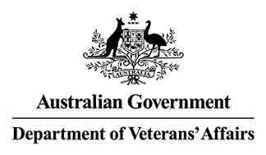 

**DVA Community Nursing program continues to be beneficial to veteran community**

A national **Client and Carer Feedback Survey** was conducted across July and August 2022.

Thank you to all those who participated in the survey. Your feedback on how well the program is fulfilling its objectives and is being delivered, is important to understanding where improvements are needed.

***Survey results***

The survey found that **high levels of overall satisfaction** with the program have continued for both clients and carers.

This is a great result despite the intervening impacts of the COVID-19 pandemic, with its increased health care service delivery challenges, including increased nursing and personal care workforce shortages.

Further, for clients who had been receiving services for a year or more, **a quarter reported the services had improved** in the past year (although a small percentage thought it declined).

Areas for improvement identified by respondents included management of appointment times, consistency of care, understanding why requests for additional services could not be met, and communication between nurses and personal care workers about their care.

***Comparison to previous survey results***

The survey questionnaire was kept as consistent as possible with the first monitoring CN survey, which was conducted in 2019, to enable trends to be identified.

There was little change from the **generally high levels of client satisfaction** for individual aspects of services measured in 2019, such as being treated with **respect** and **having their views and concerns listened to**.

There was some softening of the level of satisfaction, for satisfied carers, with the quality of treatment and care, communication with themselves and the impact on their caring responsibilities. This suggests that where there are carers, COVID-19 and related service stressors over the last two years have impacted them more than clients.

***Survey composition***

The survey consisted of a random sample of current and recent nursing clients and their carers. Orima Research, an independent market research company, was contracted to undertake the survey on behalf of DVA. The survey responses were stored securely by Orima Research. The reports on the survey were provided to DVA without any names or other identifying information for survey respondents, their carers and for any service providers mentioned in free text comments.

If you have any questions, please contact DVA at[nursing@dva.gov.au](mailto:nursing@dva.gov.au)