**PUBLIC INTEREST CERTIFICATE**

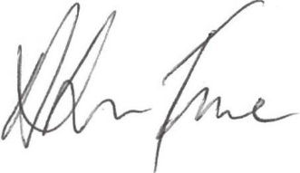

This *public interest certificate* is issued under section 22(1) of the *Government Procurement (Judicial Review) Act 2018.*

I hereby state that it is not in the public interest for the following *procurement(s)* by Department of Veterans’ Affairs to be suspended while complaints under section 18 of *the Act* are being investigated or while applications for injunctions under Part 2 of *the Act* are being considered.

AusTender ID(s) REHAB SOM 22A

Tender(s) Close Date and Time

Procuring Entity Department of Veterans’ Affairs

Contact Officer Project Manager

REHAB.SOM22@dva.gov.au

Category (UNSPSC) 85122100 – Rehabilitation Services

Description The Department of Veterans’ Affairs (DVA) funds services through its’ Rehabilitation Program to help eligible Clients to restore function, or achieve the highest possible level of function, physically, psychologically, socially, vocationally and economically; to maximise quality of life and wellbeing, and to minimise the Client’s long term health care needs and community support needs that have arisen as a result of their service.

This RFT seeks to establish a new multidisciplinary panel of approximately 10 rehabilitation providers who are able to offer high quality and cost effective services to eligible veterans residing throughout Australia.

Signature of *accountable authority*/delegate:

Alison Frame

Secretary

5 April 2023

**OFFICIAL**