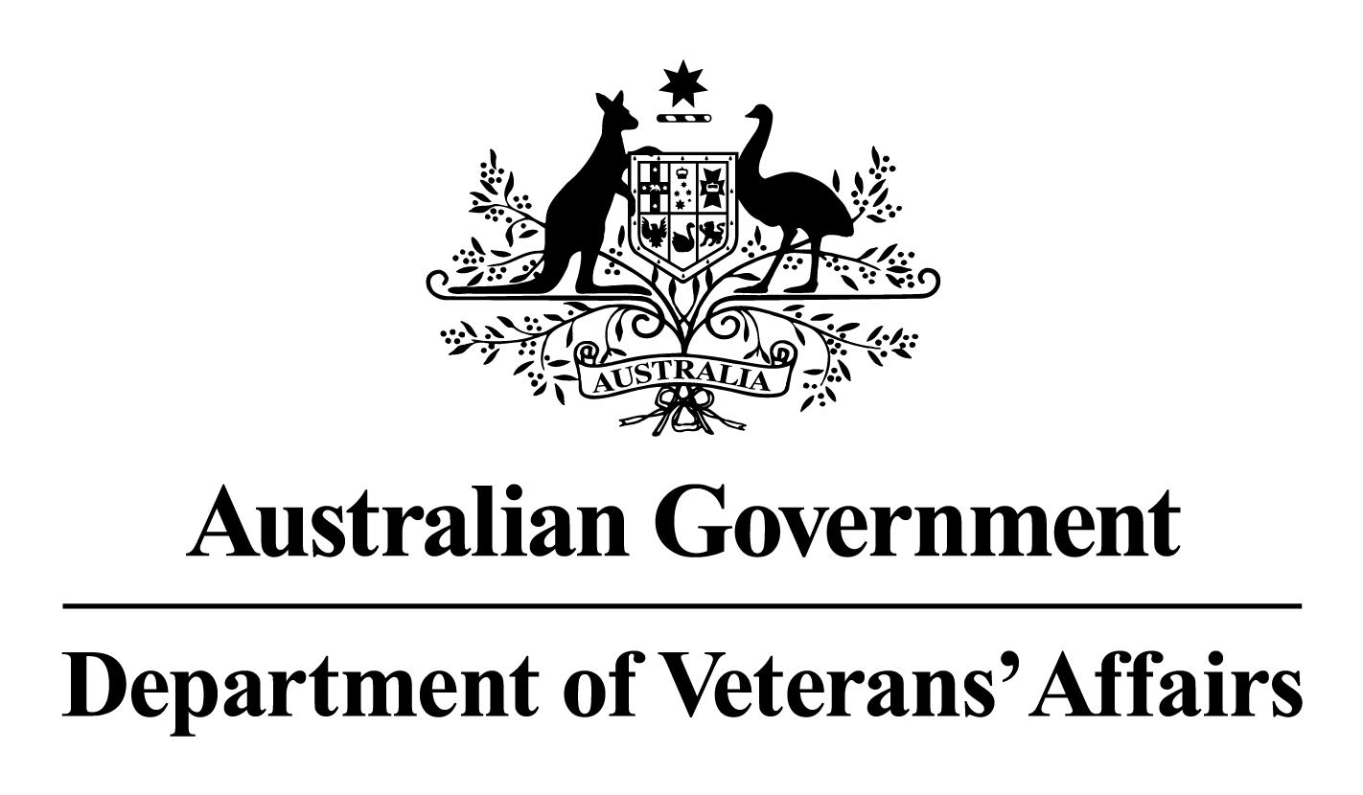

**DVA Policy**

**Client Benefits’ Division**

**Compensation Claims Communication Standards**

Contents

Version Control 2

**Introduction:** 3

Purpose 3

Application 3

Commitment 3

Summary 3

**Frequency & Mode of Contact during the Claims Process** 4

Claim Acknowledgment Letter 4

Claim Administration 4

**Claim Investigation** 4

Preliminary Phone Call 4

Claim Progress Updates 5

Pre-Determination Call 5

28 Day Reminder Letter 5

Needs Assessment 6

**Related Policies & Procedural Guidance** 7

### Version Control

|  |  |  |  |
| --- | --- | --- | --- |
| **Date of Change** | **Summary of Changes** | **Reason** | **Approved by** |

|  |  |  |  |
| --- | --- | --- | --- |
| July 2023 | New Policy – to replace Open Door Policy 2013 | To outline the expected frequency and mode of contact DVA expects its staff to have with clients during the DVA compensation claims process. | Deputy Secretary, Enabling & Commemorations Group |

# **Introduction:**

## Purpose

The purpose of this instruction is to provide advice around the expected communication standards for staff in the Client Benefits Division (CBD), to help guide client expectations and to deliver minimum client service standards during the claim process.

DVA recognises that some claimants may experience feelings of uncertainty during a claim for compensation. Regular communication throughout the claims process can alleviate a significant amount of concern and worry, and help to improve their DVA experience.

The CBD Communication Standards outline the frequency and mode of contact staff are expected to have with veterans during the compensation claims process. The policy applies across all Acts and claim types and includes:

* The frequency and mode of contact veterans can expect from the Department during the compensation claims process,
* Information and expectations regarding the 28 Day Reminder letters, Needs Assessment process, and Pre-Determination Calls.
* Links to related policies and procedural guidance

## Application

This policy applies to all CBD staff who process compensation claims.

## Commitment

A review of this policy will be conducted in mid-2024.

## Summary of Key Contact Points

|  |  |  |  |
| --- | --- | --- | --- |
| **Key Contact Points** | **Timeframe** | **Reason** |  |
| Claim Acknowledgment Letter | No later than 5 working days from registration | Acknowledging receipt of claim | |
| Claim Administration (Initial liability only) | 30 day intervals | To inform clients that their claims is still in queue, and/or request additional information to support their claim | |
| Preliminary phone call | No later than 14 days after allocation | Introductory phone call to client to set expectations of the claims process | |
| Claim progress updates | 30 day intervals, unless by exception | To provide an update on the progress of the claim investigation | |
| Pre-Determination Call | Prior to claim completion | To inform clients that a determination is about to made, the likely outcome and the reasons for the decision | |
| 28 Day reminder letter | As required | A final reminder to request information a client may be able to provide to finalise a claim | |
| Needs Assessment | Conducted following finalisation of an initial liability claim | To establish the needs of the veteran and identify benefits and services available | |

# **Frequency & Mode of Contact during the Claims Process**

### Claim Acknowledgment Letter

Upon registration, all claims must be acknowledged in writing (no later than 5 working days), using the Acknowledgement of Claims letter template generated in ISH.

Staff can refer to CLIK guidelines for information that is required in acknowledgement letters to ensure communication with veterans is both appropriate and consistent.

[1.1 Holding bays and acknowledgement | Compensation claims procedures, Pre-claim procedures (dva.gov.au)](http://auth-clik.dvastaff.dva.gov.au/compensation-claims-procedures/pre-claim-procedures/holding-bays-and-acknowledgement)

### Claim Administration

Where an Initial Liability claim cannot be allocated for investigation within a reasonable timeframe, contact will be made to claimants at 30 day intervals until their claim is allocated.

Multiple modes of communication including SMS, email or letter can be used at 30, 60 and 90 days to inform clients that their claim is still in the queue, or to request additional information to support their claim.

**Claim Investigation**

### Preliminary Phone Call

A preliminary phone call should be made to the claimant as soon as practical following the allocation of the claim to a claim support officer or delegate, and no later than 14 days after allocation.

In cases where telephone contact is unsuccessful, it is recommended that staff send an SMS call back request and include their contact details.

The preliminary phone call provides an opportunity for a staff to:

* Request additional information required to process a claim,
* Inform veterans of the key milestones in the claim investigation process and to set expectations around processing timeframes or potential delays,
* Check to see if there have been changes any circumstances that may impact on claim priority since claim lodgement, and
* Obtain advice from the claimant as to the frequency and mode of contact regarding the claim that will best suits their needs.

For consistent messaging around the key milestones in the claims process please see:

[What to expect after you have submitted a compensation claim | Department of Veterans' Affairs (dva.gov.au)](https://www.dva.gov.au/what-expect-after-you-have-submitted-compensation-claim)

Following the preliminary phone call, staff should send a follow-up email confirming what was discussed.

### Claim Progress Updates

A claimant and/or their advocate or representative is to be contacted every 30 days regarding the progress of their claim unless by agreement or at the request of the claimant (to be recorded in the claim contact notes). This contact can be made by SMS, email or telephone.

Progress updates may include:

* Reminders of requests for information needed to process a claim,
* provide details of any outstanding matters such as potential delays to medical reports,
* confirm upcoming medical appointments in respect to a claim, and
* respond to any questions a client may have about their claim.

Many staff already make routine contact with veterans throughout the claims process and understand the benefits of regular communication. To ensure that the individual needs of each veteran is being taken into account, staff should maintain discretion, and exercise sound judgement where regular contact is being made.

Some examples of where monthly contact may not be required are:

* Where the claim is awaiting a medical appointment and the claimant agrees contact will be made after the appointment takes place or the report is received.
* The claimant specifically requests to be contacted less frequently.

Specific contact requirements for Case Coordinated clients should be discussed with the Case Coordinator and recorded on the claim.

### Pre-Determination Call

To ensure procedural fairness where an adverse decision is being made, DVA must provide clients with a reasonable opportunity to comment on a medical report or provide additional information to support their claim. This opportunity must be provided before the claim is determined.

A pre-determination call provides staff the opportunity to inform a veteran that a determination is about to be made, the likely outcome of the determination, and explain the reasons for the decision, in a much more effective and supportive way than a determination letter.

For further information see:

[3.2 Natural Justice Considerations and Prior Warning of Adverse Decisions | Military Compensation SRCA Manuals and Resources Library, Liability Handbook, Ch 3 Determinations of Liability (dva.gov.au)](http://auth-clik.dvastaff.dva.gov.au/military-compensation-srca-manuals-and-resources-library/liability-handbook/ch-3-determinations-liability/32-natural-justice-considerations-and-prior-warning-adverse-decisions)

### 28 Day Reminder Letter

Throughout the claims process, staff may need to request additional documentation to support the investigation of a claim that only the client can provide. For example, claimant reports, contention information and witness statements. Where an information request has not been completed, staff can utilise any of the listed contact points to remind a claimant of the required information to finalise their claim. These reminders can be conducted through the use of SMS, telephone or email.

If numerous attempts to obtain the information fails and where the requested information could be provided by the client without unreasonable expense or inconvenience, staff may issue a final reminder in line with the 28 day reminder letter.

### Needs Assessment

A Needs Assessment must be conducted following the finalisation of an initial liability claim, to establish the needs of the veteran and to identify benefits and services available including Incapacity Payments, Permanent Impairment, and Rehabilitation & Household Services. The Needs Assessment where possible should be conducted by phone call.

Engaging directly with the client assists DVA to have a meaningful discussion about their needs and to identify services that will support their wellbeing. The needs assessment process recognises that a veterans’ needs can change along the course of the claims journey and that personal contact provides the best opportunity for these changes to be identified and acted upon.

# **Related Policies & Procedural Guidance**

Client Communication Procedures:

[Client communication procedures | Compensation claims procedures, Communication procedures (dva.gov.au)](http://auth-clik.dvastaff.dva.gov.au/compensation-claims-procedures/communication-procedures/client-communication-procedures)

Communicating with Representatives:

[Client representation and withdrawal of consent | Compensation claims procedures, Foundations, Client representation (dva.gov.au)](http://auth-clik.dvastaff.dva.gov.au/compensation-claims-procedures/foundations/client-representation/client-representation-and-withdrawal-consent)

Coordinated Client Support and T&C

[8.Engaging with Coordinated Client Support and T&C | Compensation claims procedures, Communication procedures (dva.gov.au)](http://auth-clik.dvastaff.dva.gov.au/compensation-claims-procedures/communication-procedures/engaging-coordinated-client-support-and-tc)

SMS

[SMS | Compensation claims procedures, Communication procedures (dva.gov.au)](http://auth-clik.dvastaff.dva.gov.au/compensation-claims-procedures/communication-procedures/sms)

Written communication & signature blocks:

[Written communication | Compensation claims procedures, Communication procedures (dva.gov.au)](http://auth-clik.dvastaff.dva.gov.au/compensation-claims-procedures/communication-procedures/written-communication)