 | 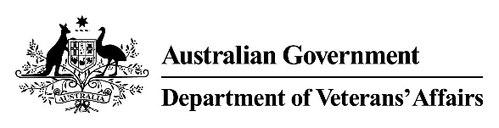 | Female Reproductive System  Medical Impairment Assessment
Veteran |  |  |  |  |  | UIN
Please assess the following conditions:
- Please select the most accurate description of impairment of fertility.
Description | Select One
None. | ☐
Infertility associated with natural menopause. | ☐
Difficulty conceiving but has conceived naturally. | ☐
Reduced fertility – successful pregnancy has been achieved only with medical intervention (e.g. IVF, hormonal stimuli). | ☐
Pregnancy is medically proscribed due to serious risk to the health of mother or potential child. | ☐
Complete infertility – unable to become pregnant or maintain a pregnancy to term. | ☐
At what age was the onset of this level of infertility?
- Please select all that apply in relation to the cervix and / or uterus.
Description | Select
No abnormality. | ☐
Scarring or partial loss of the cervix without loss of function. | ☐
Cervical incompetence. | ☐
Endometriosis. | ☐
Severe menorrhagia. | ☐
Hysterectomy. | ☐
At what age was the hysterectomy (if applicable)?

- Please select the most accurate description in relation to the ovaries and fallopian tubes.
Description | Select One
No abnormality. | ☐
Recurrent Salpingitis. | ☐
Loss or removal of single ovary. | ☐
Loss or removal of both ovaries (whether or not associated with hysterectomy). | ☐
At what age did loss of ovaries occur (if applicable)?
- Please select all that apply to any physical alteration(s) of the vagina, and external genitalia.
Description | Select
No abnormality. | ☐
Minor scarring or anatomic variation. | ☐
Clitoridectomy. | ☐
Vulvectomy. | ☐
At what age did this loss occur?
- Please list all conditions contributing to the reported impairment and indicate the percentage contribution. Include any previously known condition(s) and any new condition(s) you have identified. The contribution total must equal 100%.
Condition | Contribution %
e.g. Cervical Cancer | 25%
Total | 100%

Doctor's signature | Doctor's name | Date | Time to complete form

