 | 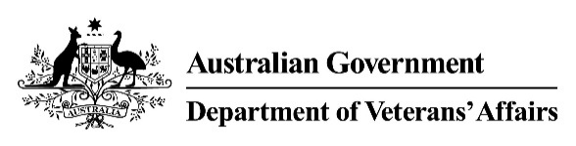 | Hernia and Stoma  Medical Impairment Assessment
Veteran |  |  |  |  | UIN
Please assess the following conditions:
- Does the veteran currently have any of the following stomas?
Description | Select
None. | ☐
Oesophagostomy or Gastrostomy. | ☐
Jejunostomy or ileostomy. | ☐
Colostomy. | ☐
- Please select all that apply in relation to any ventral and/or inguinal hernias.
Description | Ventral | Right Inguinal | Left Inguinal
None. | ☐ | ☐ | ☐
Surgically repaired hernia. | ☐ | ☐ | ☐
Easily reducible hernia. | ☐ | ☐ | ☐
Hernia not easily reduced resulting in mild symptoms. | ☐ | ☐ | ☐
Large hernia resulting in frequent symptoms. | ☐ | ☐ | ☐
- Please list all conditions contributing to the reported impairment and indicate the percentage contribution. Include any previously known condition(s) and any new condition(s) you have identified. The contribution total must equal 100%.
Condition | Contribution %
e.g. Gastric Cancer | 75%
Total | 100%

Doctor's signature | Doctor's name | Date | Time to complete form

