 | 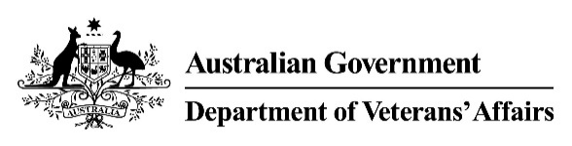 | Endocrine Condition(s)  Medical Impairment Assessment
Veteran |  |  |  |  | UIN
Please assess the following conditions:
- Please select all descriptions that apply in relation to the treatment of diabetes mellitus.
Description | Select
None. | ☐
Weight loss. | ☐
Dietary control. | ☐
Oral hypoglycaemics. | ☐
Insulin or other daily injectable agent. | ☐
- Is the veteran’s blood glucose level regularly greater than 15mmol/L? ☐ Yes ☐ No

- Please select the most accurate description of the treatment of any other endocrine disorder.
Description | Select One
None. | ☐
Regular but infrequent oral medication or injection. | ☐
Daily oral medication. | ☐
Injections / infusions once a month. | ☐
Injections / infusions once a fortnight. | ☐
Daily injections. | ☐
- Please list all conditions contributing to the reported impairment and indicate the percentage contribution. Include any previously known condition(s) and any new condition(s) you have identified. The contribution total must equal 100%.
Condition | Contribution %
e.g. Graves’ disease | 75%
Total | 100%

Doctor's signature | Doctor's name | Date | Time to complete form

