 | 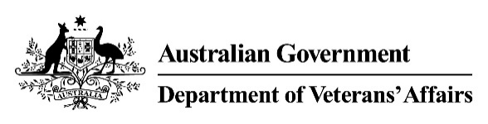 | Eye Condition(s)  Medical Impairment Assessment
Veteran |  |  |  | UIN
Please assess the following conditions:
For this assessment, each condition needs to be assessed in isolation from all others. This means that when assessing a condition, you will need to assess the impairment as though only that single condition is present, and that the veteran is otherwise healthy and normal.
- Please describe all of the signs and symptoms related to each condition, in isolation.
Condition | Signs and Symptoms
- Please record the corrected visual acuity.
Right Eye | Left Eye
- Please select the most accurate description of any visual field defects.
Description | Right Eye | Left Eye
Normal fields. | ☐ | ☐
Hemianopia (indicate if homonymous, binasal or bitemporal). | ……………………………………….
Other visual field loss (please provide % loss). | % | %
- Are there any other comments you would like to make regarding the impact of the veteran’s eye conditions?

Doctor's signature | Doctor's name | Date | Time to complete form

