

transforming

**DVA Family and Domestic Violence Strategy**

2020–25

DVA would like to acknowledge that this strategy may cause stress to a reader.

Help is available if you, or someone you know, is experiencing violence.

In the case of an emergency call 000.

**[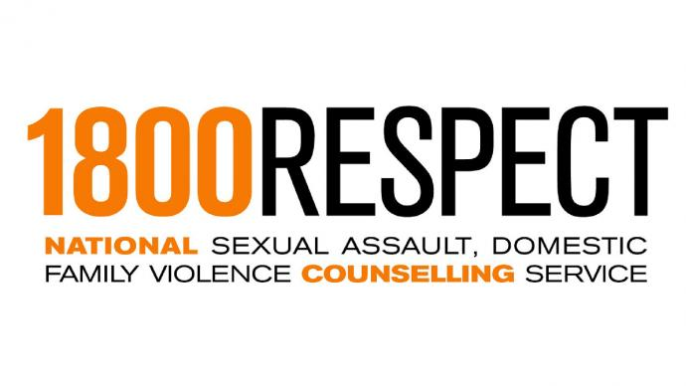](https://www.1800respect.org.au/)**

For information, support and counselling contact 1800RESPECT (1800 737 732) or visit [www.1800respect.org.au](http://www.1800respect.org.au). This service is free, confidential and open 24 hours a day.

**[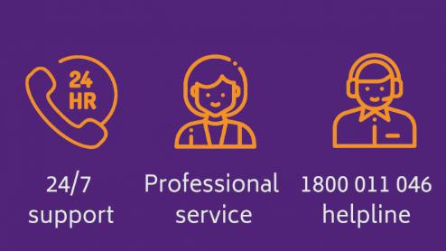](https://www.openarms.gov.au/get-support/counselling)**

If you are the family member of a Veteran, Open Arms - Veterans and Families Counselling may be able to help. Call 1800 011 046 for free and confidential 24/7 support.

1800 ElderHelp (1800 353 374) is a free service that will automatically connect callers seeking information and advice on elder abuse with the existing phone line service in their jurisdiction.

The National Disability Abuse and Neglect Hotline (1800 880 052) is a free, independent and confidential service for reporting abuse and neglect of people with a disability.

# Minister’s introduction

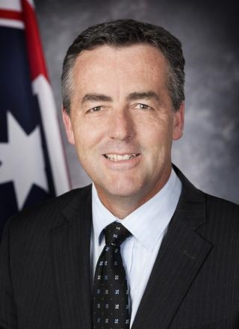Family and domestic violence affects everyone in Australia – the victims and survivors, children who witness it, their extended families, their friends, their colleagues and the broader community.

We all have a responsibility to prevent family and domestic violence, ensure gender equality and respectful relationships, hold perpetrators accountable and encourage behaviour change. The Council of Australian Governments Advisory Panel promoted this responsibility through the *National Plan to Reduce Violence against Women and their Children* developed in 2011and the launch in August 2019 of the *Fourth Action Plan*. The Council of Attorneys-General have also promoted this responsibility through the *National Plan to Respond to the Abuse of Older Australians (Elder Abuse) 2019–2023*.

The Department of Veterans’ Affairs (DVA) Family and Domestic Violence Strategy is the latest development in DVA’s ongoing commitment to veterans and their families. A key part of this commitment to support the wellbeing of veterans and their families is helping those most in need. This strategy has been developed to help our veterans, their families and DVA staff affected by family and domestic violence, by providing information, support and referrals to services.

DVA is committed to designing awareness programs, interventions and supports that seek to prevent incidences of family and domestic violence, as well as those that will have the most impact for survivors of family and domestic violence. The Council for Women and Families United by Defence Service and the newly announced Veteran Family Advocate will be key partners in the design, implementation and ongoing performance of the Strategy.

Family and domestic violence can happen to anyone in our community — violence, intimidation or disrespectful behaviour in the home, workplace or wider community is totally unacceptable.

This is a national priority, and together we will make a difference.

|  |  |
| --- | --- |
| Y:\NAT\TAESFASD\EPECOMMSB\Strat-Comms\05 SUPPORT\6 Veterans Service Design VSD (Kate Pope)\2d Policy Evaluation (Adrienne Godsmark)\Family and Domestic Violence Strategy\Minister signature thin.png | Darren Chester  Minister for Veterans’ Affairs  Minister for Defence Personnel |

# Secretary’s overview

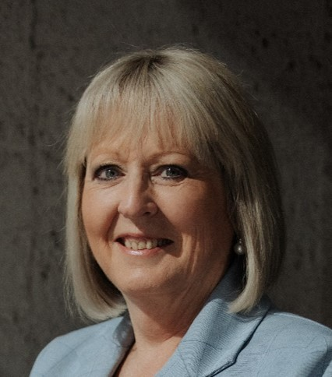Domestic and family violence is a serious problem. Australian police deal with 5,000 domestic and family violence incidents on average every week – one every two minutes. Those who experience it often do so over long periods, sometimes decades. The suffering they experience can be intense, and the effects long-lasting.

People who experience domestic violence often don’t report it, fearing that doing so will have negative impacts on them, their partner or their family.

The majority of people who experience family and domestic violence are women in their home. One in four Australian women had experienced violence by an intimate partner since the age of 15, according to the 2016 Australian Bureau of Statistics Personal

Safety Survey.

DVA has entered our third year of the most significant reform in our history, and we are transforming the department into a pro-active, responsive agency that encourages and supports the wellbeing of veterans and their families throughout their lives.

Our transformation journey has instilled in DVA staff the importance of designing solutions alongside those who will access our services. We began the journey to better supporting survivors of family and domestic violence at the 2017 Female Veterans and Veterans’ Families Policy Forum. We listened to ideas around the need to do more research on family and domestic violence to understand the impact on veterans and their families, to make information and support easier to access, for seamless support that begins with enlistment, the need to extend support to the ex-partners of veterans and the need to consider the needs of blended families.

I am proud to say that we have either addressed or are addressing all of these needs. Some highlights include: the 2019 extension of the Partner Service Pension to former partners of veterans (regardless of marital status); the creation of the Council for Women and Families United by Defence Service to provide advice on the unique experiences of families and female veterans; the ongoing work to strengthen relationships with members from enlistment to transition; and the development of this strategy, working with partners across the Australian Government, that publicly affirms our support and ongoing commitment to reducing the prevalence of family and domestic violence in Australia. We look forward to partnering with the newly announced Veteran Family Advocate to ensure the views of veterans and their families are represented and our future actions support their wellbeing.

We will continue to build the supports that survivors of family and domestic violence need, and assist perpetrators of violence to change their behaviour and support opportunities for reconnection with their family and community. We will continue to shine a light on an issue that is often hidden, empowering survivors to break their silence and fostering a culture that promotes respectful relationships among veterans and their families.

|  |  |
| --- | --- |
| Y:\NAT\TAESFASD\EPECOMMSB\Strat-Comms\05 SUPPORT\6 Veterans Service Design VSD (Kate Pope)\2d Policy Evaluation (Adrienne Godsmark)\Family and Domestic Violence Strategy\Liz Cosson Electronic Signature.png | Liz Cosson AM CSC  Secretary, Department of Veterans’ Affairs |

# What is family and domestic violence?

For the purpose of this strategy, family and domestic violence is defined as conduct that is violent, threatening, coercive, controlling or intended to cause the family or household member to be fearful. It can include, but is not limited to:

* physical, verbal, emotional, sexual or psychological abuse
* intentional or unintentional neglect
* financial abuse, such as controlling money, monitoring, neglect or interfering with employment
* legal abuse, such as intimidating, exhausting, exploiting or disempowering someone
* stalking
* harm to an animal or property
* controlling the social, employment or family relationships or a person’s decision making power
* controlling spiritual or cultural participation
* exposing children to the effects of these behaviours.

We use the term ‘family and domestic violence’ because violent behaviour is not necessarily limited to members of families connected by kinship or marriage, but may also include:

* past or current intimate relationships, including people who are dating or living together, regardless of their gender or sexuality
* relationships involving carers, where care is provided to older people, or people with a disability or medical condition
* service providers
* relatives and guardians
* other culturally recognised family groups.

We recognise that both men and women can use violence. One in six women and one in sixteen men has experienced physical or sexual violence from a current or previous cohabiting partner since the age of 15[1]. Survivors of family and domestic violence can be from any age group including children, adults and the elderly.

We recognise that a person suffering a form of family and domestic violence may not wish to take action, and the effects of abuse is an individual experience with no single response to its causes or effects.

If you, a child, or another person is in immediate danger, call 000.

For information, support and counselling, contact 1800RESPECT on 1800 737 732 or visit [www.1800respect.org.au](http://www.1800respect.org.au/). This service is free, confidential and open 24 hours a day. Alternatively you can contact 1800ElderAbuse (1800 353 374) for free information and advice around abuse of older Australians, or the National Disability Abuse and Neglect Hotline (1800 880 052) for a free, independent and confidential service to report abuse and neglect of people with disability.

# About DVA

DVA is committed to supporting the wellbeing of veterans and their families across their lifetime and commemorating their service and sacrifice. We are striving to efficiently deliver high quality, connected services to all generations of veterans and their families.

## Our approach to family and domestic violence

Family and domestic violence can affect people of any background, but research suggests some individuals and groups are more vulnerable. These include:

* people needing care, such as elderly people and people with a disability
* people who identify as lesbian, gay, bisexual, transgender or intersex
* women at particular life stages such as young women, pregnant women, women separating from their partners and women with children
* people living in remote communities where there are fewer or no local supports available
* women from culturally and linguistically diverse backgrounds
* Aboriginal and Torres Strait Islander Australians.

**Domains of Wellbeing**

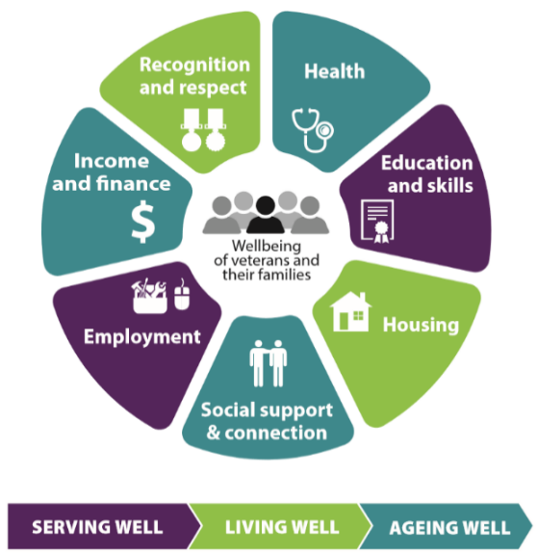

A key part of the department’s commitment to supporting the wellbeing of veterans and their families is helping those most in need. We have developed this strategy to help our veterans, their families and staff affected by family and domestic violence, by providing information, support and referrals to services.

We will respect and protect the personal information of veterans, their families and staff who have disclosed family and domestic violence, and will comply with our obligations under the *Privacy Act 1988* when collecting, sharing, disclosing and recording personal information.

# Principles

This strategy is underpinned by six principles that provide the foundation for the development and implementation of family and domestic violence policies, programs and practices across DVA.

## Family and domestic violence is never acceptable

Family and domestic violence is never acceptable in any form. We will provide a supportive service environment for veterans, their families, and staff that encourages respectful relationships.

## Safety is our first priority

Our first priority when responding to affected veterans, their families or our staff is their safety and wellbeing. We will ensure those affected know where to get immediate help to stay safe. If a client is unable to call emergency services, DVA can do so on their behalf. We have a duty of care to respond if there is risk of immediate or imminent threat to the life, health or safety of a veteran, their families or our staff.

## We avoid placing blame

The responsibility for family or domestic violence always lies with the person who uses violence. We will avoid placing blame, or an onerous burden of proof, on the person experiencing violence.

## We respond respectfully

Family and domestic violence is traumatic, disempowering and can be difficult to disclose. We will respond with respect and sensitivity to veterans, their families or staff affected by family and domestic violence and will help them to make informed decisions free of coercion. We recognise that abuse is an individual experience that affects everyone differently, and there is no single response to its cause and effects. We will provide advice and information for a survivor, and respect their decision not to take action, provided there is no immediate or imminent threat to their safety.

## We provide support

We will continue to build the skills of our staff to recognise and respond to family and domestic violence. We will offer support to veterans and their families at risk of, or experiencing, family and domestic violence. We will also assist people who use violence to change their behaviour. We will provide appropriate support for all people, ensuring we consider gender, sexuality, culture, age, ability and background.

## We work collaboratively

We will work collaboratively with government and non-government sectors, particularly the Department of Defence, and will share our approach to reduce the impact of family and domestic violence on veterans and their families.

We will align action under our strategy to the Whole of Government *National Plan to Reduce Violence against Women and their Children 2010–2022* and work to inform future Government strategies. We will engage with veterans and their families to understand and address their needs.

# Areas of focus

Five areas of focus guide our ongoing response to family and domestic violence.

## Awareness and information

We will ensure that veterans, their families and staff have access to information about family and domestic violence, including the support available through the department, other government agencies and from external service providers.

Aims

* Veterans, their families and staff affected by family and domestic violence are aware that DVA can provide appropriate support and connect them to appropriate support in the local community.
* Veterans and their families are not put at increased risk when accessing information about family and domestic violence services and support.
* Stakeholders working with veterans and their families are aware of the services and support we offer, and know that they can refer their clients to us.
* Promotion of gender equality.

Actions

* We will provide accessible, up-to-date and accurate information about our payments, services, other government agencies and wider community supports available to people affected by family and domestic violence on our website.
* We will tailor information to meet the needs of diverse groups in the veteran community.
* We will consider the safety of veterans and their families in the development and distribution of information, including the use of a ‘quick exit’ button on the DVA website.

## Support and referrals

We will offer information and support to veterans, their families and staff affected by family and domestic violence, and refer them to external service providers where appropriate.

Aims

* Veterans and their families affected by family and domestic violence are offered the most appropriate payment and/or service according to their individual circumstances.
* Support is offered to veterans and their families who identify as people who use violence where this has the potential to help them change their behaviour and enhance the safety of people affected by violence.
* There is a focus on trauma recovery.

Actions

* We will refer veterans and their families to external service providers where appropriate.
* We will offer direct support where this best meets the needs of veterans and their families, including counselling or crisis accommodation through Open Arms – Veterans and Families Counselling (Open Arms), or a Crisis Payment.
* We will monitor and adjust our procedures to minimise the possibility that people who use violence manipulate our services to the detriment of those affected by family and domestic violence.
* We will maintain regular engagement with local, state and national community service stakeholders to ensure that we are able to help veterans and their families affected by family and domestic violence access the support they need.

## Policies, systems and processes

We will continue to refine our policies, systems and processes to enhance the delivery of this strategy.

Aims

* Our strategies to support people affected by family and domestic violence are embedded in all core business processes.
* Our systems and processes contribute to strengthening the services and supports available to staff, veterans and their families affected by family and domestic violence.
* Our risk identification and referral processes are applied consistently across DVA.

Actions

* We will create a safety flag which can be applied to the records of veterans and their families who have disclosed family and domestic violence concerns, to improve our service and support.
* We will collect data through our case management system and Open Arms servicing, to improve our knowledge of and responses to family and domestic violence.
* We will work to improve data collection, including working with other government agencies, to be able to better understand and respond to veterans and their families affected by family and domestic violence.
* We will monitor our policies and processes to ensure that veterans and their families affected by family and domestic violence are offered the most appropriate service and that our processes do not put them at greater risk.
* We will keep informed of developments in family and domestic violence policy, research and service provisions in the general population and the military context.
* We will examine our programs and policies regularly to ensure that they are appropriate and flexible and meet the needs of people affected by family and domestic violence, and reflect the latest understanding of the factors involved in family and domestic violence.
* We will work with government and non-government stakeholders to ensure our policies and processes reflect best practice and align with national strategies.
* We will develop tools to ensure family and domestic violence is considered across all areas of DVA as a core business process.
* We will ensure that providers we partner with who have access to the homes of veterans and their families have an appropriate policy and process in place to act on any violent, threatening, coercive, controlling or fear causing behaviour of their employees who have contact with veterans and their families. We will also ensure these providers can identify and appropriately escalate signs of family and domestic violence that they witness when in contact with veterans and their families.
* We will fund domestic violence research specific to the Australian military context and participate in whole of government research.
* We will protect the privacy of information collected, recorded and disclosed regarding family and domestic violence.
* We will support gender equality through women’s leadership initiatives, access to flexible working arrangements including part-time, and continue to support social supports and connections.

## Training

We will ensure our staff at all levels of the department receive appropriate training so they are equipped to support veterans, their families and staff affected by family and domestic violence.

Aims

* Managers and staff have the skills and confidence to support staff, veterans and their families affected by family and domestic violence, including having the skills and knowledge to refer them to supports provided outside DVA, such as 1800 RESPECT.
* Our staff have the capability to respond effectively and appropriately to the diversity of veterans and their families affected by family and domestic violence.

Actions

* Our staff will undertake relevant and targeted training to build the skills and knowledge to support people affected by family and domestic violence.
* Staff will refer veterans and their families to available resources, such as 1800RESPECT and Open Arms, to seek advice on how to support veterans and their families.
* We will continue to update training packages to ensure our staff are able to offer appropriate information, referrals and support.
* Senior leaders will participate in training to build engagement and enhance their ability to create a department-wide supportive culture for our people.
* We will provide information and training for advocates working with veterans and their families to build their skills and knowledge to support people affected by family and domestic violence.
* We will develop resources for Community Support Advisors and Peer workers to disseminate to Ex-service and related organisations designed to build community capacity to identify, discuss and respond to family and domestic violence.

## Risk identification

We will continue to refine our risk identification approach to support veterans and their families who are concerned about their safety.

Aims

* Early identification of veterans and their families affected by family and domestic violence allows us to provide support in a timely manner.
* Every time someone from DVA engages with a veteran or family member, they are considering the family and domestic violence risk identification.
* Our risk identification approaches are included in all service delivery channels including online accounts.

Actions

* We will provide a supportive environment which encourages veterans and their families affected by family and domestic violence to tell us their concerns.
* We will continue to identify interaction points where we can better support veterans and their families at a higher risk of family and domestic violence – for example, people advising us that they have recently separated from their partner.
* We will ask our veterans and their families if they are concerned about their safety at identified interaction points, and if they are, we will offer appropriate support.
* We will continue to refine our risk identification approaches to ensure we can support veterans and their families who interact in the face to face, telephony and online channels.
* We will undertake research in the veteran community to ensure we understand our clients and their needs and have an up to date understanding of risk factors.
* Open Arms is reviewing their risk framework, including exploring ways to improve their response to those affected by family and domestic violence.
* We will tailor our risk identification approaches to accommodate the needs of specific customer groups, including culturally and linguistically diverse backgrounds and Aboriginal and Torres Strait Islander Australians.
* We will monitor and evaluate the risk identification model and referral approach on an ongoing basis and refine as required.

# Indicators of success

Measuring our success in preventing and responding effectively to family and domestic violence is important to know what is working. There is an opportunity to invest in establishing a series that examines the exposure of veterans and their families to family and domestic violence via our strategic relationship with the Australian Institute of Health and Welfare. There is also an opportunity to measure increased awareness through a staff survey.

The Council for Women and Families United by Defence Service were a key partner in the development of this family and domestic violence strategy, and will continue to be partners in helping us to measure the success of its implementation. Success will be indicated by:

* Increased awareness among veterans and their families of DVA’s role in supporting those affected by family and domestic violence.
* Proportion of staff, including senior managers, who have completed DVA’s training package which is designed on current evidence of risk factors, service options and referral pathways that are relevant to a diverse range of veteran and family groups.
* DVA managers and staff report an increase in knowledge of referral options for those affected by and those perpetrating family and domestic violence.
* Staff in DVA and Open Arms will collaborate more closely where family and domestic violence is identified and care pathways will be developed.
* We will identify increased help-seeking behaviours by people subjected to or affected by family and domestic violence.
* Information available on the DVA website and provided by DVA is current, evidence-based and regularly maintained.
* Staff are properly trained and aware of the requirements of the *Privacy Act 1988*, DVA systems are secure to protect collected and recorded personal information, and disclosure of such information meet the requirements of that Act.
* Family and domestic violence considerations are visible in DVA procedural documents and policies.
* A safety flag has been created to notify DVA staff of veterans and their families who have disclosed family and domestic violence concerns.
* Australian military family and domestic violence research program is established and funded.
* Number of advocates informed and trained in supporting those affected by family and domestic violence.
* Resources are developed for Community Support Advisors, and peer workers to disseminate to ex-service organisations.
* A risk identification and referral process is developed for use by DVA staff and tailored to each service delivery channel.
* Evidence that regular review and improvement of risk identification processes and outcomes is occurring, and that reviews are conducted with input from specific veteran and family groups who have lived experience of family and domestic violence.

1. Australian Institute of Health and Welfare, *Family, domestic and sexual violence in Australia: continuing the national story*, 2019.