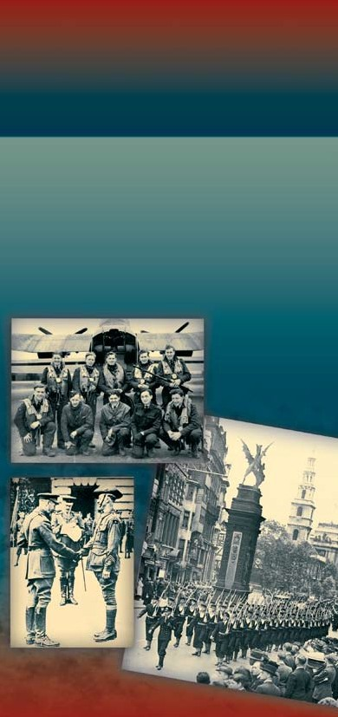
AU S T R A L I A N
WA R
M E M O R I A L ,
LO N D O N
Office of Australian War Graves


CONTENTS
MESSAGE FROM THE PRIME MINISTER
2
AUSTRALIAN WAR MEMORIAL, LONDON
4
THE MEMORIAL SITE
6
DESIGN
8
PLACE NAMES
9
BATTLE SITES
11
CONTRUCTION
12

MESSAGE FROM THE
PRIME MINISTER OF AUSTRALIA
THE HON JOHN HOWARD MP
On the occasion of the dedication of the
Australian War Memorial, London,
11 November 2003
This memorial is a lasting tribute to those Australians
who lost their lives in defending those values which are the foundation of the democracy and freedom shared and cherished by Australia and the United Kingdom.
It epitomises the struggle to ensure that the citizens of both our countries, and of the world, could enjoy peace and security. In the two great world wars of the twentieth century, we stood united against the forces of tyranny. Those wars transformed the course of
history and reaffirmed bonds of friendship and respect between our two nations which endure to this day. During those titanic conflicts, Australian servicemen and women from the Army, Navy and Air Force stood alongside their comrades from the British Isles to
face the common foe. In dedicating this memorial today, we express our gratitude for their service and commemorate their sacrifice. The sites of some of those great struggles carved into this memorial – Gallipoli, Villers-Bretonneux, Passchendaele, Tobruk, El Alamein, Normandy and the battles of the Atlantic and Berlin to name a few – are similarly etched deep in our memory.
2

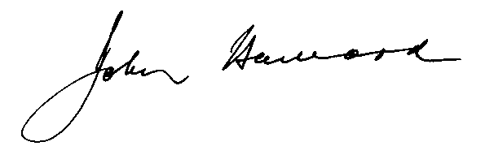

It was from Britain that so many Australians embarked
for the front line of those terrible conflicts: in the First World War for the mud of the Western Front, and in the Second World War for the skies over Europe, the bleak waters of the Atlantic and the deserts of North Africa. Although nestled in the heart of London, this memorial evokes the green and grey of the Australian bush, the sweep of our landscape and the openness of our people. It records the names of the thousands of Australian towns which sent their sons and daughters to defend our way of life, speaking not only of the memories of their courage and hardship, but also of the pain and grief of those who were left behind.
John Howard
3

AUSTRALIAN WAR
MEMORIAL, LOND ON
Memorials invite us to imagine, to reflect and to honour.
The Australian War Memorial, London, brings to the
mind’s eye those great battles and conflicts of a world
at war in 1914–1918 and 1939–1945. Carved here
in stone are words symbolising some of the deepest
wounds ever inflicted on the Australian people as they
fought with their comrades of the British Empire and
Commonwealth for principles and beliefs which all held
dear. Lone Pine, Pozières, Bullecourt, Ypres, Tobruk,
Singapore, Coral Sea, Kokoda and Berlin – at such places,
two generations of Australians forged the meanings and
messages of what it was to be Australian. For as long as
the future holds true to those stories, then the struggle
and sacrifice of Australia’s servicemen and women in war
will have left a lasting legacy.
This Memorial also reflects on the impact of war beyond the battlefield. Recorded here are 24,000 home towns of those who put on the uniform of the Royal Australian Navy, the Australian Army and the Royal Australian Air Force in two world wars. Of those one and a half million men and women, over 101,000
did not return home. Their names are etched on headstones and on memorials in dozens of countries around the world. They are also recorded on thousands of memorials across the Australian continent in those home towns where on Anzac Day and Remembrance Day since World War I Australians have gathered to remember them. Those local memorials remind us
that war has left an enduring mark of pain and loss upon the consciousness of thousands of communities and families. In these places, throughout the war years, people worked to support their loved ones overseas.
In World War I, millions of pounds were raised and thousands of parcels of comforts were dispatched to
4
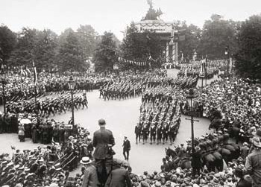
Two Australian soldiers (right foreground) watch the Royal Navy
contingent at the Victory March at Hyde Park Corner, 1919. [The
National Archives, Public Record Office Image Library WORK21/74]
the front line. In World War II, as total war engulfed
the nation, those on the home front toiled for victory
in factories and farms.
To honour those who served and died in two world wars, we must remember why they fought. In July 1913, when George V dedicated the foundation stone of Australia’s other great monument in London – Australia House
– the King uttered these words:
In any national emergency Australia will be ready to play her part for the common cause, and the loyalty of her sons will never be appealed to in vain.

That common cause was, in the words of poet John Hewitt, man’s rare hinted possibility of being just, compassionate and free. Such ideals are not empty slogans. In every era they have been challenged by those who would enslave others and bend them to their will. Australians and Britons have risen to that challenge
and shown a loyalty, even unto death, to the principles of human liberty. For as long as Australians hold those values, then as they stand before the Australian War Memorial, London, they will lower their heads in respect to those past generations who laid down their lives to protect a priceless inheritance.
5
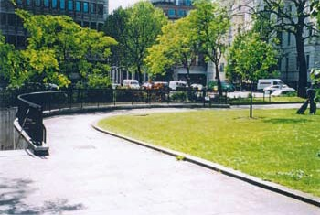
THE MEMORIAL SITE
The site of the Australian War Memorial is within the
1.5 hectare parkland known as Hyde Park Corner, in the
heart of London. The site was identified as a potential
memorial location in the master plan report on
initiatives to improve and upgrade the area. It was
commissioned by English Heritage on behalf of the
Hyde Park Corner Steering Group, comprising
representatives from major London authorities including
Westminster City Council.
Memorial site, Hyde Park Corner prior to construction
With Wellington Arch the central element, Hyde Park
Corner provides the pivot of the processional route
linking the Royal Palaces through the Royal Parks from
Admiralty Arch to Marble Arch.
The prestigious precinct is noted for existing war memorials including the Royal Artillery Monument and the Machine Gun Corps statue of David. The site presented an opportunity to locate the new Australian War Memorial in a central London location adjacent to other important memorials and to provide an ideal
6
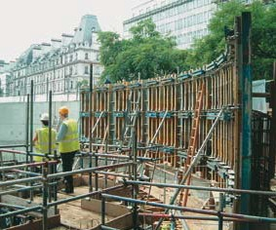
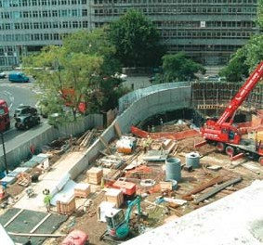
Memorial under construction - wall formwork in place
and granite panels ready to uncrate
Construction of formwork for supporting walls
area for large scale gatherings such as that expected on
Anzac Day each year.
In negotiating use of this space, the Australian Government proposed to Westminster City Council a memorial solution that also satisfied the Steering Group proposals.

In consequence, the Memorial not only commemorates those who served in two world wars but also provides an amenity that greatly improves the utility of this green space.
7
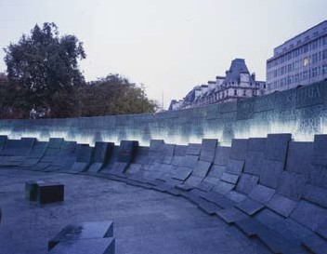
Australian War Memorial, London at night
D E S I G N
The design for the Memorial was selected as a result
of a limited, by invitation, design competition. Of the
twelve architectural firms selected, four were chosen to
prepare detailed designs and models. A panel of selectors
comprising veteran representatives, architects and art
advisers was convened to oversee development of the
brief and to assess the entries.
The winning proposal was submitted by Tonkin Zulaikha Greer Pty Ltd (TZG) architects, in association with Janet Laurence, artist. TZG had previously won competitions for the Australian National Vietnam Veterans Memorial on Anzac Parade, Canberra, and for the Tomb of the Unknown Australian Soldier within the Australian War Memorial, Canberra.

The selected design was presented to the Public Arts Advisory Panel of Westminster City Council, where it received unanimous support. The design was
subsequently approved by the Council and numerous other approvals were obtained from London authorities before construction could commence.
8

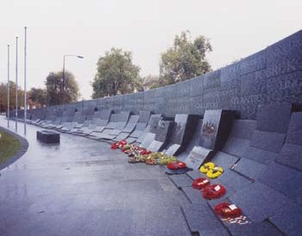
Wreaths at Australian War Memorial, London after dedication service
Principal architect Peter Tonkin states, ‘The form
chosen for the Memorial reflects the sweep of Australian
landscape, the breadth and generosity of our people,
the openness that we believe should characterise our
culture.’ Inspired by the contours of Hyde Park Corner,
the Australian War Memorial becomes partly a landform,
rising from the surface and creating a focus for the site.
Its use of green/grey Australian granite reflects the
essence of the bush.
P L AC E NA M E S
The wall is set with thousands of place names
recording the origins of Australia’s sons and
daughters who served their nation in two world wars.
These place names also recall the impact on their
families and communities. The place names were
assembled after extensive research using numerous
data bases including original records of World War I
and World War II, the World War II Nominal Roll,
National Archives of Australia and The AIF Project,
UNSW@ADFA. The list is published on the
9

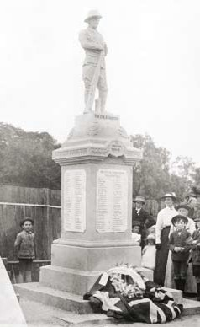
Department of
Veterans’ Affairs
Internet site and
the public was
invited to review
the selection
before the names
were finalised.
Design team architects and graphic designers determined
a random distribution pattern for positioning the names on the vertical wall panels.
Memorial unveiled in December 1917 to honour
the men and women of Ipswich, Queensland,
who enlisted in World War I. [AWM H17698]
Computers were used extensively to achieve the
density of text required to ensure the superimposed
‘battle sites’ were legible. Individual stones were then
masked with a sheet vinyl material on which the
computer-generated names had been laser-cut and
individual letters removed. These letter surfaces were
then sand blasted by stone masons. A durable water
proof coating was applied to the sand blasted letters to
enhance legibility.
10

BAT T L E S I T E S
Superimposed on the place names and etched in
large lettering are 47 battle sites representing theatres
of conflict from both world wars that involved
the Australian Navy, Army and Air Force. The
representative battle sites were selected by a group of
military historians from the Department of Veterans’
Affairs, the Australian War Memorial and all three
arms of the Australian Defence Force. The selection
is not intended to be exhaustive, but rather to reflect
the geographic spread of the service and sacrifice of
Australians during two world wars.
Amiens
Crete
Lone Pine
Polygon Wood
Atlantic
Damascus
Markham-Ramu
Pozieres
Bardia
Darwin
Mediterranean
Rabaul
Beersheba
El Alamein
Megiddo
Ruhr
Berlin
Fromelles
Mesopotamia
Savo Island
Bismarck Sea
Gallipoli
Messines
Singapore
Borneo
Gaza
Milne Bay
Sunda Strait
Bougainville
Imphal
Mont St Quentin Tobruk
Brallos Pass
Indian Ocean
Normandy
Villers-Bretonneux
Bullecourt
Kokoda
North Sea
Wewak
Cocos Keeling
Krithia
Okinawa
Ypres
Coral Sea
Lingayen Gulf
Passchendaele
11

CONSTRUCTION
The Memorial consists of the green/grey Australian
granite from Jerramungup, Western Australia, on a
reinforced concrete base, with elements of bronze,
stainless steel and hydraulic fittings. Granite is
used for cladding and paving on all visible surfaces.
Highly complex computer modelling of the entire
Memorial site was needed before it was possible to
detail the three dimensional shapes and sizes of the
thousands of stone components that fit together with
exceptionally fine tolerances.

A substantial underground plant room accessed
from the subway staircase landing accommodates the
necessary electrical gear, hydraulic pumps and filters
to operate the water display. Falls of water will be
programmed to change in sequence and be recycled
via a series of concealed ducts and weirs. Special LED
lighting bars will illuminate the text panels by night.
The ceremonial area of the Memorial utilises large monolithic blocks of granite to support cast bronze elements such as the three Service insignia and
the Australian Commonwealth Coat of Arms. A
dedication text is located centrally on one stone,
with supporting descriptive and explanatory plaques
mounted atop two of the seating blocks placed
forward of the wall on the forecourt.
All visible components of the Memorial were sourced from Australia, despatched to the site and incorporated during the construction phase. All the Australian granite was shaped and finished in
Australia and fixed on-site by Australian tradesmen.
The Office of Australian War Graves will manage ongoing care and maintenance of the Memorial in perpetuity on behalf of the Australian Government.
12

