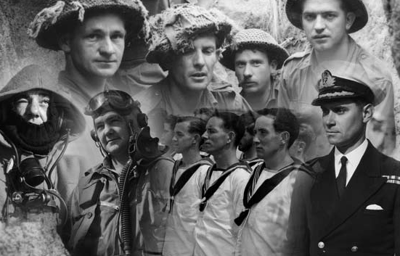
www.koreanroll.gov.au
NomiNal Roll
of australian Veterans
of the KoreaN War
Are you interested in Australia’s wartime history?

Are you searching for information about a family member who served in Australia’s defence forces in Korea between 1950 and 1956?

The Nominal Roll of Australian Veterans of the Korean War website can assist you.

The Nominal Roll commemorates some 18 000 men and women who served in Australia’s defence forces during the Korean War between 1950 and 1956. The website provides worldwide access to an index of information collected from service records.

The Nominal Roll is a Federal Government initiative, administered by the Commonwealth Department of Veterans’ Affairs.

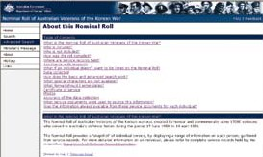
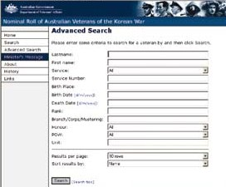


Nominal Roll
of australiaN Veterans
of the Korean War

