Australian Government Mental Health Lifecycle Package Study to Improve Treatment Options for Hard to Engage Clients

Final Report for the Department of Veterans’ Affairs

Revised 7 October, 2009


A centre of excellence supported by the Australian Government

This document is the final report for the Government’s Mental Health Lifecycle Package Study into Improving Treatment Options for Hard to Engage Clients undertaken by ACPMH, submitted to the Department of Veterans Affairs Mental Health Policy Section for consideration.

This report has been prepared by Ms Andrea Phelps (Project Manager),Ms Marie Donnelly, Associate Professor John Pead (Project Leader), Ms Lynette Averill and Captain Philippa Weiland.

Disclaimer
The views and recommendations stated in this report are solely those of the consultants, the Australian Centre for Posttraumatic Mental Health, and do not necessarily reflect those of the Australian Government.

Enquiries
Further information concerning this report is available from:

Ms Andrea Phelps
Project Manager
Australian Centre for Posttraumatic Mental Health
The University of Melbourne
Phone: 03 9496 2190
Fax: 03 9496 2830
Email : ajphelps@unimelb.edu.au

Contents
List of Figures v
List of Tables v
1. Executive Summary 1
1.1 Introduction 1
1.2 Project Design 1
1.3 Preparatory Work 1
1.4 Project Implementation 2
1.5 Evaluation 3
1.6 Recommendations 6
2. Introduction 8
3. Project Design 10
3.1 Aim 10
3.2 Objectives 10
3.3 DVA Human Research Ethics Committee Approval 10
3.4 Preparatory work 10
4. Project Implementation 19
4.1 Participants 19
4.2 Objective 1: Raising Awareness 19
4.3 Community Meetings 24
4.4 Assertive Provider Outreach 29
5. Evaluation 31
5.1 Primary outcome measure: Contact with mental health services 32
5.2 Evaluation of each intervention 34
5.3 Qualitative feedback on process 38
5.4 Summary of activity 40
6. Summary and Recommendations 42
6.1 Retain promotional materials and letter signed by DVA Principal Medical Adviser 43
6.2 Increase use of media 43
6.3 Retain the role of DVA as administrative support in consultations and community meetings 43
6.4 Retain community meetings with some amendment 43
6.5 Further refine target audience 44
6.6 Consider alternate web-based interventions for the younger client group 44
7. References 45
8. Appendices 46
8.1 Appendix A: Improving Treatment Options for Hard to Engage Clients: Target groups, interventions and work plan 13 June 2008 46
1. Executive Summary 46
8.2 Appendix B: Steering Group Terms of Reference 50
3. Composition of the Steering Group 50
4. Role and Tasks 50
5. Frequency of meetings 52
6. Reporting and communication 52
8.2 Appendix B: Project Information Sheet December 2008 53
8.4 Appendix D: Hard to Engage Clients Study Document Matrix 56
8.5 Appendix E: Stage 1 Design Concepts 58
8.6 Appendix F: Stage 2 Design Concepts 61
8.7 Appendix G: Stage 3 Design Concepts 65
8.8 Appendix H: Final Designed Products 66
8.9 Appendix I: Anzac Day Media Release 69
8.10 Appendix J: General Practitioner “Friday Fax” 71
8.11 Appendix K: Product Dissemination 72
8.12 Appendix L: How are you travelling? Website content 75
8.13 Appendix M: Letter from DVA 80
8.14 Appendix N: Community Meeting Evaluation Form 82
8.15 Appendix O: Key Speaking Points 84
8.16 Appendix P: Mental Health Provider Presentation 85
8.17 Appendix Q: Mental Health Care for Veterans 89
8.18 Appendix R: Assessment and Referral Form 92
8.19 Appendix S: Community Meetings Media Release 95
8.20 Appendix T: Newspaper Advertisements 97
8.21 Appendix U: Engaging Veterans Flowchart 101
8.22 Appendix V: Assertive Provider Outreach Record 103
8.23 Appendix W: Steering Group Feedback Form 104
8.24 Appendix X: ESO Feedback Form 108
8.25 Appendix Y: Improving Treatment Options for Hard to Engage Clients: Target groups, interventions and work plan 13 June 2008 Section 4.7 Web based interventions 109

List of Figures
Figure 1: Summary of clinical activity April - August 2009 41

List of Tables

Table 1: Potential key messages for the Hard to Engage Clients Study 13
Table 2: Risk assessment and risk management 17
Table 3: Media coverage following April 25 media release 20
Table 4: Distribution of promotional material 22
Table 5: Running order for the community meetings 25
Table 6: Speakers at the Geelong meeting, Warrnambool meeting and Colac meetings 26
Table 7: Print media coverage following second media release 28
Table 8: Electronic media coverage following second media release 28
Table 9: Paid newspaper advertisements during the ‘How are you travelling?’ initiative 29
Table 10: Details of attendance and requests for help at the community meetings 32
Table 11: New client registrations for the five month period of the trial and the same period last year. 34
Table 12: Characteristics of new clients registered during the trial period as a result of the initiative 34
Table 13: Source of information about the initiative from those who attended community meetings 35

1. Executive Summary

1.1 Introduction

This report describes the development, implementation and evaluation of activities undertaken for the Study to Improve Treatment Options for Hard to Engage Clients, conducted by the Australian Centre for Posttraumatic Mental Health (ACPMH), as part of the Australian Government’s Mental Health Lifecycle Package. The tag line for the initiative was “You served your country. How are you travelling now?”

1.2 Project Design

The target group for the initiative was veterans and former serving members with a mental health problem for which they had not previously had treatment. The primary aim was, in the Barwon-South Western Health Region of Victoria (population 350,000), to significantly increase the numbers of target group members who engage in mental health care for the first time. Interventions included raising awareness of mental health issues and treatment options, a series of community meetings across the region, and assertive outreach on the part of service providers.

1.3 Preparatory Work

The project was approved by the Department of Veterans Affairs Human Research and Ethics Committee.

A partnership was established with key service providers in the region: VVCS - Veterans and Veterans Families Counselling Service; Healthscope Geelong Clinic; St John of God Healthcare, Warrnambool; and Austin Health Veterans Psychiatry Unit (VPU). A steering group was formed comprising these service providers, as well as DVA staff from the Geelong and Warrnambool Veterans Affairs Network (VAN) Office and the Location Manager Community Mental Health.

Over 3000 letters were sent to veterans and former serving members, who were entitled to or receiving treatment under the Veterans Entitlement Act 1986 (VEA), the Military Rehabilitation and Compensation Act 2004 (MRCA) and/or the Safety, Rehabilitation and Compensation Act 1988 (SRCA). It should be noted that the total number of target group members living in the region (including those not registered with DVA) was not known. On the basis of the total number of past defence force members who have served since the Vietnam War (approximately 70 000), it was estimated on a simple proportional basis that with a population of 350 000 there were about 750 past defence force members residing in the region. Although a relatively arbitrary estimate, it was considered that recruiting 50 new people (at an average cost of $3000 per person), including partners, to mental health care would justify the resources required to undertake the project.

How are you travelling? promotional materials were developed in consultation with the steering group and representatives of the Ex-Service Organisations (ESOs) in the region.

1.4 Project Implementation

The trial ran for a five month period from April 2009 to the end of August. The activities and timeline is summarised in the following table and detailed below.
Month | Activities
April | Launch of the initiative to coincide with Anzac Day
May | Preparation for community meetings  Publicity for community meetings  First community meeting in Geelong  Collection of contact data
June | Publicity for community meetings  Community meetings in Colac, Warrnambool and Geelong  Assertive provider follow up  Collection of contact data
July | Assertive provider follow up continued  Collection of contact data
August | Assertive provider follow up continued  Collection of contact data

Interventions to raise awareness included a letter signed by the DVA Principle Medical Advisor to inform all veterans and former serving members residing in the region about the initiative, a print and electronic media campaign, dissemination of promotional material through health practitioners and ESO’s, and the establishment of a website dedicated to the initiative (www.howareyoutravelling.org.au). A total of 3,144 letters were sent out by ACPMH, each with an information brochure enclosed. In addition, 12,720 brochures and 10,048 postcards were distributed through health providers and ESO representatives. The media campaign resulted in nine newspaper articles, three radio interviews and two television interviews. In addition, there were ten paid advertisements in the lead up to community meetings. There were 504 unique hits on the website.

Community meetings were planned to provide the opportunity for the target group to: a) hear from other veterans, partners and services providers about their experience of mental health issues and options for care, and b) have a consultation with a mental health practitioner if they chose to do so. Four meetings were held across the region; two in the largest population centre of Geelong and one each in the smaller regional towns of Colac and Warrnambool.

Assertive outreach involved up to three attempts at follow-up being made to any member of the target group following an expression of need on their part or an expression of concern on the part of a family member or friend.

1.5 Evaluation

A summary of contacts with the target group during the course of the initiative is shown on the next page.

During the course of the initiative 97 people, including veterans, family members and friends, attended the community meetings. Of those who attended community meetings, 26 requested help and 14 took the opportunity for a brief consultation with a mental health practitioner on the night. The remaining 12 requested follow-up in the few days following. Ultimately 14 new client registrations came out of the community meetings.

In this period 88 people made direct contact for the first time with the service providers who were partners to the initiative. Of those who contacted a service provider directly, 60 requested help and were registered as new clients.

The total number of new client registrations over the period of the initiative was 74. This compares to 48 for the same period in the previous year. Of the new registrations, 26 clients indicated that they had sought help for mental health problems the first time solely because of the initiative.

Summary of contacts with the target group during the course of the initiative
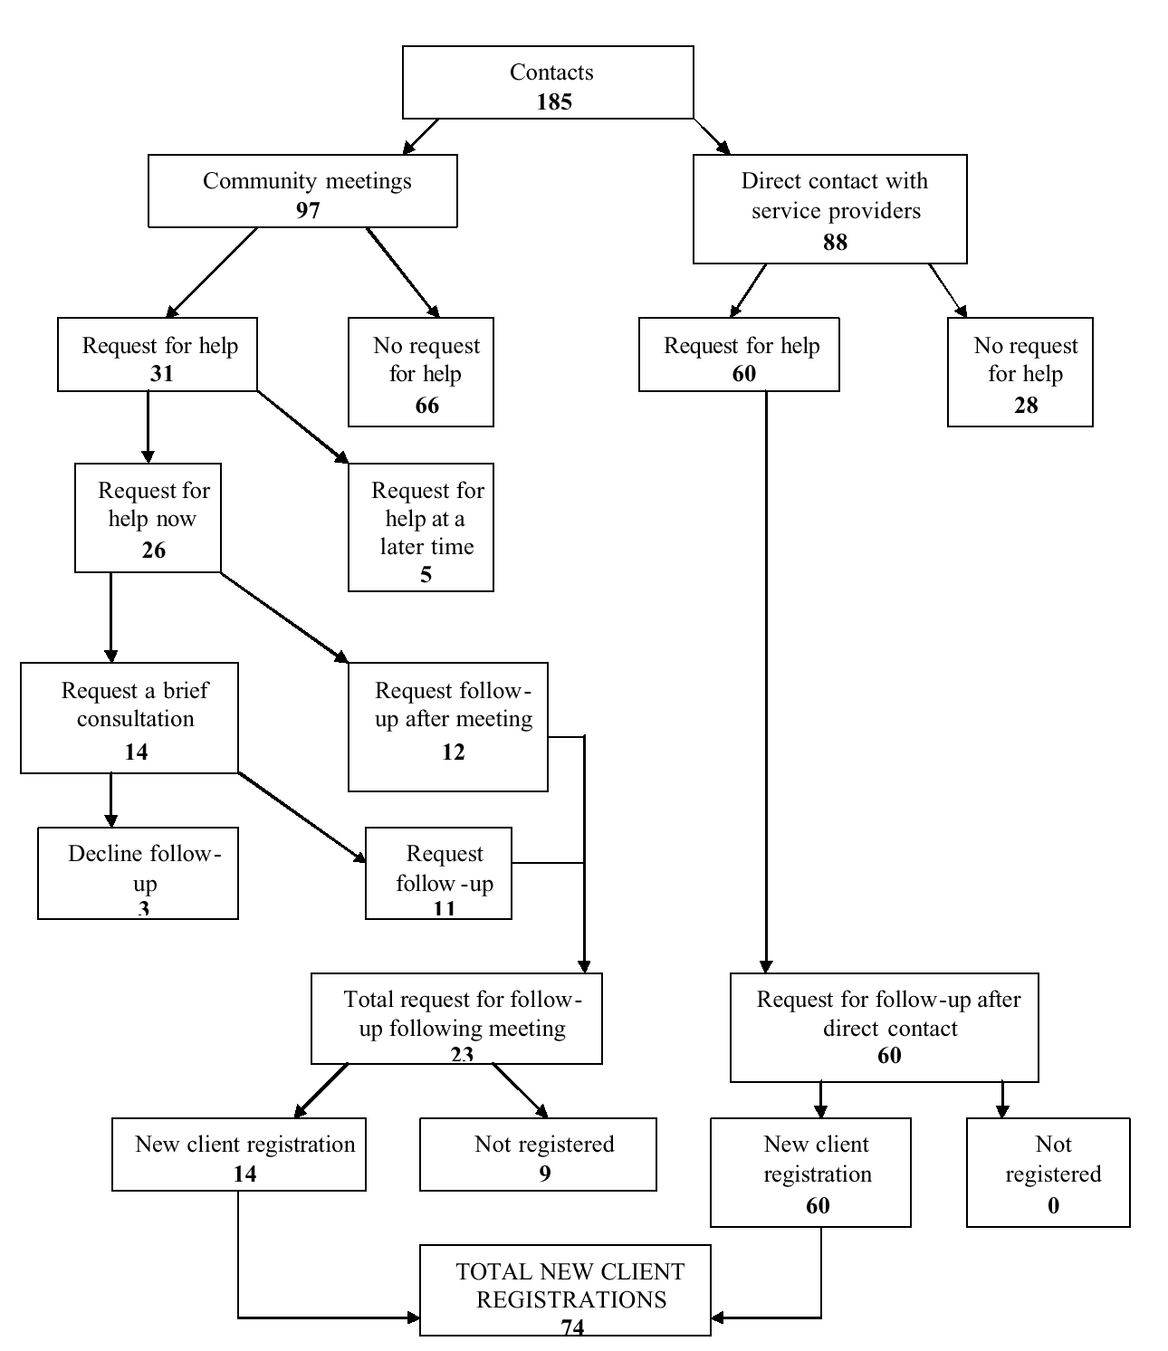

It should be noted that this contact and new client registration data includes just those who made contact in the 60 day follow-up period. It seems likely that others will make contact over the ensuing months, perhaps at the insistence of their partners or family members who attended the community meetings or heard about the initiative.

Eighty-five percent of the new client registrations arising from the initiative were aged over 54. The initiative was less successful in engaging the younger cohort of veterans and former serving members, that is, those who served post 1975. This may not be surprising given their relatively low numbers in the region, but consideration is given to effective strategies to reach this group.

On the basis of information about how people found out about the initiative, the most valuable activities undertaken to increase awareness were determined to be the signed letter from DVA Principal Medical Adviser and the media campaign. Qualitative feedback indicated that those who attended community meetings found them helpful and particularly valued the presentations given by fellow veterans. Although the number of assertive outreach contacts made was relatively small, results indicate that if clients are to be effectively engaged this is likely to happen following initial contact from a service provider. Additional contacts appeared to be of limited value in that they did not result in any additional clients taking up care.

1.6 Recommendations

The results of this trial initiative indicate that a significant number of veterans and former serving members with unmet need for mental health care will come forward if systematic and well supported efforts are made to increase their awareness and accessibility of mental health care. This trial was successful in engaging the stakeholders and recruiting past defence force members and their partners. It is a model that can be adapted and implemented in other larger regions of Australia. If it were implemented, even in its present form, it is projected that in metropolitan Melbourne up to 500 people with unmet mental health needs could be engaged for the first time. Given that the resources for the initiative have now already been developed it would require few additional resources to do this.

On the basis of what has been learned from this trial, the key recommendations for any future endeavours to engage veterans in mental health care are:
- To retain the letter signed by the DVA Principal Medical Advisor giving notice of the initiative
- To increase further the use of print and electronic media
- To retain the role of DVA as administrative support in consultations and community meetings
- To retain the community meetings with minor adaptations
- To consider narrowing target groups to allow more tailoring of interventions
- To consider alternative web-based means of communication and intervention
While the trial was successful with past defence force members and their partners aged 54 years and over, only a few people with service after the Vietnam War were recruited. It is likely that many of these younger people do not identify themselves as having mental health problems and those that do may be unwilling to come forward for help. New technologies, including an internet based strategy, for reaching younger members of the target group are recommended for trial as one possible means for engaging with them.

2. Introduction

This report describes the development, implementation and evaluation of activities undertaken for the Study to Improve Treatment Options for Hard to Engage Clients, conducted by the Australian Centre for Posttraumatic Mental Health (ACPMH), as part of the Australian Government’s Mental Health Lifecycle Package. The background literature has already been presented in the 13 June 2008 report to DVA entitled Improving Treatment Options for Hard to Engage Clients: Target groups, Interventions and Work Plan. The executive summary is attached at Appendix A.

In the initial phase of the project, consideration was given to the potential scope of “hard to engage” veterans. Consultation was undertaken with service providers and Ex-Service Organisation representatives on which of seven potential “hard to engage” groups should be prioritised. As a result, the target group for the initiative was defined as all veterans and former serving members of all age groups who had a mental health concern for which they had not received treatment.

The initiative aimed to trial innovative ways of engaging more of these veterans and former serving members in care. The selection of interventions to be trialled in this initiative was informed by the work undertaken in the research phase of the project. Specifically, consideration was given to: 1) identified barriers to care; 2) recommendations arising from the consultation process; and, 3) potential motivating factors according to the readiness to change model of health care utilisation. A summary of the key points pertaining to each of these factors follows.

Potential barriers were identified as:
- difficulty accepting one has a mental health problem; uncertainty about what help is available; and services not being available locally (Hawthorne et al., 2004)
- concerns about stigma, negative judgement from others, impact on career, mistrust of health professionals (Hoge, 2004)
- fear of stigma and negative impact on career, negative evaluation of others (family and work), own belief that “I should be able to handle it alone” (Stecker et al., 2007)
- ambivalence about change, avoidance, fear or lack of confidence in mental health treatment (Murphy, 2007)

Service provider and ESO priority interventions for hard to engage clients were:
- increased awareness and early intervention
- increased accessibility of mental health services
- peer outreach and support
- assertive outreach
- motivational interviewing

Interventions likely to motivate clients in the pre-contemplation, contemplation and preparation stages of change would need to:
- increase awareness of services available
- increase awareness of benefits and effectiveness of treatment
- increase awareness of negative consequences of not taking action
- use a credible source of information (e.g. personal account of value of mental health treatment from another veteran and family)
- increase ease of access to service providers
- use motivational interviewing

3. Project Design

3.1 Aim

The target group for the initiative was veterans and former serving members with a mental health problem for which they had not previously had treatment. The primary aim was, in a selected demonstration site in Victoria, to significantly increase the numbers of target group members who engage in mental health care for the first time.

3.2 Objectives

1) To increase awareness of mental health problems and available treatment through information dissemination;
2) To increase accessibility and acceptability of mental health treatment through holding community meetings; and,
3) To increase the effectiveness of efforts to engage veterans and former serving members through assertive provider outreach interventions.

3.3 DVA Human Research Ethics Committee Approval

The initiative was approved by the Department of Veterans Affairs (DVA) Human Research Ethics Committee (HREC) on October 10 2008. An amendment to the initiative, to distribute the letter signed by the DVA Principal Medical Advisor to all veterans registered with the Department rather than just those with Accepted Mental Health Disability, was given out of session approval by the Chair of the HREC on April 28 2009.

3.4 Preparatory work

3.4.1 Governance arrangements
Given the timelines for this initiative (June 2008 to September 2009), the type of initiative (an intervention trial) and the objective (to trial novel ways to encourage veterans and former serving members to access mental health care), it was agreed that the project would only be feasible if it was undertaken “at arms length” from DVA. Specifically this meant that DVA would be acknowledged as the funder of the project but DVA logos would not appear on project materials (excepting the VVCS logo which was used on the basis of VVCS’s participation as a service provider partner) and the part played by DVA in community meetings and consultation meetings with Ex-Service Organisation (ESO) representatives would be agreed in consultation with the Steering Group (See Appendix A for Steering Group Terms of Reference).

3.4.2 Consultation Deputy Commisioner Victoria
ACPMH provided a detailed briefing to the Deputy Commissioner Victoria on the initiative including the management of any potential risks associated with the research. The initiative was supported by the Deputy Commissioner.

3.4.3 Selection of trial location
The Barwon-South Western Health Region of Victoria was selected as the trial site for the initiative. The following criteria were considered:

1. Prevalence of veterans
2. Prevalence of veterans with unmet need for mental health care
3. Feasibility – network of service providers including potential leaders
4. Generalisability – eg. Area includes provincial city and rural
5. Willing partners

DVA advised that, of the non-metropolitan regions, the Barwon-South Western Health Region of Victoria contained the highest population of veterans. The precise number with unmet need for mental health care was not known but would include those with Accepted Mental Health Disability (AMHD) not currently receiving mental health care as well as some without AMHD who nevertheless have mental health concerns.

The feasibility of the Barwon-South Western Health Region, in terms of availability of service providers, was determined in consultation with DVA. The region contains two DVA contracted hospitals – Healthscope Geelong Clinic (Geelong Clinic) and St John of God Healthcare Warrnambool (SJOG Warrnambool) - and is well served by Veterans and Veterans Families Counselling Service (VVCS) counsellors, private psychologists and psychiatrists. In addition, Austin Health Veterans Psychiatry Unit (VPU) covers the region through their statewide responsibility for mental health services to veterans.

In terms of generalisability of trial findings, it was considered important that the Barwon-South Western Health Region includes a large provincial city in Geelong (population 197,000 in Greater Geelong) as well as smaller population centres (e.g. Warrnambool, Portland, Hamilton, Colac) and rural areas.

Initial briefing of service providers in the area indicated a willingness to be involved in the initiative.

3.4.4 Engaging partners
Briefing meetings were held with potential partners in the region – Healthscope Geelong Clinic, St John of God Healthcare Warrnambool and Austin Health VPU - in December 2008. An information sheet (Appendix B) was prepared that outlined the objectives and proposed methodology for the initiative. Each of these hospital service providers was keen to be involved in the initiative. Subsequently, VVCS as a specialised state-wide provider of community based mental health care for veterans, was also engaged as a partner in the initiative.

3.4.5 Briefing Ex-Service Organisation representatives
Briefing meetings with local ESO representatives were also arranged, with the assistance of the Geelong and Warrnambool Veterans’ Affairs Network (VAN) office staff, in Geelong and Warrnambool in December 2008.

3.4.6 Establishing steering group
In addition to the hospital service providers (Geelong Clinic, SJOG Warrnambool, VPU) and VVCS, a number of DVA staff were included on the steering group. This included staff from the Geelong and Warrnambool VAN offices and the Location Manager Community Mental Health Victoria. Terms of reference for the steering group were established and endorsed by the group (see Appendix A).

3.4.7 Key stakeholder consultations
In recognition of their particular expertise and knowledge of veterans with mental health issues, representatives of all of the ESO’s in the Barwon-South Western Health Region were invited to contribute to the initiative through taking part in a series of consultation meetings.

As the likely first point of contact for many veterans and former serving members with health concerns, it was considered important that general practitioners throughout the region were aware of the initiative. With the support of the Mental Health Project Officers in the Greater Geelong and Otway Divisions of General Practice, information about the initiative was disseminated to general practitioners (GPs) throughout the region. The GP dissemination process is described below in section 4.2.2.2.

3.4.8 Establishing key messages
A number of key messages for the initiative were developed on the basis of the literature regarding barriers and readiness to change (See previous report Improving Treatment Options for Hard to Engage Clients: Target groups, Interventions and Work Plan). The key messages are presented in Table 1 below, along with the attitudes and beliefs that they are intended to address and supporting arguments.

Table 1: Potential key messages for the Hard to Engage Clients Study

1. | Having a mental health problem is not a sign of weakness.
 | Encapsulating |  |  |  | If someone has a mental health problem, they are weak.
 | Precontemplation |  |  |  | I think people with mental health problems are weak.
 | Contemplation + Prep |  |  |  | I worry that admitting I have a mental health problem means that I'm weak.
 | Action + Maintenance |  |  |  | I feel weak because I have a mental health problem.
 | Loved Ones |  |  |  | My loved one or I feel that people with mental health problems are weak.
Supporting arguments
- It takes a great deal of courage to admit to having a problem and to seek treatment.
- 1 in 5 experiences a mental health problem during their life.
- 1 in 20 experiences anxiety at any given time.

2. | Many former ADF members experience mental health problems as a result of their service.
 | Encapsulating |  |  | I'm the only one having a hard time with this.
 | Precontemplation |  |  | I’m not the one with the problem, it’s everyone else
 | Contemplation + Prep |  |  | I worry that I'm the only having these problems.
 | Action + Maintenance |  |  | I worry that I'm the only having these problems.
 | Loved Ones |  |  | My loved one or I feel that they are the only one having these problems.
Supporting arguments
- Everyone is impacted in some way by combat and exposure to trauma.
- Many veterans and former serving members experience similar symptoms.
- Around 20% of veterans registered with DVA have an Accepted Mental Health Disability

3. | Help is available and accessible in your local area.
 | Encapsulating |  |  | I don't know where to turn for help; I don’t want to have to leave home to get help.
 | Precontemplation |  |  | I don't know why people waste their time and money on treatment.
 | Contemplation + Prep |  |  | I worry that I can't find help without travelling a long way to see someone.
 | Action + Maintenance |  |  | Not Applicable to the Action Group.
 | Loved Ones |  |  | I worry that my loved one won’t travel to get help and I worry how we’ll cope while he’s away from home.
Supporting arguments
- Help is available and accessible for veterans, their partners, and children.
- Getting help will make a difference to your life
- Provide information about services and resources in their area.

4. | Treatment is confidential.
 | Encapsulating | I worry that people will find out about my problems or that I'm in treatment.
 | Precontemplation | I don't know why anyone would share their problems or secrets with a stranger you can't trust.
 | Contemplation + Prep | I worry that people will find out about my problems or that I'm in treatment.
 | Action + Maintenance | I worry that people will find out about my problems or that I'm in treatment.
 | Loved Ones | My loved one or I worry that people will find out about their problems or treatment.
Supporting arguments
- There are ethical and legal guidelines about confidentiality
- It is important that you feel you can trust someone, start somewhere
- Other people don’t have to know you’re getting help if you don’t want them to

5. | You may be experiencing mental health problems and not know it.
 | Encapsulating | I don't need help, I would know if I had a problem.
 | Precontemplation | I would know if I had a problem, and I don't.
 | Contemplation + Prep | I don't feel like myself lately, but I don't know what's going on.
 | Action + Maintenance | Not Applicable to the Action Group.
 | Loved Ones | My loved one or I feel that something is not right, but don't know what it is.
Supporting arguments
- At times people may experience a sense of unease, or a sense that things are ‘not right,’ ‘different,’ or ‘changed,’ but not know where to attribute these feelings. It is possibly a mental health problem.
- Discuss common symptoms of posttraumatic mental health, provide education.
- Underestimate the impact of self on others (family, mates, co-workers)

6. | Treatment really can make a difference.
 | Encapsulating | I feel like treatment is a waste of time because it doesn't work.
 | Precontemplation | I think people who get mental health treatment are wasting their time.
 | Contemplation + Prep | I worry that if I have a problem, treatment wouldn't work for me.
 | Action + Maintenance | I feel like treatment will be a waste of my time.
 | Loved Ones | My loved one or I feel that treatment is a waste of time because it doesn't work.
Supporting arguments
- Treatment can help you get back to “your old self.”
- If you won’t do it for you, do it for your family, loved ones, children

7. | Getting treatment is not 'laying on a couch' like in the movies, it is a safe time and place to deal with things with someone who you can trust.
 | Encapsulating | I don't think treatment is right for me because I've seen the stupid things they do in movies.
 | Precontemplation | What I know of treatment came from movies and tv, people should just lay on their own couches.
 | Contemplation + Prep | I worry that I have a problem, but don't want to waste my time doing stupid things that won't work.
 | Action + Maintenance | I worry that treatment won't work because what I've seen in movies seems stupid.
 | Loved Ones | My loved one or I don't know if treatment is the way to go because of what we've seen on tv.
Supporting arguments
- Many common assumptions about counseling and treatment are not accurate. Learn more about it, ask questions and try it out before deciding it won’t work for you.
- Don’t just take someone else’s word for what treatment involves. Find out for yourself. Everyone is different.

8. | No matter how long you've been having problems, it's never too late to get treatment.
 | Encapsulating | I worry that treatment won't work because it's been so long.
 | Precontemplation | This is just me. I don’t need treatment.
 | Contemplation + Prep | I don't know what to do because I've felt this way so long.
 | Action + Maintenance | I don't know if treatment will work because I've felt this way so long.
 | Loved Ones | My loved one or I worry that treatment won't work because it's been so long.
Supporting arguments
- Even if you have been out of the military for 40+ years, treatment can still be helpful.
- It’s never too late to work at making positive changes in your life.

9. | It's never too early to get treatment.
 | Encapsulating | I haven't felt this way very long so I don't think I need treatment.
 | Precontemplation | I’ll be fine.
 | Contemplation + Prep | I don't know if I should get treatment because I've only felt this way for a little while.
 | Action + Maintenance | I don't know if treatment will work because I haven't felt this way for very long.
 | Loved Ones | My loved one or I don't know if treatment is appropriate since it hasn't been very long.
Supporting arguments
- It’s best to get treatment before your problems worsen.
- If you’re not sure whether you should get help, ask a professional.

10. | Your mental health and well-being are just as important as physical or medical health.
 | Encapsulating |  | Other kinds of problems don't matter since I am physically healthy.
 | Precontemplation |  | I know I don't have a problem because I'm physically healthy.
 | Contemplation + Prep |  | I worry that I have a problem, but I think I'm pretty physically healthy.
 | Action + Maintenance |  | I already see a doctor, so I wonder if I really need this treatment.
 | Loved Ones |  | My loved one or I don't see the need for treatment since we already see a doctor.
Supporting arguments
- Feeling well mentally and emotionally is just as important as feeling well physically/medically.
- Being unhealthy mentally/emotionally can have dire consequences, just as physical ailments can.

11. | Just like physical or medical health, many mental health problems may not go away on their own.
 | Encapsulating |  | If you just ignore those problems long enough, they'll go away.
 | Precontemplation |  | People with mental health problems should just ignore them until they go away.
 | Contemplation + Prep |  | I don't think I need treatment because the things I'm feeling will probably go away on their own.
 | Action + Maintenance |  | I don't know if I really need this treatment because these problems will probably go away on their own, anyway.
 | Loved Ones |  | My loved one or I don't know if treatment is appropriate since the problems might go away on their own.
Supporting arguments
- Some individuals are able to work through their problems, while some get ‘stuck’ and will benefit from professional help.
- Some loved ones believe they can provide all the support and assistance someone needs. Sometimes this is true. Other times people may benefit from professional help.

In consultation with steering group members, the following priority key messages were decided upon:
- You’re not alone - it is not uncommon for people to experience mental health problems following military service.
- It takes courage to get help.
- You can feel more like your ‘old self’ again and enjoy life!
- Treatment is available locally
- It’s never too early or late to get treatment.
- If you have a veteran family member or friend that you’re concerned about, they might need a nudge to get the help they need.

3.4.9 Development of campaign materials
The range of materials to be developed for the initiative and their intended audience was detailed (see Appendix C). A writer and designer were commissioned to develop the public advertising materials for the initiative. This included a poster, brochure and postcard. The brief requested a range of sample materials from conservative to more “edgy”. Three designs were initially developed: “Become you again”; “Elephant in the room”; and “Help!” (See Appendix D). After consultation with the steering group, alternate versions of these three concepts and an additional concept “We want you” were developed(see Appendix E). The designs were then presented at two ESO consultation meetings. The meetings did not endorse any of the designs and as a result of feedback from ESO’s an additional concept “How are you travelling?” was developed. The designers provided three images for this concept, each with two text options (see Appendix F). ACPMH selected the first of these and the design was endorsed by the steering committee and representatives of local ESO’s who attended a consultation meeting. Unfortunately, the actual photo could not be used because of copyright restrictions, so an alternative image was produced. The final poster, together with postcard, brochure and information sheet are included in Appendix G.

3.4.10 Risk assessment and risk management
A comprehensive risk assessment and risk management strategy was developed by ACPMH and reviewed by DVA. In the table below, the estimate of severity of risk is rated on a 5 point scale where 1= lowest severity and 5 = highest severity. Similarly, the estimate of the likelihood of risk is rated on a 5 point scale where 1= lowest likelihood and 5 = highest likelihood. These factors are then combined to form an overall estimate of risk for each item of low, medium or high.

Table 2: Risk assessment and risk management

Activity | Risk | Severity | Likeli-hood | Overall | Mitigation strategy
1. Distribution of letters to those with AMHD | 1.1 Complaint about receiving letter | 1 | 2 | LOW | Consult with Client Liaison Unit for advice on approach if any intended recipients of letters are clients of the Unit.
1. Distribution of letters to those with AMHD | 1.2 Letter sent to a deceased person | 4 | 1 | LOW | DVA to re-check the list immediately prior to distribution for any deceased person.
2. Distribution of brochures and postcards to those without AMHD | 2.1 Person takes exception to suggestion they have a mental health problem and complains | 3 | 2 | LOW | Risk lies with the person who distributes the brochure or postcard. Project briefings will promote a sensitive approach to distribution of material.
 | 2.2 Person feels excluded by or takes exception to content of material | 2 | 1 | LOW | Review draft material from perspective of different members of target group
3. Media campaign | 3.1 Project misunderstood by veteran community in a negative way e.g. as compulsory treatment, threat to pension etc. | 4 | 2 | MEDIUM | Prior consultation with ESO’s to allay this fear.  Ensure that all contact with media is appropriately managed and spokesperson sticks to key messages.
3. Media campaign | 3.2 Becomes a trigger to re-activate focus on veteran issues following suicide of local veteran in DVA offices in 2006 | 3 | 2 | LOW | Consult with local journalists who have written pieces about veteran issues in the past 2 years.
4. Public meetings | 4.1 Message misunderstood in a negative way e.g. as compulsory treatment, threat to pension etc. | 4 | 2 | MEDIUM | Appropriate briefing of speakers to ensure that they stick to the “key messages”
4. Public meetings | 4.2 Meeting used as a public forum for complaints about DVA | 4 | 3 | MEDIUM | Do not have prominent DVA leadership of the event
4. Public meetings | 4.3 Veteran suicide or self harm following “quick check” at public meeting | 5 | 1 | LOW | Ensure risk assessment and transfer of duty of care if necessary, is discussed in workshop
4. Public meetings | 4.4 Veteran complaint because unrealistic expectation regarding treatment or entitlements following meeting or individual consultation | 2 | 2 | LOW | Adequate preparation in workshop  Presence of senior DVA entitlements staff

Activity | Risk | Severity | Likeli-hood | Overall concern | Mitigation strategy
4. Public meetings (cont.) | 4.5 Low attendance | 1 | 4 | LOW | Run an effective campaign, with support from ESO’s  Position meetings “at arms length” from DVA
 | 4.6 Meeting “high-jacked” by lobby group | 2 | 3 | LOW | Ensure meeting is effectively chaired
 | 4.7 Attendance of journalists/ film crew | 2 | 3 | LOW | Pre-determine response: no film crew or recordings, media to identify themselves, member of team nominated to deal with media
5. Assertive outreach interventions | 5.1 Veteran complaint about being “harassed” | 4 | 3 | MEDIUM | Brief providers on appropriate level of outreach at workshops. Rely on clinical judgement and experience. Be available for ongoing support/advice to providers.
5. Assertive outreach interventions | 5.2 Provider concern about perception of harassment leading to avoidance of assertive outreach | 3 | 4 | MEDIUM | Brief providers on appropriate level of outreach at workshops. Rely on clinical judgement and experience. Be available for ongoing support/advice to providers.
5. Assertive outreach interventions | 5.3 Where contact follows referral from family/friend, veteran anger/aggression towards that person | 5 | 2 | MEDIUM | Ensure appropriate risk assessment with referring person including discussion of likely consequences of initial contact.
5. Assertive outreach interventions | 5.4 Assertive outreach not being undertaken due to insufficient resources | 3 | TBA |  | Discuss capacity and strategies to manage demand during the workshop
6. Overall Project | 6.1 Lack of timely response from DVA for approvals | 4 | 4 | HIGH | Ensure that key decision makers within DVA are fully briefed and support the project before it proceeds.
6. Overall Project | 6.2 Demand for care arising from the campaign exceeds the capacity of service providers | 4 | 3 | MEDIUM | Brief service delivery section of DVA to allow contingency planning incl. contract counsellors, temporary adjustment to hospital contracts

4. Project Implementation

4.1 Participants
The target population was all veterans and former serving members living in the catchment area of the demonstration site who had a mental health problem that had not been treated. Importantly, participants did not have to have an accepted mental health disability to participate. In addition, referrals were accepted from family or other community members who had concerns about the wellbeing of a veteran or former serving member, if that person gave permission for the veteran to be advised of the source of referral.

4.2 Objective 1: Raising Awareness

The objective of the first intervention, raising awareness, was to increase awareness of mental health problems and the help that is available, as well as giving notice of the forthcoming community meetings. A number of awareness raising activities were undertaken.

4.2.1 Media campaign
The launch of the How are you travelling? Initiative was timed to coincide with Anzac Day, April 25 2009, to capitalise on media interest in veterans at this time. A media release (see Appendix H)that outlined the aims of the initiative and detailed the community meetings was sent to local print media including: Geelong Advertiser; Colac Extra; Corangamite Extra; Hamilton Spectator; Port Fairy Moyne Gazette; Portland Observer; Warrnambool Standard; Warrnambool Extra and Western District Farmer; local radio including 3-WAY FM; Coast FM (out of Warrnambool); Coastal Radio (out of Portland); ABC Radio South Western Vic; and ABC Ballarat. National media was reached through ABC Radio 774, The Age and The Australian. The resulting media coverage is summarised Table 3 below.

Table 3: Media coverage following April 25 media release

Date | Newspaper | Page number | Title | Interviewee
25/04/09 | The Age | 4 | ‘Search for war’s hidden victims’ | Based on media release
30/04/09 | Colac Extra | 4 | ‘Counselling is available’ | Based on media release
01/05/09 | Portland Observer | 9 | ‘How are you travelling?’ | Based on media release

4.2.2 Mail out to target group
In consultation with ESO representatives, it was decided (and approved by DVA HREC) that the letter from DVA should go out to all veterans and former serving members residing in the region, rather than just those with Accepted Mental Health Disability. This was in recognition of the likely prevalence of undisclosed mental health concerns. The mail out was held off until the week following Anzac Day to avoid the potential for distress arising for veterans receiving a letter from the Department in the week of Anzac Day, already an emotional time for many. From Tuesday 28 April, 2009, a letter signed by Dr Graeme Killer, Principal Medical Adviser and accompanied by a How are you Travelling? brochure, was sent to 3 144 veterans and former serving members residing in the Barwon-South Western health region in Victoria. This letter explained the initiative and how the veterans could become involved. Please refer to Appendix L for a copy of the letter.

4.2.3.1 Parameter of database
The database was provided by the DVA’s Statistical Services and Analysis section and included veterans and former serving members with treatment entitlement under the Veterans Entitlement Act1986 (VEA) or an accepted condition under the Military Rehabilitation and Compensation Act 2004 (MRCA) or the Safety, Rehabilitation and Compensation Act 1988 (SRCA). Due to limitations of the MRCA database, only those clients who had received a medical payment in the previous two years were included.

The data excluded:
- War Widows(ers)
- Dependant children
- Spouses
- British and Allied veterans
- Australian veterans without a treatment entitlement under the VEA
- Serving members who were identified through cross referencing with the department's CADET and Defcare data bases
- Veterans and former serving members who did not physically reside in the Barwon-South Western Health Region

4.2.3.2 Letters returned
From the 3 144 letters sent out, 34 or just over 1% were returned. From the VEA database there were 23 letters returned with the recipient unknown at the address, two returned because the recipient was deceased and one returned because the recipient was a current serving member. The breakdown of returned letters by age (and other reason) was as follows:
75+ 18 (+ 2 deceased)
55-74 2
40-54 3
Under 39 (1 current serving member)

There were eight letters returned with recipient unknown at the address from those receiving services under SRCA or MRCA. The age breakdown was not available for these individuals.

4.2.3 Dissemination of materials
A total of 3 144 brochures were distributed with the letter signed by the DVA Principle Medical Advisor to all veterans and former serving members residing in the Barwon-South Western Health Region. In addition, materials were distributed through general practitioners, ESO representatives, other health agencies in the region and our service provider partners. The distribution tally is as follows:

Table 4: Distribution of promotional material

Point of distribution | Brochures | Postcards
DVA | 3 144 | -
General practitioners | 7 070 | 5 348
ESO representatives | 4 350 | 3 700
Other health agencies | 700 | 600
VVCS and hospital service provider partners | 600 | 400
TOTAL | 15 864 | 10 048

Dissemination of promotional material beyond these points of distribution was outside of the control of the steering group. As such, a reliable estimate of the number actually received by members of the target population cannot be made.

4.2.3.1 ESO dissemination
In the week preceding Anzac Day, briefings and campaign materials were delivered to local ESO representatives. Two hundred and fifty-four posters, 4 350 brochures, 3 700 postcards and 4 650 information sheets were distributed amongst the following ESO’s in the Barwon-South Western region: Geelong Returned and Services League (RSL); Lara RSL; Geelong and District Vietnam Veterans Association of Australia (G&DVVAA); Torquay RSL & Vets Centre; Geelong Partners of Veterans Association (PVA); Australian Peacekeepers and Peacemakers Veterans Association (APPVA); Geelong Veterans Welfare Centre (VWC), Vietnam Veterans Federation (VVF); RSL Hub members; Korean Veterans Naval Association; Royal Australian Air Force (RAAF); Geelong RSL Welfare Committee; Warrnambool RSL; Camperdown RSL; Camperdown RSL; Terang RSL; Mortlake RSL; Hamilton RSL; Coleraine RSL; Casterton RSL; Portland RSL; Macarthur RSL; and RSL Hub members.

4.2.3.2 GP dissemination
The DVA Location Manager Community Mental Health Victoria generated a list of general practitioners who see veterans in the trial location and, with backup support from ACPMH, made personal phone calls to each to advise them of the initiative and ask them to accept campaign materials for display and dissemination. Eighty GP surgeries were contacted; 7070 brochures, 5348 postcards, and 160 posters were distributed. In addition, the initiative was advertised through the “Friday Fax” for general practitioners in the Greater Geelong and Otway regions.(See Appendix I for content of the Friday Fax.)

4.2.3.3 Barwon Health and other health services dissemination
The DVA VAN office staff liaised with Barwon Health, the major public mental health provider in the region, and information was disseminated throughout their services.
Organisations usually in contact with veterans were also asked to distribute information brochures to any veteran or former serving member whom they thought may have a mental health problem, and provide a link to mental health providers if they indicated they would like help. Please refer to Appendix J for the record of product dissemination.

4.2.3.4 How are you travelling? website
A website http://www.howareyoutravelling.org.au/ was established in the week prior to Anzac Day. The content of the website is included in Appendix K. The site included information regarding the background and aim of the intervention, mental health symptoms experienced by veterans, community meetings and contact details for referrals and further information. A link to the website was posted on the DVA At Ease and ACPMH websites as well as the websites of a number of the ESOs.

Effort was made to ensure that the website was promoted in internet search engines. Strategies included: 1) ensuring the use of good document structure within the site; 2) ensuring that relevant metadata (key word search information) was embedded into every page; and, 3) including links to the site from respected organisations such as DVA, ACPMH and the partner service providers.

4.2.4 Briefing vetsline and VVCS intake
VVCS (and VetsLine after hours) were listed as the key point of contact for veterans and others who sought further information about the initiative. To ensure an informed response to any enquiries, VetsLine staff were provided with a briefing on the initiative and advice on how to respond to enquiries. For maximum reach, the briefing was provided on a DVD to be posted on the VetsLine intranet and accessible to workers across all shifts. VVCS intake staff were briefed on the initiative by ACPMH and the VVCS Deputy Director.

4.3 Community Meetings
The objective of the second intervention, a series of community meetings, was to increase awareness, accessibility and acceptability of mental health treatment. In planning the community meetings, consideration was given to ways in which stigma would be minimised and the meetings would be as accessible as possible to the target group, and how to effectively convey the key messages of the initiative and provide the opportunity for veterans and family members to take the first step to seeking mental health care in a relaxed setting.

4.3.1 Timing and location
The meetings were planned as a series, taking place across the region over a period of weeks. The core content and key messages remained constant but different speakers at each meeting would ensure that those who attended more than one meeting would derive benefit each time. Two meetings were scheduled for Geelong – May 21 and June 29, and one each for Colac – June 4 and Warrnambool – June 11. This selection was based on population distribution in the region.

It was decided to schedule all of the meetings out-of-hours, commencing at 7pm, to make them as accessible as possible to working veterans and family members.

4.3.2 Venues
The venues were chosen taking into consideration the following criteria:
- Easy to access, close to public transport
- Neutral location – e.g., not affiliated with a particular ESO or associated with mental health
- Known venue for community meetings
- Appropriate facilities
Responsibility for selection of venues was delegated to members of the steering group from the local area. The selected venues were the Geelong West Town Hall, Colac Performing Arts and Culture Centre (COPACC) and Lyndoch Aged Care Facility in Warrnambool.

4.3.3 Format
The meetings comprised two sections. In the first half of the meeting, brief presentations were given by a range of speakers, including chairperson, local identity, veteran, partner and mental health practitioner. In the second half of the meeting, there was an opportunity for attendees to have a brief (10-15 minute) consultation with a local mental health provider for preliminary assessment of needs and advice on referral options. The running order of the meetings was as follows:

Table 5: Running order for the community meetings

6:40pm | Service providers and ACPMH welcome people as they enter
7:00pm | Formal welcome (chair)
7:10pm | Keynote address
7:25pm | Veteran speaker
7:35pm | Partner of veteran speaker
7:45pm | Mental health provider speaker
7.55pm | Questions/discussion (chair)
8.10pm | Explanation of brief counselling sessions (chair)
8:15pm | Refreshments
8:25pm | Check appointment for brief counselling sessions
8.30pm | Brief counselling sessions commence
9.30pm | Meeting finish

At the conclusion of the presentations participants were asked to complete a meeting evaluation form (Appendix M).

4.3.4 Speakers
Speakers for each meeting were arranged and briefed by members of the steering group. Partner speakers were not available for the Colac and Warrnambool meetings so an audiovisual recording of a partner’s perspective was played instead. Key speaking points were provided for each of the speakers as a guide (see Appendix N) and a standard mental health presentation (Appendix O)was given by one of the service provider partners. Table 6 lists the speakers at each of the meetings.

Table 6: Speakers at the Geelong meeting, Warrnambool meeting and Colac meetings

Role | Meeting
Role | Geelong 1 | Colac | Warrnambool | Geelong 2
Chair | John Pead  ACPMH | Sue Eddy  Geelong Clinic | Jane Nursey  VPU | Sue Eddy  Geelong Clinic
Local identity | Mr Ted Heffernan  Retired surgeon and Vietnam veteran | Max Simons  Psychologist/ VVCS contract counsellor | Frank O’Connor  Psychologist/ VVCS contract counsellor | Chris Mackey  Psychologist/ VVCS contract counsellor
Veteran speaker | Gordon Traill  Peacekeeper | Damien Vella  Vietnam Veteran | Ron Bawdon  Vietnam Veteran | Mick Quinn  Peacekeeper  Barry Heard Vietnam Veteran
Partner of veteran speaker | Rita Matthews | DVD | DVD | Shona Traill
Mental health provider | Dr Edmund Van Ammers  Geelong Clinic | Christian Gill VVCS | John Parkinson  SJOG Warrnambool | Jane Nursey  VPU

4.3.5 Individual consultations
Counsellors to conduct the individual consultations were sought from our partner organisations, the Veteran Psychiatry Unit, VVCS, Geelong clinic, and SJOG Warrnambool. Six counsellors were available for each of the Geelong meetings, and five were available for the Colac and Warrnambool meetings. The level of demand for counsellors was not known in advance and it was thought better to err on the side of over, rather than under, supply. The counsellors were briefed on the purpose of the consultation, making clear that in their role they were representing the How are you travelling? Initiative, rather than their particular service. Decisions about referral would be made on the basis of the agreed framework of mental health services in the region (see Appendix P). During the consultation mental health practitioners were asked to complete the How are you travelling? Assessment and referral form. (see Appendix Q).The completed form was photocopied and a copy given to the client to take away with them.

4.3.6 DVA support
DVA’s involvement in the meetings was limited to logistical assistance to minimise the risk of issues of DVA entitlements or complaints diverting the meeting from its focus on mental health care. DVA was acknowledged as the funder of the initiative and At Ease materials were provided at the meetings. ‘At Ease’ tote bags were made available on seats, and contained the following materials: At Ease fact sheets (Debunking the Myths, Beat Depression, Beat Anxiety, About Mental Health, Alcohol and Mental Health, Family and Friends); an At Ease brochure; a listing of local ESO organisations; a Veterans’ Affairs Network brochure; a “How are you travelling?” postcard; and a copy of “Beyond the Call”. VVCS materials were also available to attendees.

4.3.7 ESO involvement
ESOs were encouraged to attend the meetings and promote them amongst their members. Representatives of the Veterans Welfare Centre, Vietnam Veterans Association of Australia, Australian Peacekeepers and Peacemakers Veterans Association, Geelong Partners of Veterans Association, Colac RSL, and Warrnambool RSL attended one or more of the meetings.

4.3.8 Advertising and media
Two weeks prior to the first scheduled community meeting a second media release (see Appendix R) was sent to the same media organisations. The resulting media coverage is summarised in the Tables 7 and 8 below.

Table 7: Print media coverage following second media release
Date | Newspaper | Page no. | Title | Interviewee
19/05/09 | Geelong Advertiser | 8 | ‘Saving lives ‘helped ease’ war stress’ | Ted Heffernan  Sue Eddy
20/05/09 | Colac Herald | 14 | ‘Help with Mental Health’ | Reg O’Reilly Colac RSL
21/05/09 | Colac Extra | 4 | ‘Help at hand for veterans’ | Based on media release
03/06/09 | Geelong Times | 4 | ‘Research into regional veterans’ | Sue Eddy
10/06/09 | Warrnambool Standard | 7 | ‘Battling mental health’ | John Parkinson SJOG Warrnambool
24/06/09 | Colac Herald | 9 | ‘Program success’ | Sue Eddy

Table 8: Electronic media coverage following second media release

Date | Time | Radio / TV | Region | Interviewee
25/04/09 | 7-8am | Radio 3YB/ 3HA/ 3CS | Colac, Warrnambool, Hamilton | Sue Eddy
20/05/09 | 9:30pm | Radio ABC 774 | Melbourne | Gordon Trail  Sue Eddy  Ted Heffernan
21/05/09 | 6:15pm | TV Channel 9 | Melbourne | Gordon Trail  Sue Eddy  Ted Heffernan
2/06/09 | 10 am | Radio ABC Ballarat | Ballarat region | Sue Eddy
10/06/09 | 6pm | Win TV | Regional Vic | Frank O’Connor

In addition, a series of paid advertisements (see Appendix S) were placed in the local newspapers in the lead up to each of the four meetings. These are listed in Table 9.

Table 9: Paid newspaper advertisements during the ‘How are you travelling?’ initiative

Date | Newspaper | Page number
16/05/09 | Geelong Advertiser | 23
19/05/09 | Surf Coast Times | 3
20/05/09 | Geelong News | 5
22/05/09 | Colac Herald | 5
28/05/09 | On the Land | 5
29/05/09 | Colac Herald | 3
10/06/09 | Warrnambool Extra | 5
23/06/09 | Surf Coast Times | 4
24/06/09 | Geelong News | 7
27/06/09 | Geelong Advertiser | 5

4.4 Assertive Provider Outreach
The objective of the third intervention, assertive provider outreach, was to increase the effectiveness of efforts to engage veterans and former serving members in care. Assertive outreach strategies agreed by the mental health practitioners involved in the initiative were to:

1.Pro-actively contact the client(veteran or family member) rather than wait for the client to contact them;
2.Make at least three attempts to contact the client by phone, email or written correspondence;
3.Be flexible in making arrangements to meet the client at a convenient time and place;
4.Promote engagement by offering information, advice, support and care that meets the expressed needs and priorities of the client.

A flow chart was developed (Appendix U)to guide the use of assertive provider outreach in follow-up work. This would apply whether contact was made directly with providers or through attendance at one of the community meetings. Importantly, the assertive outreach work was undertaken on behalf of the How are you travelling? Initiative, rather than on behalf of the practitioner’s own organisation. Appropriate follow-up arrangements were made in accord with the “Mental health care for veterans” document (Appendix Q) prepared by the steering group.

Target group members attending the community meetings were given the option of a face-to-face consultation that evening, or to be followed up over the next few days. Requests to follow up a family member or friend who was not in attendance at the meeting were also accepted, with permission sought to mention the name of the referring family member or friend when making contact with the individual concerned. Requests for follow-up were divided between VVCS and the local service providers (Geelong Clinic or SJOG Warrnambool) as appropriate. Service providers were asked to keep a record of assertive outreach contacts using the Assertive Provider Outreach Form (Appendix V).If the client was not engaged after three attempts or declined further contact at any point, no further contact was made. If the client accepted referral for mental health care, the standard intake procedure for each organisation applied.

5. Evaluation

‘The initiative was life changing for me… I attended the first Geelong meeting and had a brief consultation with a nurse who really fit the bill. Since then, I’ve been seeing a fantastic psychologist and I’m just so pleased…… I’ve also just done a Men’s Peer Group Health course, and I’m trying to raise awareness around the issues that veterans are having; this initiative has really driven me’. Kevin Bate, Vietnam Veteran Geelong

The aim of the initiative was to engage the target group with mental health treatment services. As such, the primary outcome measure was contact with mental health care providers as a result of the initiative. This included:
- The number of target group members and their families who attended the community meetings. The number who took the opportunity to attend a brief consultation in the second half of the meeting and/or was willing to be referred to a mental health service provider, as indicated by completion of an expression of interest form at the meeting, was also measured.
- The number of target group members and their families who made contact with services or contacted a provider directly. Each service provider was asked to keep a record of new contacts, including what prompted the contact.
- The number of new client registrations with treatment services over the five month period of the project, compared to the same period in the previous year (the baseline).

The evaluation also considered the value of each of the three interventions - raising awareness, community meetings and assertive provider follow-up - using the available quantitative and qualitative data (see Appendix N Meeting Evaluation Form, Appendix W Steering Group Feedback and Appendix X ESO feedback). The design of the trial does not permit conclusions about the relative value of these interventions.

5.1 Primary outcome measure: Contact with mental health services

5.1.1 Attendance at community meetings
As expected, attendance at the two Geelong meetings was greater than either of the regional meetings in Colac and Warrnambool. The greatest response to the brief counselling sessions was at the first Geelong meeting, which also generated the highest proportion of requests for follow-up contact.

See table 10 for attendance figures, and the number of people who opted to have the brief counselling sessions. Please note that these figures do not include the invited speakers (3-4 at each meeting), service providers/ counsellors (4-6 at each meeting) or ACPMH (2-4 at each meeting).

Table 10: Details of attendance and requests for help at the community meetings

Request for help | Meeting |  |  |  | TOTAL
Request for help | Geelong 1 | Colac | Warrnambool | Geelong 2
Attendance | 39 | 10 | 8 | 40 | 97
Indicated that help is required | 18 | 2 | 2 | 7 | 29
Opted for brief counselling session | 7 | 2 | 1 | 4 | 14
Requested contact in next few days | 10 | 0 | 0 | 2 | 12
Indicated a need for help but declined follow-up | 1 | 0 | 1 | 1 | 3

Based on the 75% of attendees who completed meeting evaluation forms, the average age of attendees was 57 with an age range from 20 to 87 years old. Seventy-four percent were male and ex-service members, while 15% were family members. Around one-third (n=19) of people at the Geelong meetings came from the Belmont area, while eight came from Bell Park and five from Clifton Springs. Attendees at the Colac and Warrnambool meetings were most commonly from the immediate Colac and Warrnambool areas.

5.1.2 Direct contact with mental health care providers
Eighty-eight people made contact directly with service providers during the course of the initiative. Of these, 57 contacted VVCS, 27 contacted Geelong Clinic and four made contact with SJOG Warrnambool. VPU received no direct contacts. A total of 60 people from this group registered as new clients, meaning that 28 people made direct contact with services but did not register as clients (17 from Geelong Clinic, 7 from VVCS and 4 from SJOG Warrnambool). Reasons for this included giving feedback about the initiative, getting information about counselling and simply discussing their situation and whether they may need help.

5.1.3 New client registrations
VVCS and Geelong Clinic reported new client registrations during the period of the initiative. The number of new client registrations to each of these services over the five month period of the project is listed in Table 11, alongside the new client registrations for the same period last year. This data clearly indicates an increase in the number of new client registrations for the region, with a total of 27 additional client registrations this year across VVCS and Geelong Clinic, compared to last year.

Notably, 26 of all new clients registered in the region decided to get help in response to the initiative. All new clients registered with Geelong Clinic did so in response to the initiative, while this was only the case for a small proportion of new VVCS clients. Those who did respond to the initiative had an average age of 66, and most were either Vietnam Veteran era or World War 2 era. Almost all had become aware of the initiative through the DVA letter (Table 12). The time period over which these people had been concerned about their mental health and wellbeing varied widely; for some it was only a matter of months, while for others it had been a ‘long-standing’ concern ongoing for an unspecified number of years.

Table 11: New client registrations for the five month period of the trial and the same period last year.

 | New client registrations  (Apr-Aug 2009) | New client registrations  (Apr-Aug 2008) | Change in number of clients registered | % of new clients registered from Apr-Aug 2009 in response to the initiative
Geelong Clinic | 16 | 6 | + 10 | 100%
VVCS | 59 | 42 | +17 | 12%
TOTAL | 75 | 48 | +27 | N/A

Table 12: Characteristics of new clients registered during the trial period as a result of the initiative

Characteristics of new clients resulting from the initiative (n=26)
Age | Average = 66 years  ≤40 years (n= 3)  41-53 years (n=1)  54-70 years (n=12)  71+ (n=10)
Gender | Male (n=25)  Female (n=1)
Source of information about the initiative | Letter (n=21)  ESO (n=1)  Partner (n=1)  Unknown (n=3)

5.2 Evaluation of each intervention

5.2.1 Increasing awareness
Target group members who made contact directly with a mental health care provider or who attended one of the community meetings were asked to indicate how they heard about the initiative. The results of this give an indication of the relative success of the strategies used to increase awareness. Of the 73 meeting attendees who completed evaluation forms (representing 75% of all attendees), most heard about the meeting through the letter from DVA, followed by the media, and then ESO’s. Of note, no meeting attendees indicated that they had heard about the initiative through their general practitioner. A complete breakdown is shown in the table below, ordered from most to least responses.

Table 13: Source of information about the initiative from those who attended community meetings

Source of information | Number of responses
Letter from DVA | 36
Media | 19
Word of mouth / friend | 8
ESO | 6
Geelong Clinic | 3
VVCS | 2
VAN office | 2
Father Kevin Dillon | 2
Postcard | 2
Geelong Hospital noticeboard | 1

A dedicated website (www.howareyoutravelling.org.au) was developed to provide information about the initiative, and a mobile phone voicemail was set up to allow for people to register their support for the initiative or give any feedback. The website received a total of 504 unique visitors in the period from June-September 2009, with most ‘hits’ being recorded between June and August. A number of people linked to the initiative website from external websites. Specifically, these links came from the ACPMH website (168 links), the At East website (48 links) and the VVCS website (34 links). Eight links came from the Australian Peacekeeper and Peacemaker Veterans’ Association website. The mobile phone received only three messages, and these were from people indicating their intention to attend a community meeting.

Qualitative feedback from steering group members indicated that raising awareness through the media was a high priority, and gave an average rating of 5 out of 5 for how important it would be to include this in a future initiative. One person commented that it was ‘the most important strategy used to promote the initiative’. Another person noted that in future initiatives it would be useful to budget for the employment of marketing and media consultants, given the importance of the development of materials and raising awareness through the media. The letter signed by the DVA Principle Medical Advisor was also mentioned as being particularly important for raising awareness.

The steering group gave slightly less weight to the importance of raising awareness through distribution of information brochures and other marketing materials, with an average rating of 3 out of 5 for how important it would be to include in a future initiative.

The two ESO representatives who provided qualitative feedback considered that raising awareness through the media and distribution of brochures was highly important, with scores of 8 and 9 out of 10 respectively, for importance in encouraging more veterans and former serving members with mental health concerns to seek help.

5.2.2 Community meetings
Seventy-five percent of those who attended the community meetings completed the meeting evaluation form. In addition to the demographic information and how people heard about the initiative that have already been reported, these evaluation forms asked respondents what had prompted them to come, what was most useful about the meeting, whether they had any suggestions for improvement and an overall rating of how helpful the meeting had been for them.

The most frequent prompt to attend was interest and curiosity, a desire to learn more information, because of personal problems or need, to find out about services available, and to accompany a partner or family member.

Attendees most frequently stated that the most useful thing about the meeting was the speakers. Eight people felt that all speakers were most useful, while nine others felt that hearing other people’s experiences was most useful (ie. veteran and partner speakers). Finding out about available services was also mentioned by eight people as being most useful.

The meetings were very well received overall. Most people did not give any ideas for improving the meeting, although four did suggest that question time could be expanded. The average and most common rating for helpfulness of the meetings was five, where 1=not at all helpful, and 6=extremely helpful.

Qualitative feedback from the steering group indicated that members thought very highly of the community meetings, with all members rating it as 5 out of 5 for how important it would be to include in a future initiative. Comments were made that the Geelong meetings were more worthwhile than those in Colac and Warrnambool, and that meetings might be better held during the day, or a mixture of day and evening.

Provision for individual counselling sessions at the community meetings required the attendance of a number of counsellors and there were mixed views amongst members of the steering group about the cost/benefit of this arrangement. The opportunity to have an immediate experience of counselling was valued but some felt that the outcome may have been the same if interested attendees were followed up by phone the following day.

The two ESO representatives providing feedback also rated the community meetings as highly important, giving ratings of 8 and 9 out of 10 for importance in encouraging more veterans and former serving members with mental health concerns to seek help.

5.2.3 Assertive provider outreach
As an indicator of service change, the number of assertive outreach contacts (by phone or in person) made by providers to target group members following first contact with services was recorded (see Table 14).

All those who requested follow-up at the meetings, whether or not following a brief consultation, were allocated to either Geelong Clinic or VVCS for assertive follow-up. Of the nine people allocated to Geelong Clinic, six engaged in care following one phone call. Only one person was phoned more than once (three times), and this person did not engage in care. Fourteen people were allocated to VVCS following the meetings. At that point, those clients entered the standard VVCS intake process. VVCS assertively contacted two of this group who were unable to complete intake and requested a callback. Three unsuccessful phone calls were made to one person, and the other person was found to be already accessing treatment with Geelong Clinic. Eight people registered as new VVCS clients.

On the basis of this limited data, it seems that having the service provider make initial contact with the client was reasonably successful in engaging them in treatment, but if they were not engaged after the first such contact, additional contacts were unlikely to be successful.
Table 14: Assertive Outreach by Service Providers

 | Number of people assertively contacted | Number of people engaged in care following assertive outreach
Geelong Clinic | 9 | 6
VVCS | 2 | 0
TOTAL | 11 | 6

The views of members of the steering group on the value of assertive follow-up were mixed. Those who thought it was important commented that it was ‘necessary to ensure opportunities for engagement are maximised’ and that ‘follow-up should be timely, and assertive outreach guidelines were important’. On the other hand, the view was expressed that it was of limited value because those who were ambivalent about therapy did not respond to assertive follow-up, while others who were keen responded to the standard practice of leaving a message or two on their phone.

5.3 Qualitative feedback on process

5.3.1 Steering group processes
All members of the steering group felt that the composition of the steering group was suitable and well balanced, and that ACPMH gave them sufficient opportunities to provide guidance to the project and be involved in decision making. However, there was general consensus amongst members that the time commitment required was significant, particularly when there were intense bursts of activity. Other comments indicated that the high level of involvement had not been anticipated, and that it would have been difficult to fit in if competing demands were stronger at the time. A couple of members estimated their time contribution at 70-80 hours, excluding time attending community meetings.

Most people felt that their organisation did benefit from involvement in the initiative; for some this was because they gained a greater understanding of this particular veteran population, while for others it was because they gained more referrals. However, people did comment that the gains were relatively small in comparison to the time investment. Steering group members indicated that their organisation would likely to be willing to be involved in a similar initiative in the future if it was run when there were few competing demands, if effort was made to increase exposure and hence increase referrals, and if a reliable estimate of the time commitment required could be made at the outset.

5.3.2 Development of Materials

The development process was viewed very favourably by steering group members (average rating 5 out of 5). People felt that it was an important investment of time, and a good collaborative process between the steering group, ACPMH, and ESOs. One person suggested that future budgets should allow for employment of marketing consultancy, given the importance of this process. Steering group members noted that the consultation with ESO representatives was valuable and that their commitment to the initiative was of critical importance.

The two ESO representatives who provided feedback were very satisfied with the ESO consultation that took place, giving ratings of 8 and 10 out of 10 for satisfaction.

5.3.3 Role of DVA
DVA gave ACPMH autonomy to run the initiative at arms length, particularly with regard to the design of campaign materials, consultation with ESOs, and running of community meetings. With the exception of one steering group member who suggested that DVA attendance at the meetings might have attracted higher numbers, all other members strongly agreed that this arms length approach was a strength of the initiative because it allowed the focus to stay on mental health.

5.3.4 Overall Perception of Effectiveness
When asked to rate the effectiveness of the initiative in encouraging more veterans and former serving members with mental health concerns to seek help, the steering group gave an average rating of 5 out of 10, where 1= not at all effective, and 10= extremely effective.

5.3.5 Suggested modifications for future campaigns

Steering group members were asked what they would do differently if a future initiative were to be undertaken. They made a variety of suggestions:
- Reduce the time-frame for the project, e.g. six months in total
- Schedule meetings for daytime, and possibly during warmer months
- Focus on larger population centres
- Clarify the likelihood of potential payoffs to service providers before committing to the initiative
- Involve groups such as the RSL, Vietnam Veterans and other subgroups from the military service from the beginning
- Undertake more investigation regarding size and accessibility of ESOs in regional areas
- Clarify the purpose of the mini-counselling sessions, and clarify processes around allocation of clients and recording requirements
- Give more support for service workers to integrate new recording requirements into their existing organisational procedures
- Narrow the target audience (e.g. Vietnam Veterans, post 1975 veterans)

5.4 Summary of activity

See Figure 1 for a depiction of all recorded activities from April – August 2009 in the Barwon South West Region (April – Aug 2009). This includes – but is not limited to – activities in response to the initiative.
Figure 1: Summary of clinical activity April - August 2009
Contacts
185

Community meetings
97
Direct contact with service providers
88

Request for help
31
Request for help
60
No request for help
66
No request for help
28

Request for help now
26
Request for help at a later time
5
Request a brief consultation
14
Request follow-up after meeting
12
Decline follow-up
3
Request follow-up
11
Total request for follow-up following meeting
23
New client registration
14
Not registered
9
Request for follow-up after direct contact
60

New client registration
60
Not registered
0
TOTAL NEW CLIENT REGISTRATIONS
74

6. Summary and Recommendations

During the course of the Hard to Engage Clients trial conducted in the Barwon-South Western Health Region of Victoria between April and August 2009, there were 185 contacts made by veterans, former serving members, and their families, to mental health providers. Eighty-eight people made direct contact with service providers and 97 made contact through attending a community meeting. It needs to be acknowledged that there was some overlap in these groups. During the period of the initiative 74 new clients were registered with mental health care providers. This compares to 48 for the same period in the previous year.

The evaluation of the initiative indicates that the most effective awareness raising interventions were the letter signed by the DVA Principle Medical Advisor to all veterans and former serving members living in the region, and the media campaign. Qualitative feedback from steering group members also endorsed these strategies as being most effective. Feedback from ESO representatives indicate that they also valued the promotional material that was made available to them for dissemination through their networks.

Community meetings, particularly in the Geelong region, were well attended and resulted in a number of new referrals. Both steering group members and ESO representatives thought that the community meetings were worthwhile. It needs to be acknowledged however, that the meeting attendees were predominantly older age groups.

Although based on small numbers, experience in this trial suggests that veterans responded positively to receiving a call from service providers but those who were not engaged after the initial call were unlikely to be engaged after additional calls.

The results of this trial initiative indicate that a significant number of veterans and former serving members with unmet need for mental health care will come forward if systematic and well supported efforts are made to increase their awareness and accessibility of mental health care. This trial was successful in engaging the stakeholders and recruiting past defence force members and their partners. It is a model that can be adapted and implemented in other larger regions of Australia. If it were implemented, even in its present form, it is projected on a population basis that in metropolitan Melbourne up to 500 people with unmet mental health needs could be engaged for the first time. Given that the resources for the initiative have now already been developed it would require few additional resources to do this.

On the basis of what has been learned from this trial, the key recommendations for any future endeavours to engage veterans in mental health care are:

6.1 Retain promotional materials and letter signed by DVA Principal Medical Adviser

Promotional materials and the mail-out from DVA were integral to the awareness raising component of the initiative, and therefore should be retained in any further initiatives.

6.2 Increase use of media

Awareness raising through the media was a very successful element of the initiative. Tlhe campaign resulted in 14 positive reports in the electronic and print media on the help available for veterans with mental health concerns. There were no negative reports arising from the initiative. The media campaign was highly regarded by the steering group as a crucial element that should be retained and perhaps expanded in future initiatives.

6.3 Retain the role of DVA as administrative support in consultations and community meetings

Engaging veterans and former serving members in mental health care was maintained as the focus of the initiative throughout the consultations with ESO representatives and the community meetings. The ACPMH project team and steering group believe that this was made possible by the administrative support role adopted by DVA, with concerns that a higher DVA profile at consultations and community meetings may have distracted from the main purpose of the initiative. The role of DVA as administrative support should be retained for any future initiatives of this type.

6.4 Retain community meetings with some amendment

The brief consultations could arguably be dropped from future initiatives, as this was a highly time intensive process that resulted in relatively few new client registrations.

Given that veteran and partner speakers were most commonly identified as the most useful thing about the community meetings, there is reason to recommend that the veteran experience should be incorporated in any similar, future endeavours.

To optimise turnout at community meetings: only hold these meetings in larger population centres; have a variety of meeting times to allow a variety of veterans to attend, including those who work during the day; and hold the meetings in warmer months to increase the likelihood of veterans being available to attend.

6.5 Further refine target audience

Narrowing the target audience in future initiatives would allow for the generation of more specific key messages and materials, and more tailored community meetings. If each aspect of the initiative were more specifically focused on a smaller, less varied target group, it may result in superior outcomes.

6.6 Consider alternate web-based interventions for the younger client group

Given that average age of those attending the meetings was 60 years old, there is some evidence to suggest that such events are more likely to draw an older demographic, and that other methods may be required to engage younger veterans and former serving members. Potential web-based interventions were canvassed in the 13 June 2008 Improving Treatment Options for Hard to Engage Clients: Target groups, Interventions and Work Plan report (see Appendix Y). In particular, it was noted that online treatment may be more acceptable to people who do not want to approach a mental health professional in person, and online chat rooms are an accessible way of providing outreach contact. In the course of this trial it was noted that a number of hits on the howareyoutravelling? Website were linked from the Australian Peacekeepers and Peacemakers Veterans Association website, generally representing the younger cohort of veterans and former serving members. Web-based strategies for engaging people in mental health care should be considered, particularly if the target group is younger veterans.

7. References

Hawthorne, G., Hayes, L., Kelly, C., & Creamer, M. (2004). Pathways to care in veterans recently compensated for a mental health condition. Melbourne: Australian Centre for Posttraumatic Mental Health.

Hoge, C. W., Castro, C. A., Messer, S. C., McGurk, D., Cotting, D. I., & Koffman, R. L. (2004). Combat duty in Iraq and Afghanistan, mental health problems, and barriers to care. New England Journal of Medicine, 351(1), 13-22.

Murphy, R. T. (2007). Enhancing OEF/OIF Veterans' Engagement in Mental Health Treatment. Paper presented at the International Society for Traumatic Stress Studies 23rd Annual Meeting.

Stecker, T., Fortney, J. C., Hamilton, F., & Ajzen, I. (2007). An assessment of beliefs about mental health care among veterans who served in Iraq.

8. Appendices

8.1 Appendix A: Improving Treatment Options for Hard to Engage Clients: Target groups, interventions and work plan 13 June 2008

Executive Summary
1.1 Introduction
This report describes activities undertaken to date, for the Study to Improve Treatment Options for Hard to Engage Clients, conducted by the Australian Centre for Posttraumatic Mental Health (ACPMH), as part of the Australian Government’s Mental Health Lifecycle Package. The initiative aims to improve understanding of factors contributing to the failure of some veterans with mental health problems to engage in treatment and to develop a service model to address those issues and, hence, increase uptake of treatment.

1.2 Deliverables
The paper reports on the following deliverables and associated tasks.
For deliverable 1, preliminary discussion paper for the Lifecycle Reference Group (LRG):
- initial consultation with key stakeholders (Department of Veterans Affairs (DVA) community health location managers, service providers in secondary and tertiary care settings, ADF mental health professionals);
- literature review on service models for hard to engage clients, and;
- review of veteran interventions in other countries.

For deliverable 2, a brief report to LRG including details of proposed focus groups:
- develop focus group/consultation questions;
- identify suitable participants for focus groups/consultation, and;
- arrange focus groups/consultations

For deliverable 3, prepare and submit draft work plan including tasks, deliverables, milestones and budget for 2008-2009:
- conduct focus groups/consultations
- analyse findings from focus groups/consultations and write brief summary report
- finalise arrangements for a workshop in July-September with policy makers, service managers and veteran representatives.

1.3 Target groups
The first task has been to consider how the “hard to engage” group should be defined. Potential target groups are listed below in ascending order of the extent of their engagement with mental health care:
- Veterans who are homeless, itinerant (alienated group)
- Veterans with a mental health problem who have not told anyone they have problems (unidentified need group)
- Veterans with a mental health disorder that has been diagnosed but who have not had any mental health treatment. This includes the group with a DVA accepted mental health disability who do not access treatment (unmet need group)
- Veterans who do not access mental health treatment services because they have poor access, for example, work fulltime, live in remote locations, are frail elderly (access group).
- Mental health services that are available may not meet their needs or preferences, for example, people who do like group treatments, female veterans reluctant to attend group treatments with all males (acceptability group).
- Veterans who access mental health treatment on only single occasions; in times of crisis or drop out of treatment prematurely (suboptimal treatment group)
- Veterans who have an acrimonious relationship with DVA that appears to interfere with their willingness or capacity to engage in treatment (disgruntled group)

The characteristics of each of these groups and available information about the potential size of each group are considered. A process for deciding which target group or groups should be given a priority in this initiative is proposed.
1.4 Interventions
The report then canvases a range of potential interventions for hard to engage veterans on the basis of existing literature and interventions developed internationally. The scope of these models is intentionally broad at this stage, so as not to pre-empt the decision about how the concept of hard to engage clients will be operationalised for the purpose of this initiative.

The potential interventions considered include:
- Improved detection and early intervention
- Improved treatment in primary care
- Integration of mental health into primary care
- Outreach models
- Motivational interviewing and enhancement
- Telephone monitoring and support
- Web-based service models

1.5 Application of interventions to each target hard to engage group
Preliminary analysis is provided of the potential application of these interventions, or aspects of them for engaging veterans from each of the target groups.

1.6 Consultations
Opinions were sought from veteran representatives as well as service providers across the primary, secondary and tertiary care sectors on the target groups, specifically, whether all potential target groups had been included and what priority should be given to each. Opinions were also sought on the range of potential interventions for hard to engage veterans and their likely effectiveness. The trend in opinion was that the Initiative should target veterans with a mental health disorder that has been diagnosed but who have not had any mental health treatment. This includes the group with a DVA accepted mental health disability who do not access treatment. There is a consistent view that early intervention is most likely to be effective, but differing views about the effectiveness of other interventions including improved primary care and veteran peer outreach.

  - Target group priority considerations
The advantages and disadvantages of focusing on each of the identified target groups is considered. It is concluded that, on the basis of number of veterans affected, associated burden, likely benefits for each group and the opinion of stakeholders, veterans with an acknowledged mental health problem who are not engaged in treatment should be the priority group for the Hard to Engage Veterans Initiative.

  - Foundations for developing improved model of treatment for hard to engage veterans
The development of an improved service model for hard to engage veterans needs to be informed by: theoretical models of health care utilistation that seek to explain the progression of an individual from an identified health care need through to engagement with a mental health service; knowledge of currently available mental health services; and interventions that are likely to be effective for the target hard to engage group of veterans.

1.9 Next steps
The proposed future directions outlined in the draft work plan, include:
- Through a workshop with key stakeholders including policy makers, service managers, service providers and veteran representatives, operationalise the target group of hard to engage clients and reach agreement on relevant improved treatment interventions.
- Establish an ongoing reference group to advise and comment on the development of a service model that integrates the agreed interventions.
- Develop a service model that is informed by the international literature, tailored to the Australian context and mapped onto existing treatment options.
- Investigate prospective sites for a trial of the agreed service model.

8.2 Appendix B: Steering Group Terms of Reference
Hard to Engage Veterans Initiative
(Barwon South-Western Region, Victoria)
Steering Group
Terms of Reference

- Background
The Hard to Engage Veterans Initiative will trial a number of innovative strategies, for possible future national application, designed to encourage veterans and other former serving defence members with mental health problems, to take up mental health care. The Barwon South-Western Region will be the trial location. The initiative has been funded by the Department of Veterans Affairs (DVA) as part of the government’s mental health lifecycle package.

- Leadership, partners and funding
The initiative will be led by a partnership of Geelong Clinic, St John of God Hospital, Warrnambool, Austin Health Veterans Psychiatry Unit, Veterans and Veterans Families Counselling Service (VVCS) and the Australian Centre for Posttraumatic Mental Health (ACPMH). The partners have autonomy in managing the initiative subject to keeping the DVA contract manager and local DVA officers informed in a timely way.

Composition of the Steering Group
The steering group will comprise the following representatives of each of the partners leading the initiative together with representatives of the funder DVA.

Partners
Geelong Clinic – Sue Eddy, PTSD Program Co-ordinator
St John of God Hospital, Warrnambool – John Parkinson, Manager Mental Health Services
Veterans Psychiatry Unit, Austin Health – Tony McHugh, Manager Business Development
VVCS Melbourne – Christian Gill, Barwon Area Co-ordinator
Australian Centre for Posttraumatic Mental Health - Andrea Phelps / John Pead

Department of Veterans Affairs
Veterans Affairs Network– Kerry Mills Geelong Veterans Affairs Network (VAN) office and Keith McKenzie Warrnambool VAN office
Community Mental Health – Louise Howlett, Community Health Location Manager

Role and Tasks
In general terms, the steering group will provide ideas and advice on the development of Hard to Engage trial strategies and their implementation in the Barwon South-western Region. The role of the group will be:
- To ensure that the trial strategies are relevant to providers and the target client group
- To ensure that trial strategies are feasible to implement in the Barwon South-western Region
- To facilitate the progress and achievement of the agreed goals and deliverables to September 30, 2009.

Beyond this, the respective roles of steering group members will be as follows:
- DVA members will be a resource for the initiative, providing information about the region and local issues, as well as providing advice and linkages with other interested parties such as ex-service organisation (ESO) representatives and primary health providers.
- The mental health service provider members will be the public leaders of the initiative and as such, will need to approve all of the trial interventions and campaign materials.
- ACPMH will have overall responsibility for coordination of the initiative including evaluation, with accountability to DVA Mental Health Policy. ACPMH will responsible for communication of the decisions of the Steering Group to the DVA contract manager and for the resolution of differences of opinion between the partners.

Within the limit of these respective roles, the tasks, to be undertaken by agreed delegation between the partners, of the steering group will include:
To facilitate a thorough consultation process
- Identify and facilitate consultation with relevant individuals and groups in the local community
To contribute to the planning of the trial
- Trial strategies and their implementation
- Written campaign materials and strategy
- Public meeting venues and speakers
- Evaluation methods to be used
To participate in the trial
- Arranging public meetings
- Conducting public meetings
- Doing media presentations
- Undertaking assertive outreach interventions
- Collecting evaluation data
To evaluate the trial
- Review outcomes
- Disseminate outcomes

Frequency of meetings
The steering group is expected to meet monthly from the start of the initiative until September 2009 when the initiative is completed. Meetings will be held via teleconferencing unless otherwise negotiated.

Reporting and communication
Steering group members are responsible for reporting back to their respective organisations as appropriate. ACPMH will be responsible for progress reports to DVA Mental Health Policy and will report to the Lifecycle Advisory Group as required.

Secretariat
Secretariat support will be provided by ACPMH, and a summary of outcomes will be circulated after meetings.

8.2 Appendix B: Project Information Sheet December 2008


Australian Government Mental Health Lifecycle Package
Improved Treatment Options for Hard to Engage Clients Project

Information for Service Providers 27 November 2008
A significant number of people who have served in the Australian Defence Force (ADF) and currently have mental health problems still do not receive, or seek, mental health treatment. As a consequence, they risk enduring and sometimes life long social and mental health disabilities. While some may have discharged only recently from the ADF, many have a longer course, often with accepted DVA entitlements for mental health disability. The Hard to Engage Clients Project will trial strategies that address barriers to care, as a means of engaging more veterans and past defence force members with mental health treatment services.

1. Goal and Target Population
The goal of this pilot initiative is, in a selected demonstration site, to significantly increase the numbers of veterans and former ADF members who engage in mental health treatment for the first time. The primary target group is veterans and former ADF members with mental health problems who have never been involved in treatment, although the initiative will also benefit those who have approached mental health care in the past but failed to engage for a sufficient period to derive any benefit.

2. Key features
Features of the activities of the initiative are:
- Led by an existing provider of mental health services to veterans, in partnership with a DVA state office, a VVCS office, a GP Division, and ex-service organisations (including those targeted at partners and families)
- Practical, simple to implement, and able to be undertaken within existing resources
- Sustainable beyond the demonstration period
- Supported by ACPMH with the necessary resources, measures and implementation planning
- Transferable (if effective) to service providers in other areas
- Measurable outcomes using data that is routinely collected on new client registrations, as well as qualitative feedback from those involved

3. Interventions
The following three broad areas of intervention will be implemented.

3.1 Awareness Campaign
Potential participants will receive information about the availability of local mental health services for veterans and notice of four public meetings scheduled over the coming months. Potential participants will be contacted in one or more of these ways:
- DVA will provide ACPMH with a list of target group members who reside in the catchment area of the demonstration site and have a DVA-accepted mental health disability for which they have not received specific mental health treatment.

ACPMH will send a letter from Dr Graeme Killer Principal Medical Adviser DVA to explain the study.

ACPMH will follow up with an information brochure detailing local service providers and notice of the public meetings.

- DVA, VVCS, Vetsline, ex-service organisation representatives, family services and primary health care providers will be asked to distribute information brochures to any veteran or former serving member who resides in the catchment area of the demonstration site, whom they consider may have a mental health problem. They will be asked to advise the local mental health service provider if the veteran or former serving member is willing to receive a call from the service provider.

- Family members who contact ESO representatives, primary care practitioners or mental health service providers with concerns about the mental health of a veteran or former serving member, will be given an information brochure to be passed on to the individual concerned. They will be asked to advise the local mental health service provider if the target group member is willing to receive a call from the service provider.

- Mental health service providers will be asked to distribute information brochures and make a follow-up phone call to any target group member who has previously been in contact with their service but has not engaged in treatment.

- Target group members who respond to web-based and other general marketing activities about the public information meetings will be sent an information brochure and follow-up phone call from a mental health service provider.

3.2 Public meetings
Four monthly public meetings will be conducted out-of-hours in a community venue such as school hall or sporting facility. The meetings will include presentations from mental health treatment providers, as well as from former ADF members and family members who have been, or are, engaged in mental health treatment. The meeting venue and presentations will be designed to reduce the stigma of mental health problems and increase the accessibility and acceptability of local mental health services for veterans. Following each meeting, opportunities will be provided for brief (10-15 min) individual discussions with local mental health practitioners for preliminary assessment of needs, advice on referral options and, where appropriate, arrangement of appointment times.

All attendees will be encouraged to leave their contact details to be followed up by mental health service providers. When enquiries are made by family members or other health practitioners concerning a target group member who did not attend the meeting, the permission of the family member or practitioner to use their name will be sought as a means to contact the target group member directly.

3.3 Assertive provider outreach
Initial contact from a target group member (or initial contact from family or other professional as described in the paragraph above) as a consequence of the awareness campaign may be made through a direct phone call to a service provider or by attendance at one of the four public meetings. In either case, a mental health practitioner will provide assertive outreach in an attempt to engage that person in treatment. This means that the mental health practitioner will:
- pro-actively contact the individual rather than wait for the individual to contact them;
- make at least three attempts to contact the individual by phone, email or written correspondence;
- be flexible in making arrangements to meet the individual at a convenient time and place; and,
- promote engagement by offering information, advice, support and care that meets the expressed needs and priorities of the individual.

A one day workshop will be conducted by ACPMH to brief providers about the project and to promote assertive outreach practices.

4. Demonstration site
The Barwon South West region was selected as the demonstration site on the basis of:
- Identified need – 11% of Victoria’s veterans with AMHD live in the region and there is low uptake of mental health care;
- project feasibility - ready availability of mental health service providers including general practitioners, VVCS counsellors, psychologists, psychiatrists and hospitals;
- generalisability of outcomes – the trial site takes in a major regional city (Geelong) as well as regional towns and rural areas.

Service providers in the region have been identified.
- Potential leaders include Geelong Clinic and St John of God Warrnambool as well as Heidelberg Veterans Psychiatry Unit, which provides specialist care and consultation on a state-wide basis.
- Other potential participants include community based psychiatrists, psychologists and VVCS contract counsellors. DVA has provided ACPMH with the names and contact details of local providers who treat veterans.

5. Evaluation
As the aim of the initiative is to engage the target group with mental health treatment services, the primary outcome measure will be the number of new client registrations with treatment services, compared to a baseline period and over the six month period of the project. In the awareness material distributed clients will be asked to identify themselves to providers as coming forward as a consequence of this project.

Secondary outcome measures include the number of target group members and their family members who:
- Receive brochures (whether through the initial mail out or subsequently at the instigation of ESOs, primary care or mental health practitioners).
- make contact with services or contact a provider directly. Each service provider will be asked to keep a record of new contacts, including whether contact was initiated following receipt of a brochure.
- attend the public meetings. The number who take the opportunity to attend a brief consultation in the second half of the meeting and/or are willing to be referred to a mental health service provider, as indicated by completion of an expression of interest form at the meeting, will also be measured.

As an indicator of service change, the number of assertive outreach contacts (by phone or in person) made by providers to target group members following first contact with services will be recorded.

At each point of contact with target group members and/or families, there will be opportunity for feedback from target group members concerning barriers and facilitators of engagement with mental health care. This will include anonymous feedback sheets following information sessions, and simple feedback forms from providers who have referred or re-engaged clients (to be sent by the provider to ACPMH, with the client fully de-identified). This would give the opportunity for both provider and client feedback. On-line feedback will also be possible as part of the web-based information about the project.

6. Timelines
Preparation for the pilot study has begun with development of draft resources. Further preparation will be undertaken between December 2008 and February 2009. This will involve:
- Establishing partnerships with service providers and ESO representatives
- Conducting a workshop with lead providers
- Finalising resources, measures and a local implementation plan

The trial of interventions will commence at the beginning of March 2009 and run for a six month period until the end of August 2009. The four public meetings will be scheduled throughout this period.

The outcome of the trial will be evaluated during the course of September using the outcome measures identified above. If the trial proves successful, the resources developed during the course of the project, will be provided in a form that can be readily disseminated for use in other areas to increase the engagement of the target group with mental health services.

For information about the Hard to Engage Project
ACPMH
Project Manager: Andrea Phelps, Email: ajphelps@unimelb.edu.au; Phone: 03-9496 2190
Project Leader: Assoc Prof John Pead, Email: Phone: 0402 858326
DVA Mental Health Policy Section: Lynne Terry, Email: Phone: 03 9284 6570

8.4 Appendix D: Hard to Engage Clients Study Document Matrix
Resource |  | Audience | Purpose | Format | Available from
Promotional & support material
Letter from DVA to target group | Vets/former serving members in the target region who are receiving compensation for MH problem, but not getting DVA-funded treatment |  | Inform people in target group about campaign. | DVA letterhead | Mail to those in target group
Letter to service providers | Service providers in the Geelong/Barwon area likely to be involved. |  | Inform about campaign and that they will be contacted about being involved. | ACPMH letterhead | Mailed to various service providers in the region.
Letter from DVA | Likely partners (VPU, Geelong Clinic, SJOG Warrnambool) |  | To inform likely partners about the campaign and that they will be contacted about being involved. | DVA letterhead | Mailed to likely partners.
Brochure | Target group |  | Identify with the target group and encourage them to get help. | A4 brochure, folded 3 ways. | Mailed out with letters. Distributed by GPs, DVA.
Posters | Target group AND wider community |  | To inform people about what they can do about getting help. Particularly draw attention of those in target group, or anyone who knows someone in target group. | A4 word doc | Placed in windows/information boards/toilets in milk bars, libraries, RSLs.
Postcards | General community |  | Publicise the campaign in the general community, so that more veterans hear about campaign because they are told by others or posted a postcard. | A6. Picture on one side; flip side contains letter to community member and details of meetings. | As for posters?
Wallet card | Target audience, or community members who know the people in the target audience |  | To give people a copy of meeting details and other ways to get help, without them having to stand at the poster and take notes. More likely to be kept –straight into wallet. | Wallet card (business card size) | Placed beside posters, for a handy way to ‘take away’ information on the poster.
Info sheets - general | Partners, service providers, ESOs or general public wanting more information about project |  | Briefly explain background to project, what it aims to achieve, how to achieve it, and what people should do if they or someone they know needs help. | A4 double sided | ACPMH print and online
Info sheets -detailed | Partners and service providers who will actually be involved in public meetings or increasing engagement. |  | To give directions about what exactly is required as part of this project. | A4 | ACPMH hand outs to providers.
Press release | General local community |  | Publicise the campaign: explain why the campaign is necessary, the key messages we hope to get out and key features of the campaign, including details of the public meetings. |  | Local newspapers, local radio stations, ACPMH website
Website blurb | General wider community, anyone browsing web. |  | To let the general public know what we are doing. Details about info sessions and how to get help. | Blurb and link to more information on At Ease website. | ACPMH web

8.5 Appendix E: Stage 1 Design Concepts
Design Concept 1: Become you again

Design Concept 2: Elephant in the room

Design Concept 3: Help

8.6 Appendix F: Stage 2 Design Concepts
Design Concept 1 Version 2: Become you again

Design Concept 2 Version 2: Elephant in the room

Design Concept 3 version 2: Help

Design Concept 4: We want you

8.7 Appendix G: Stage 3 Design Concepts

Design Concept: How are you travelling?

8.8 Appendix H: Final Designed Products
Poster

Brochure

Postcard

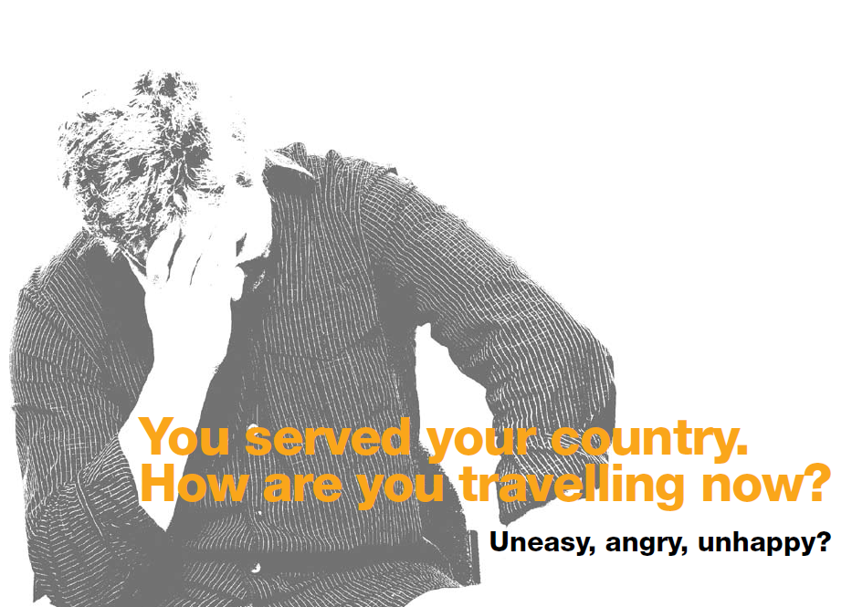

8.9 Appendix I: Anzac Day Media Release


Media Release: Embargoed until Sat April 25th @ 1am

NEW INITIATIVE TO ENCOURAGE VETERANS TO SEEK HELP FOR MENTAL HEALTH ISSUES

A new pilot initiative will be launched on Anzac Day in the Barwon South-Western region of Victoria to encourage veterans and former defence force members with mental health problems to seek help for the first time.

The How Are You Travelling? initiative will raise awareness across the region through brochures, postcards and posters with information about services across the Barwon South-Western region.

ACPMH Associate Professor John Pead said community meetings for interested veterans, families and friends would be held in Geelong, Colac and Warrnambool.

“Local mental health providers will be on the phone to follow up enquiries about help from veterans or family members,” A/Prof. Pead said. “The results of this pilot will help us understand better how to provide help to those who most need it.”

A/Prof. Pead said the mental health effects of military deployment have been recognized for thousands of years.

“Psychiatric casualties are as old as war itself,” he said. “The difference is that we now have effective treatments –– if we can encourage our veterans to seek help.”

A/Prof. Pead said about one in ten Australians returning home from a deployment would suffer from mental health problems –– including depression, anxiety, posttraumatic stress disorder, or alcohol and drug abuse.

“Around 40 per cent of those veterans do not seek mental health care,” he said.

“Two of the important barriers appear to be that people don’t recognize or don’t want to admit that they might have a mental health problem. Secondly, many are uncertain about what help is available.

“We’re trying to tackle those barriers by getting the word out to veterans, families and friends that if they are concerned about their mental wellbeing, they are not alone. Help is available and really can make a difference.”

Community meetings, where veterans, family and friends can find out more:
Thursday 21 May 7pm Geelong West Town Hall
Thursday 4 June 7pm Colac Otways Performing Arts & Cultural Centre
Thursday 11 June 7pm “Lyndoch” Warrnambool
Monday 29 June 7pm Geelong West Town Hall

If you need help right now: Talk to your local doctor or call the VVCS – Veterans and Veterans Families Counselling Service on 1800 011 046 (24 hours).

How are you travelling? is being led by a partnership between: Geelong Clinic; St John of God Healthcare, Warrnambool; Austin Health Heidelberg Repatriation Hospital Veterans Psychiatry Unit; and the VVCS – Veterans and Veterans Families Counselling Service. It is supported by the Australian Centre for Posttraumatic Mental Health (ACPMH) and funded through the Department of Veterans’ Affairs.

For more information contact Tania Ewing on 0408378422

8.10 Appendix J: General Practitioner “Friday Fax”

NEW INITIATIVE TO ENCOURAGE VETERANS TO SEEK HELP FOR MENTAL HEALTH ISSUES

You served your country. How are you travelling now? A pilot initiative has begun this week in the Barwon South-Western region of Victoria to encourage veterans and former defence force members with mental health problems to seek help for the first time. Many of these people will seek help from their general medical practitioner.

Posters and brochures have been distributed to General Practices across the region with a request that they be displayed in patient waiting areas.

Veterans, families and friends are encouraged to come along to one of the community meetings in Geelong, Colac or Warrnambool, to find out more. They are also advised to seek help directly from their local doctor or VVCS – Veterans and Veterans Families Counselling Service on 1800 011 046 (24 hours).

How are you travelling? is led by a partnership between: Geelong Clinic; St John of God Healthcare, Warrnambool; Austin Health Heidelberg Repatriation Hospital Veterans Psychiatry Unit; and the VVCS – Veterans and Veterans Families Counselling Service. It is supported by the Australian Centre for Posttraumatic Mental Health (ACPMH) and funded through the Department of Veterans’ Affairs.

For more information contact ACPMH on 03 9936 5100
Andrea Phelps ajphelps@unimelb.edu.au
Associate Professor John Pead jpead@unimelb.edu.au

8.11 Appendix K: Product Dissemination

How Are You Travelling?
Dissemination of promotional materials.
South-West Region

RSL Region 8 HUB

Warrnambool Cluster Brochures P/Cards Posters

Derrinallum RSL 19001-19050 13751-13800 2 small

Mortlake RSL 19051-19100 13801-13850 2 “

Port Fairy RSL 19101-19150 13851-13900 2 “

Terang RSL 19151-19200 13901-13950 2 “

Warrnambool RSL 19801-19900 15251-15350 5+5

Hamilton Cluster of RSL Sub-branches

Balmoral 19201-19250 13951-14000 2 “

Casterton 19251-19300 14001-14050 2 “

Cavendish 19301-19350 14051-14100 2 “

Coleraine 19351-19400 14101-14150 2 “

Dunkeld 19401-19450 14151-14200 2 “

Hamilton 19451-19500 14201-14250 2 “

Heywood 19501-19550 14251-14300 2 “

Macarthur 19551-19600 14301-14350 2 “

Penshurst 19651-19700 14351-14400 2 “

Portland 19601-19650 14401-14450 2 “

Keith McKenzie 04701-04800
Warrnambool VAN 04801-04900
300 brochures 04901-05000
Posters 20 small, 20 large

RSL Region 8 HUB
Geelong Cluster Brochures Info Sheets Posters

Geelong RSL 00900-01000 4000 5+5 large
(Plus 2000 x P/cards) 3000 (No’s?)

Anglesea RSL 00051-00100 50 3

Apollo Bay 50 5+5 large

Barwon Heads 04401-04450 50 2
(Plus 50 x P/cards 15001-15050)

Colac 00101-00200 100 3 + 4

Drysdale 19951-20000 100 2
(Plus 50 x P/cards 15151-15250)

Inverleigh 00200-00250 50 3

Lara 4451-4500 0 3
(Plus 50 x P/cards 15451-1500)

Lorne 00251-00300 50 3

Norlane 19701-19750 50 5+5 large
(Plus 50 x P/cards 13601-13700)

Ocean Grove 00351-00400 50 3

Portarlington/St Leonards 04301-04400 0 5+5 large
(Plus 100 x P/cards 15051-15150)

Queenscliff/Pt Lonsdale 00351-00400 50 3

Winchelsea 00301-00350 50 2

Rokewood 19901-19950 0 3
(Plus 50 x P/cards 15401-15450)

Distributed at the ESO meeting on 21st April.

G&DVVAA & VWC 00701-00900
(Plus 250 x P/cards 19751-20000)

Torquay RSL & VWC 2000 (no numbers) 2000 50+50 large
(Plus 1000 P/cards – no numbers)

APPVA 00501-00601
(Plus 100 x P/cards – 19651-19750)

Other Organisations

Brochures Posters

Geelong Clinic 00601-00700 1+1 large
(Plus 100 x P/cards 00601-00700)

Geelong VAN 00451-00500 2 large
(Plus 100 P/cards 13701-13750, 15351-15400)

VVF 04251-04300 2
(Plus 50 x P/cards 14751-14800)

Geelong Hospital 19751-19800 10+4 large
(Plus 200 x P/cards 13501-13700)

Barwon Health/ 04101-04200
Mental Health

Mental Health Team Colac 04003-04050

Kevin Hyatt (50) 04501-04550 10
Men’s Health Peer Education (Plus 50 x P/cards 14801-14850)
Volunteer (Norlane/Corio)

PVA Geelong 04672-04700

Geelong T& PI Association

Geelong Naval Association 04052-04100 1 + 1
(Plus 50 x P/cards 14551-14600)

Geelong National Servicemen’s 04201-04250
Association (Plus 50 x P/cards 14651-14750)

Geelong Legacy 04641-04671 1

Reservists – Geelong 04602-04640 1+1

8.12 Appendix L: How are you travelling? Website content

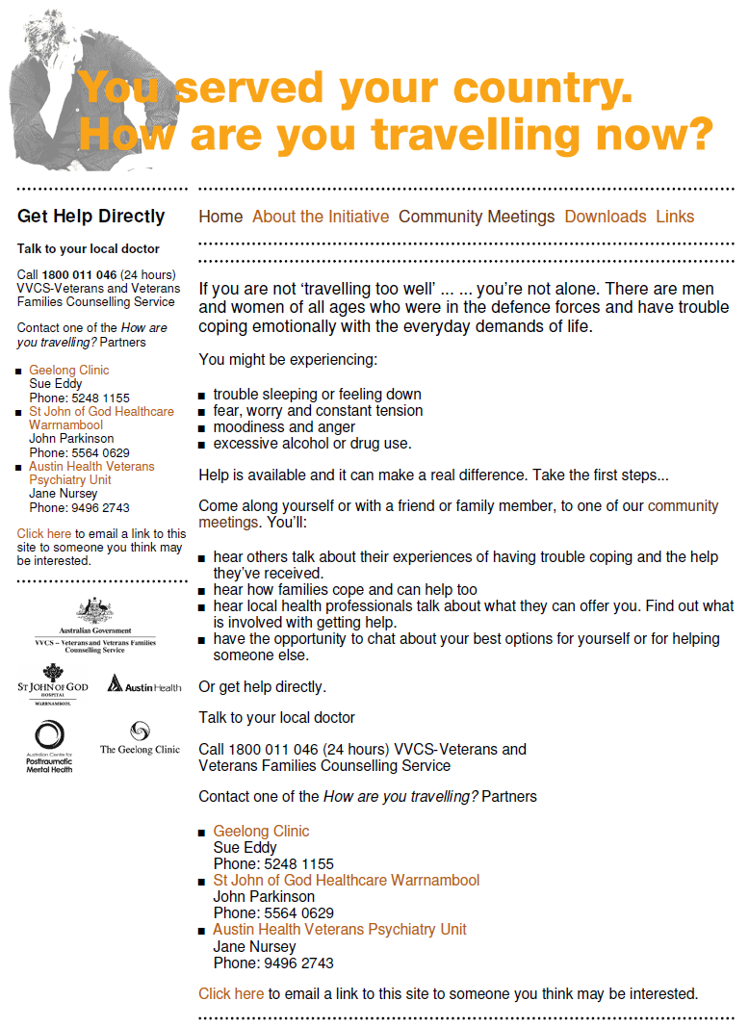
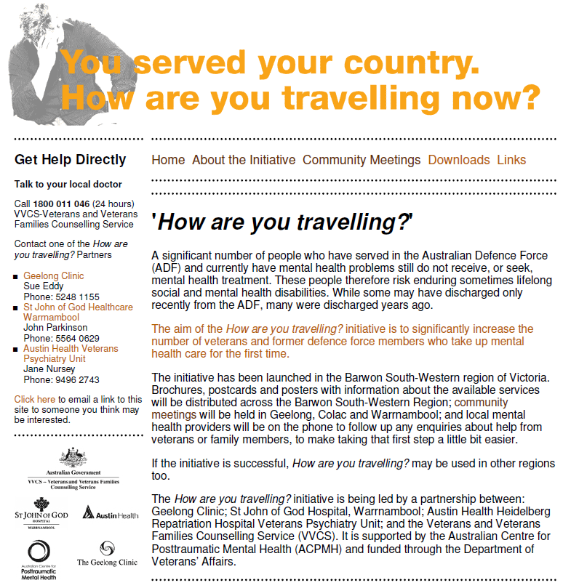
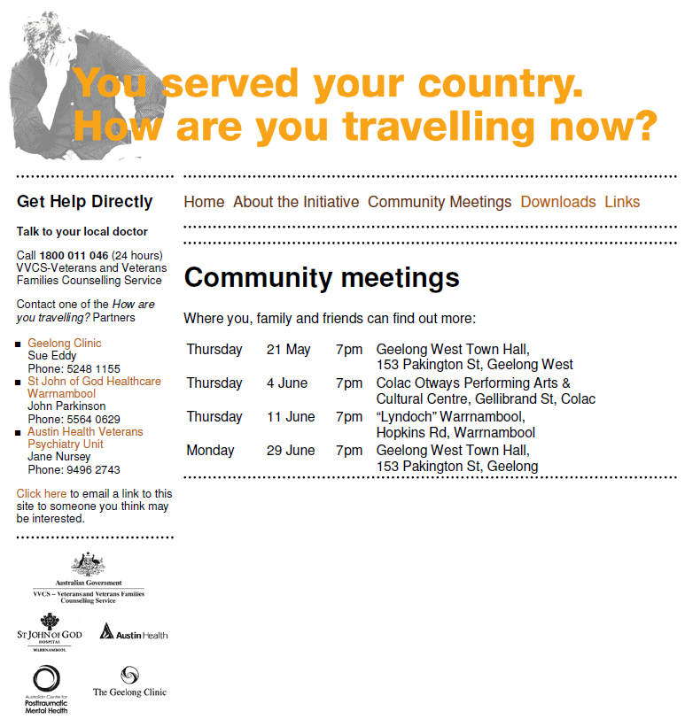
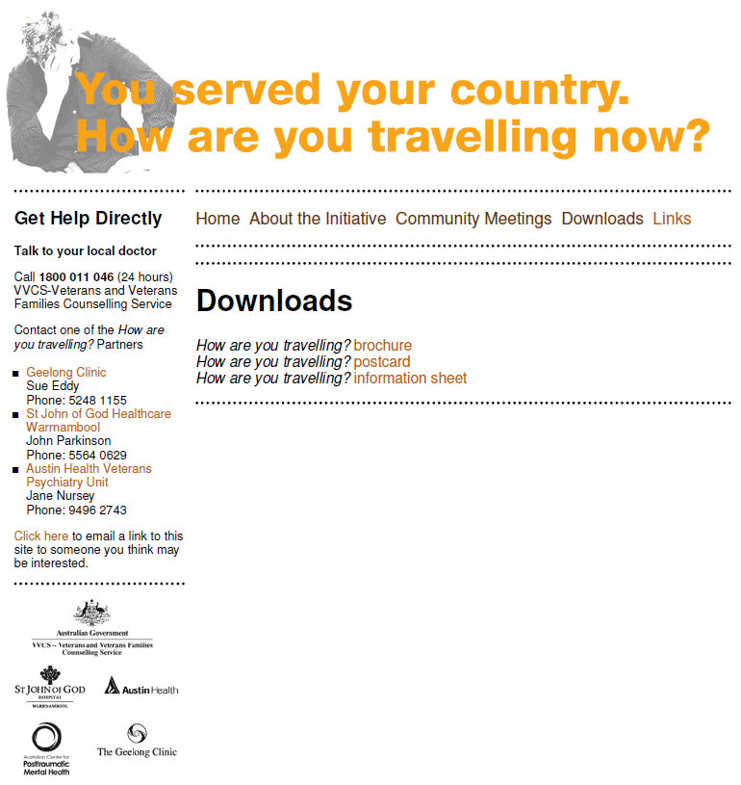
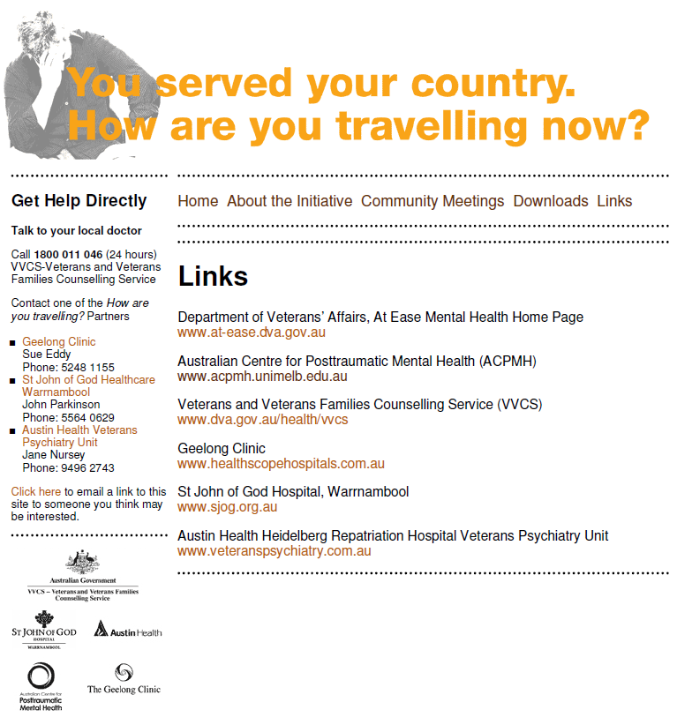

8.13 Appendix M: Letter from DVA
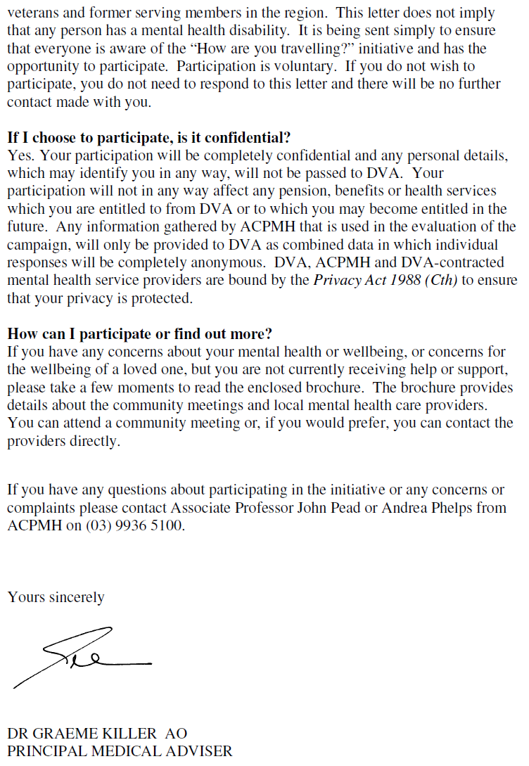

8.14 Appendix N: Community Meeting Evaluation Form


Community Meeting
Evaluation Form

How did you hear about the meeting tonight?

What prompted you to come?

What was most useful about the meeting?

Do you have any ideas for how we could improve the meeting?

Overall, how helpful has tonight’s meeting been for you? (please circle your rating)

1 2 3 4 5 6
Not at all Extremely

To help us understand who has attended this meeting please tell us:
- Your gender: ◻male ◻ female
- Your age:
- Your postcode:
- Are you: ◻ an ex-service member ◻ a family member
◻ a friend ◻ other

Do you want to get help, for yourself or someone close to you?

Is the help for yourself or someone else?

Myself / someone else

Would you like to have a brief chat with one of the mental health professionals this evening?
(circle your answer)

Yes / No

If you answered ‘yes’ please check your time slot in the refreshments room in about 10 minutes time.

If you answered ‘no’ would you like one of the mental health professionals to give you a call to have a chat in the next few days?

Yes / No

If you have requested help, please tell us your name and contact phone number.

_________________________________ ______________________
Name Phone number

8.15 Appendix O: Key Speaking Points
Key points for speakers at community meetings
Keynote speaker
- Great to have this initiative being trialled in our local area
- Opportunity for us all to be involved and get the word out that:
  - If you’re a veteran or former serving member with concerns about your mental health and well-being you’re not alone …
    - Many others are in the same position.
    - Help is available.
  - Mental health care really can make a difference
    - For you and for your family
  - It’s never too early or too late to ask for help

Mental health practitioner speaker
- Demystify mental health care and humanise mental health practitioners
- Outline of mental health care that is available in the region
- Emphasise options commensurate with need

Veteran speaker
- Personal account of:
  - I first realised that I wasn’t travelling too well when …..
  - I tried to cope with it by ……
  - I didn’t ask for any help to start with because …….
  - What made me get some help in the end was ……..
  - My experience of getting help was …….
  - The difference that it’s made to my life has been ……
- Words of encouragement to others to take the opportunity of this campaign to ask for help now

Partner speaker
- Personal account of:
  - Noticing your partner has changed
  - Not knowing what to do about it, who to talk to, feeling like you’re on your own and no-one else will understand
  - Impact on you and family
  - Getting help
  - The difference that getting help has made
- Words of encouragement to ask for help, even if your partner isn’t ready to accept help for him or herself

8.16 Appendix P: Mental Health Provider Presentation

Good Evening. Tonight I am wanting to talk very briefly about what mental health is and what mental health support options are available to you and your family.

WHAT IS MENTAL HEALTH?:
First of all let me explain a little bit about what we mean when we talk about mental health.

Mental Health or Mental Wellbeing is about how we are coping emotionally and psychologically with the ordinary demands of life. For example, how well do you cope with the demands of school, work, family and friends? Are you having trouble concentrating or feeling like it is all too hard? Have you had to give up work or other activities because you were no longer performing at your best? Are you able to go out with friends and enjoy yourself or do you lock yourself away from others and find it hard to talk to other people? Do you feel anxious or stressed a lot of the time and does that anxiety stop you from doing the tasks or activities that you have to do or want to do? Do you have problems sleeping or feel tired all the time? Do you feel sad a lot of the time or have trouble motivating yourself to get out of bed in the morning? Do you have a bad temper and fly off the handle easily when little things go wrong or get into fights with other people on a regular basis? Do you feel concerned that your anger (or other feelings) could get ‘out of control’. Do you drink alcohol to blot out the bad thoughts and feelings that you have? Do you have visions, nightmares or flashbacks of traumatic events from your past? If any of these are true for you, then you may well benefit from some mental health support.

Unfortunately, many people grappling with mental health concerns feel weak and ashamed about having a hard time, and doubtful that any useful help is available. They might also feel isolated and alone, though the truth is that at least 1in 5 veterans are likely to experience some mental health concerns at any time. In fact, it can be a bit of a relief to find others who have grappled with some similar feelings.

HOW DO I GET HELP?:
There are many ways you can get help for yourself or a family member that might be suffering from a mental health problem. For Veterans there are 4 levels of mental health care available starting with basic care for simple or minor problems through to intensive care for people with more severe and complex problems. I will talk briefly about each of these now:

Level 1: Self Care with support from your family and GP:
Self care means looking after yourself physically and emotionally. It could involve getting information on mental health problems from your GP, a trusted friend, the library or a recommended website. You might get some self help materials from these sources that you can practice at home and that help you to manage the symptoms that you are having. These self help strategies might include things like a simple relaxation and stress release exercises, or a diet and exercise program. Sometime just sharing your concerns with someone else is enough to get some relief.

Level 2: Care from your GP (Primary Care):
Your GP is the first important step in seeking assistance with mental health problems. He/She will be able to listen to your concerns, diagnose the problem, offer some treatment recommendations which might include some basic counselling with the GP, teaching you some self help strategies, prescribing medications that might help improve your mood and sleep and monitor your progress over time. If a GP is unable to offer the level of support that you require then he will refer you on for more specialised treatment in the community.

Level 3: Care from a Mental Health Provider in the Community (Secondary Care):
Not all GP’s feel that they have the expertise to treat mental health problems. If this is the case or if they decide that your problem is more complex they can refer you on to a specialist mental health service provider. There are 3 options available to veterans at this level.

- A psychologist, social worker, counsellor or psychiatrist working in your local community. This could be funded through your DVA entitlement, medicare or private health insurance.

- Another Level 3 option is to link in with the Veterans and Veterans Families Counsellign Service (VVCS).

VVCS is a community-based mental health servicefor Australian veterans, peacekeepers, eligible ADF personnel, and their families . VVCS provides free of charge, specialist counselling, case management and psychoeducational group programs. The services are provided by qualified psychologists and social workers with experience assisting individuals and families cope with the impact of military service and trauma.

VVCS counsellors can provide help with a range of concerns including:
Depression, Anxiety and PTSD, Anger Management, Alcohol and Drug Use, Sleep Disturbance, and Relationship Issues. VVCS can also provide help as you move between life stage, for example, between military and civilian life, or between working life and retirement. VVSC can also provide information and referral for more intensive tertiary care where appropriate.

- Veterans can also be referred to their local community mental health team and regional drug and alcohol services for assistance. These services are state government funded.

Level 4: Care from a specialist mental health hospital: (Tertiary Care):
For veterans with more severe mental health problems, hospital based mental health care may be required. This could involve being treated as either an inpatient or an outpatient at a specialist mental health facility. Inpatient admissions are usually required for people in acute crisis or feel that they may harm themselves or someone else or that they cannot manage in the community. Veterans may be referred to an outpatient clinic for assistance with a severe or complex mental health problem that is difficult to treat. Or they may be referred to a treatment program for a specific problem that require a multidisciplinary treatment approach. An example of this would be a program that treats Post Traumatic Stress Disorder.
There are 3 options available to veterans in this region requiring a level 4 standard of care:

1. Geelong Clinic. Services include:
- Outpatient PTSD program
- Acute inpatient admissions
- Outpatient psychiatric and psychological services
- Alcohol withdrawal services

2. St John Of God Hospital - Warrnambool. Services include:
- 1/2 Day programs for Depression, Anxiety, Grief, Loss and Trauma
- In patient Admission
- Outreach/ Community Follow up
- Alcohol With drawl Services

3.Austin Health Veteran Psychiatry Unit - Heidelberg. :
The Austin Health Veteran Psychiatry Unit (VPU) at Heidelberg Repatriation Hospital has statewide responsibility for the delivery of specialist mental health care to veterans, war widows and current serving ADF members residing in the state of Victoria. It also provides secondary consultation and training to other service providers. Services available include:
- Acute inpatient admissions
- Alcohol program
- Outpatient group and individual therapy programs
- Outpatient Psychiatry Clinic
- Outpatient Occupational Therapy Clinic
- Sleep clinic
- Telepsychiatry clinic
- PTSD programs
- Older Veteran Psychaitry Programs

SOME USEFUL NUMBERS AND WEBSITES:
Here are some contact numbers and websites that might help you take the first step in getting help. There are also a number of counsellor here tonight who would be happy to talk to talk to you about what the best options for you or your family member might be.

Thankyou.

On slide (details required):
Useful internet sites are:
- List At Ease and a few others e.g. ACPMH, VPU Website, beyond blue
- VVCS fact Sheets
- VVCS group program brochures (eg heart health program, Sleep program)

VVCS FREECALL 1800 011 046.
Geelong Clinic:
SJOG Warnambool:
Heidelberg Repatriation Hosptial – VPU:

8.17 Appendix Q: Mental Health Care for Veterans
Mental health care for veterans: An agreed framework for the Barwon South-Western Region Hard to Engage Clients Initiative

NB: the term ‘veteran’ has been used throughout to refer to veterans and other former serving members who are eligible for treatment funded by DVA.

Principles:
1. Mental health and wellbeing is conceptualised in broad terms, encompassing psychological well-being, satisfactory adjustment to society and capacity to manage the ordinary demands of life.
2. DVA purchases a range of mental health care services for veterans, across primary, secondary and tertiary care levels. In addition, veteran self-care is considered integral and veterans have access to DHS services based on assessed need.
3. The level of care for each veteran should be commensurate with assessed need and consistent with the person’s preferences.
4. Service providers should be familiar with all other aspects of the service system.
5. Service providers should have a shared understanding of the respective roles and responsibilities of services and make appropriate referrals between services.

A stepped care model
Mental health services for veterans can be conceptualised as a stepped care model, starting with the least intensive level of care for the least severe and/or complex problems, moving up to more intensive levels of care for more severe and/or complex problems. As circumstances change, veterans might need different levels of care at different times, and can move up or down the ‘ladder’ accordingly.

Level 1: Self care with support from your family and GP
Self care means looking after yourself physically and emotionally. It could involve getting information on mental health problems from your GP, a trusted friend, the library or a recommended website. You might get some self help materials from these sources that you can practice at home and that help you to manage the symptoms that you are having. These self help strategies might include things like a simple relaxation and stress release exercises, or a diet and exercise program. Sometime just sharing your concerns with someone else is enough to get some relief.

Useful internet sites are:
- At Ease at-ease.dva.gov.au
- Beyondblue www.beyondblue.org.au
- ACPMH www.acpmh.unimelb.edu.au

Level 2: Care from your GP (Primary Care)
Your GP is the first important step in seeking assistance with mental health problems. He/She will be able to listen to your concerns, diagnose the problem, offer some treatment recommendations which might include some basic counselling with the GP, teaching you some self help strategies, prescribing medications that might help improve your mood and sleep and monitor your progress over time. If a GP is unable to offer the level of support that you require then he will refer you on for more specialised treatment in the community.

Level 3: Care from a mental health provider in the community (Secondary Care)
Not all GP’s feel that they have the expertise to treat mental health problems. If this is the case or if they decide that your problem is more complex they can refer you on to a specialist mental health service provider. There are 3 options available to veterans at this level.

- A psychologist, social worker, counsellor or psychiatrist working in your local community. This could be funded through your DVA entitlement, medicare or private health insurance.

- Another Level 3 option is to link in with the Veterans and Veterans Families Counsellign Service (VVCS).

VVCS is a community-based mental health servicefor Australian veterans, peacekeepers, eligible ADF personnel, and their families . VVCS provides free of charge, specialist counselling, case management and psychoeducational group programs. The services are provided by qualified psychologists and social workers with experience assisting individuals and families cope with the impact of military service and trauma.

VVCS counsellors can provide help with a range of concerns including:
Depression, Anxiety and PTSD, Anger Management, Alcohol and Drug Use, Sleep Disturbance, and Relationship Issues. VVCS can also provide help as you move between life stage, for example, between military and civilian life, or between working life and retirement. VVSC can also provide information and referral for more intensive tertiary care where appropriate.

- Veterans can also be referred to their local community mental health team and regional drug and alcohol services for assistance. These services are state government funded.

Level 4: Care from a specialist mental health hospital (Tertiary Care)
For veterans with more severe mental health problems, hospital based mental health care may be required. This could involve being treated as either an inpatient or an outpatient at a specialist mental health facility. Inpatient admissions are usually required for people in acute crisis or feel that they may harm themselves or someone else or that they cannot manage in the community. Veterans may be referred to an outpatient clinic for assistance with a severe or complex mental health problem that is difficult to treat. Or they may be referred to a treatment program for a specific problem that require a multidisciplinary treatment approach. An example of this would be a program that treats Post Traumatic Stress Disorder.
There are 3 options available to veterans in this region requiring a level 4 standard of care:

1. Geelong Clinic. Services include:
- Outpatient PTSD program
- Acute inpatient admissions
- Outpatient psychiatric and psychological services
- Alcohol withdrawal services

2. St John Of God Hospital - Warrnambool. Services include:
- 1/2 Day programs for Depression, Anxiety, Grief, Loss and Trauma
- In patient Admission
- Outreach/ Community Follow up
- Alcohol With drawl Services

3.Austin Health Veteran Psychiatry Unit – Heidelberg.
The Austin Health Veteran Psychiatry Unit (VPU) at Heidelberg Repatriation Hospital has statewide responsibility for the delivery of specialist mental health care to veterans, war widows and current serving ADF members residing in the state of Victoria. It also provides secondary consultation and training to other service providers. Services available include:
- Acute inpatient admissions
- Alcohol program
- Outpatient group and individual therapy programs
- Outpatient Psychiatry Clinic
- Outpatient Occupational Therapy Clinic
- Sleep clinic
- Telepsychiatry clinic
- PTSD programs
- Older Veteran Psychaitry Programs

8.18 Appendix R: Assessment and Referral Form
8.19 Appendix S: Community Meetings Media Release
Help for Veterans – Community Meetings in Geelong, Colac and Warrnambool
For those Australians who have served their country through military service, there is a new initiative being piloted in Geelong, Colac and Warrnambool. From 21 May until 29 June, there will be four community meetings held specifically targeted at veterans who have concerns about their mental health and wellbeing. Families, friends and veterans are invited to a series of free meetings where health professionals and former service men and women can discuss the depression, anxiety, sleeplessness and alcohol and drug abuse that can result if mental health issues, particularly prevalent in those who have served in combat zones, are ignored.
Former Peacekeeper, Gordon Traill, from Geelong, is available for interview about the stresses of war zones, and the consequences on mental health. Sue Eddy Posttraumatic Stress Disorder (PTSD) treatment program co-ordinator from Geelong Clinic is also available for interview.
Tens of thousands of Australian soldiers have served overseas in recent years in places such as East Timor, Afghanistan and Iraq.
It is estimated that one in ten Australians returning home suffers from mental health problems – including depression, anxiety, sleeplessness and post traumatic stress disorder. Around 40% of these veterans do not seek mental health care. They might not recognize or don’t want to admit that they have a mental health problem or are uncertain about what help is available.
The “How Are You Traveling?” initiative is being piloted in the Barwon South-Western region of Victoria and is aimed at increasing the number of veterans and former defence force members who ask for help for the first time.
Coordinated by the Australian Centre for Posttraumatic Mental Health, the How are youtravelling? Will raise awareness right across the Region by distributing brochures, postcards and posters with information about the available services across the Barwon South-Western Region; community meetings will be held in Geelong, Colac and Warrnambool; and local mental health providers will be on the phone to follow up any enquiries about help from veterans or family members.

According to Associate Professor John Pead from the Australian Centre for Posttraumatic Mental Health, “a significant number of veterans and former serving members who have mental health problems do not ask for help.” Professor Pead explains that research undertaken with Australian veterans has identified a number of reasons why these people have not taken up mental health care. “Two of the important barriers appear to be that people don’t recognize or don’t want to admit that they might have a mental health problem and secondly, many are uncertain about what help is available. We’re trying to tackle those barriers by getting the word out to veterans, families and friends that if they are concerned about their mental wellbeing, they are not alone. Help is available and really can make a difference.”

Community meetings, where veterans, family and friends can find out more:
Thursday 21 May 7pm Geelong West Town Hall
Thursday 4 June 7pm Colac Otways Performing Arts & Cultural Centre
Thursday 11 June 7pm “Lyndoch” Warrnambool
Monday 29 June 7pm Geelong West Town Hall

If you need help right now: Talk to your local doctor or call 1800 011 046 (24 hours) VVCS – Veterans and Veterans Families Counselling Service

The How are you travelling? initiative is being led by a partnership between: Geelong Clinic; St John of God Hospital, Warrnambool; Austin Health Heidelberg Repatriation Hospital Veterans Psychiatry Unit; and the Veterans and Veterans Families Counselling Service (VVCS). It is supported by the Australian Centre for Posttraumatic Mental Health (ACPMH) and funded through the Department of Veterans’ Affairs.

For more information contact:
Tania Ewing on 0408378422

8.20 Appendix T: Newspaper Advertisements
Meeting 1
If you are not ‘travelling too well’ ... ... you’re not alone. There are men and women of all ages who were in the defence forces and have trouble coping emotionally with the everyday demands of life.
Come along to one of our community meetings where you, family and friends can find out more:
Thursday | 21 May | 7pm | Geelong West Town Hall,  153 Pakington St, Geelong West
Thursday | 4 June | 7pm | Colac Otways Performing Arts &  Cultural Centre, Gellibrand St, Colac
Thursday | 11 June | 7pm | “Lyndoch” Warrnambool,  Hopkins Rd, Warrnambool
Monday | 29 June | 7pm | Geelong West Town Hall,  153 Pakington St, Geelong
Please register your interest in coming along Ph: 0424 089 515

www.howareyoutravelling.org.au
An initiative of Geelong Clinic, St John of God Hospital Warrnambool, Austin Health Veterans Psychiatry Unit, VVCS – Veterans and Veterans Families Counselling Service and the Australian Centre for Posttraumatic Mental Health.

Meeting 2

If you are not ‘travelling too well’ ... ... you’re not alone. There are men and women of all ages who were in the defence forces and have trouble coping emotionally with the everyday demands of life.
Come along to one of our community meetings where you, family and friends can find out more:
Thursday | 4 June | 7pm | Colac Otways Performing Arts &  Cultural Centre, Gellibrand St, Colac
Thursday | 11 June | 7pm | “Lyndoch” Warrnambool,  Hopkins Rd, Warrnambool
Monday | 29 June | 7pm | Geelong West Town Hall,  153 Pakington St, Geelong
Please register your interest in coming along Ph: 0424 089 515

www.howareyoutravelling.org.au
An initiative of Geelong Clinic, St John of God Hospital Warrnambool, Austin Health Veterans Psychiatry Unit, VVCS – Veterans and Veterans Families Counselling Service and the Australian Centre for Posttraumatic Mental Health. Funded by the Department of Veterans’ Affairs.

Meeting 3
If you are not ‘travelling too well’ ... ... you’re not alone. There are men and women of all ages who were in the defence forces and have trouble coping emotionally with the everyday demands of life.
Come along to one of our community meetings where you, family and friends can find out more:
Thursday | 11 June | 7pm | “Lyndoch” Warrnambool,  Hopkins Rd, Warrnambool
Monday | 29 June | 7pm | Geelong West Town Hall,  153 Pakington St, Geelong
Please register your interest in coming along Ph: 0424 089 515

www.howareyoutravelling.org.au
An initiative of Geelong Clinic, St John of God Hospital Warrnambool, Austin Health Veterans Psychiatry Unit, VVCS – Veterans and Veterans Families Counselling Service and the Australian Centre for Posttraumatic Mental Health. Funded by the Department of Veterans’ Affairs.

Meeting 4
If you are not ‘travelling too well’ ... ... you’re not alone. There are men and women of all ages who were in the defence forces and have trouble coping emotionally with the everyday demands of life.
Come along to our final community meeting in the region to hear more from veterans, peacekeepers, their partners and service providers:
Monday | 29 June | 7pm | Geelong West Town Hall,  153 Pakington St, Geelong

Special guest speaker Barry Heard, author of
Well Done, Those Men: Memoirs of a Vietnam Veteran

Please register your interest in coming along Ph: 0424 089 515

www.howareyoutravelling.org.au
An initiative of Geelong Clinic, St John of God Hospital Warrnambool, Austin Health Veterans Psychiatry Unit, VVCS – Veterans and Veterans Families Counselling Service and the Australian Centre for Posttraumatic Mental Health. Funded by the Department of Veterans’ Affairs.

8.21 Appendix U: Engaging Veterans Flowchart

NOTES ON THE FLOWCHART

1. People attending the community meetings will be given the option of 1:1 consultation or to be followed up over the next few days. The 1:1 consultations at community meetings will be done by project partners - VVCS (core staff), Geelong Clinic, SJOG Warrnambool and VPU - all of whom will have an understanding of the services offered by each of the others and make referrals based on client need irrespective of their own place of work.

2. Following referral, the standard referral procedure for each organisation will apply. Depending upon the standard protocols, a point of difference may be that referrals from a family member or ESO will be followed up, rather than the veteran themselves having to make the first contact. (Acknowledgement that decision making around this issue may differ between organisations.)

3. If the client follows through on the referral normal intake procedures occur.

4. If the client doesn't follow through (e.g. doesn't ring or turn up to an appointment) or expresses ambivalence at the point of first contact, practitioners will provide assertive outreach. We've described this previously as:
Assertive provider outreach means that the mental health practitioner will:

1. Pro-actively contact the individual rather than wait for the individual to contact them;

2. Make at least three attempts to contact the individual by phone, email or written correspondence;

3. Be flexiblein making arrangements to meet the individual at a convenient time and place;

4. Promote engagement by offering information, advice, support and care that meets the expressed needs and priorities of the individual.

If the client accepted a referral following the intitial assessment, to one of the partners and didn't follow through, that organisation will provide the assertive outreach. In the case of VVCS, the intake worker may arrange for a VVCS contract counsellor to provide the assertive outreach.

If the client asked to be contacted after the meeting, or had an initial chat but didn't commit to accepting a referral, assertive provider outreach can be provided by any of the partners (including VVCS contractors as arranged on a case by case basis by VVCS).

During the assertive outreach phase, the individual is not yet a client of any particular service. The goal of assertive outreach is to engage the person to the point where the initial assessment and appropriate referral can be made.

When the person is willing to accept referral, they will go through normal intake procedures for that service.

8.22 Appendix V: Assertive Provider Outreach Record
Assertive outreach contacts
Client  Number | Method of assertive outreach (phone, email, in person) | Outcome  (client engaged in care or not)
 | 1.
 | 2.
 | 3.
 | 1.
 | 2.
 | 3.
 | 1.
 | 2.
 | 3.
 | 1.
 | 2.
 | 3.
 | 1.
 | 2.
 | 3.
 | 1.
 | 2.
 | 3.
 | 1.
 | 2.
 | 3.

8.23 Appendix W: Steering Group Feedback Form
Steering Group Feedback
1. Your experience as a member of the steering group

Do you have any thoughts about the composition of the steering group?

Do you feel that the steering group were given sufficient opportunities to provide guidance to the project and be involved in decision making?

Do you think the time commitment required of steering group members was reasonable? Can you estimate roughly how much time you spent working on this initiative?

Did your organisation benefit from involvement in this initiative? How?

Would your organisation be willing to be involved in another initiative? What are the factors that would determine this?

2. Perceptions of processes used

The following questions ask for your opinions about the way in which the initiative was developed and rolled out.

Do you have any thoughts about the development of the concept brand and products?

ESO representatives in the region were asked, on multiple occasions, for their opinions about the branding and materials associated with the initiative. What are your thoughts about the value of this process?

Do you feel that there was effective communication between ACPMH and the steering group over the course of the initiative? Why or why not?

DVA gave ACPMH autonomy to run the initiative at arms length, particularly with regard to the design of campaign materials, consultation with ESOs and the running of community meetings. What are your views about the relative strengths and weaknesses of this approach?

3. Perceptions of the interventions

There were four components to the ‘How are you travelling?’ initiative.
- Development of the materials (design and content)
- Raising awareness through media and Distribution of information brochures, posters etc.
- Community meetings
- Assertive follow-up from mental health service providers

In your judgement, how important would it be to include these components in a future initiative?
(on a scale from: 1 = not at all important, to 5 = extremely important)

Component | Rating of importance (1-5) | Any specific comments?
Development of materials (design and content)
Raising awareness though media

Raising awareness through distribution of information brochures, posters etc

Community meetings

Follow-up from mental health service providers

4. General perceptions of the initiative
The following questions relate to any general thoughts you might have about the initiative.

- What did you like most about the initiative?

- Do you think any components of the initiative were a waste of time?

- What would you do differently next time?

- Do you have any other general comments about the initiative or recommendations for future initiatives?

  - Overall, how would you rate the effectiveness of the initiative in encouraging more veterans and former serving members with mental health concerns to seek help?

1 2 3 4 5 6 7 8 9 10
Not at Extremely
all effective effective

8.24 Appendix X: ESO Feedback Form
ESO Feedback

Thank you for your involvement in the ‘How are you travelling?’ initiative.
The purpose of this questionnaire is to seek your feedback about the initiative.

There were four components to the ‘How are you travelling?’ initiative.
- development of the materials (design and content)
- raising awareness through media and Distribution of information brochures, posters etc.
- community meetings
- assertive follow-up from mental health service providers

1. Overall, how would your ate the importance of each of these components in encouraging more veterans and former serving members with mental health concerns to seek help?
(using a scale from: 1 = not at all important, to 10 = extremely important)

Component | Rating of importance (1-10) | Any specific comments?
Development of materials (design and content)
Raising awareness though media

Raising awareness through distribution of information brochures, posters etc
Community meetings

Follow-up from mental health service providers

2.How satisfied were you with the consultation that took place with local ESOs (on a scale of 1-10)?

1 2 3 4 5 6 7 8 9 10
Not at Extremely
all satisfied satisfied

3. If you would like to provide specific feedback, please do so in the space below.

8.25 Appendix Y: Improving Treatment Options for Hard to Engage Clients: Target groups, interventions and work plan 13 June 2008 Section 4.7 Web based interventions

Self-help therapies are known to be an effective way of reducing mental health problems and have been increasingly available on the internet in recent years (van Straten, Cuijpers, & Smits, 2008). Studies have found web-based interventions to assist in the treatment of headache, chronic pain and obesity, as well as mental health disorders including depression, generalised anxiety disorder, panic disorder, alcohol dependency, and PTSD (Andersson, 2006; H. Christensen, Leach, Barney, Mackinnon, & Griffiths, 2006; Linke, Murray, Butler, & Wallace, 2007; van Straten et al., 2008). Internet interventions are typically based on cognitive behavioural therapy, and most involve some level of therapist contact in the form of email (Andersson, 2006), although research is currently underway investigating the effectiveness of online interventions with no therapist input (see for example www.shyness.tv).

There are a number of advantages to self-help internet treatment compared to both traditional self-help mediums and face to face therapy. Advice is available outside normal office hours and psychologists involved in online programs are typically required to respond to queries within 24 hours. Unlike self-help books, the internet provides an opportunity for interactivity which is thought to enhance the potential for behaviour change (Andersson, 2006). Online treatment may be more acceptable to people with psychological issues who do not want to approach a mental health professional in person, and those in rural and remote locations access to services not otherwise available in their area. Crucially, online interventions may cater for people whose needs are not met by traditional services (Linke et al., 2007) and are cost effective both for clients and providers (Andersson, 2006; Linke et al., 2007; van Straten et al., 2008).

Of particular relevance to veterans, Dr Helen Christensen, Dr Kathy Griffiths and Dr Stephen Rosenman from the ANU Centre of Mental Health Research presented to the National Veteran Mental Health and Wellbeing Forum in April 2007 on mental health web based tools including Mood Gym (on-line cognitive behavioural therapy for depression and anxiety) and a moderated chat room that could assist veterans with mental health problems (National Veterans' Mental Health & Wellbeing Forum, 2007).

With respect to the use of chat rooms, Hallet et al., (2007) report on a study using an online community (in this case, a chat room for gay men) to provide health promotion on an outreach basis. This intervention adapted to the veteran community would involve an outreach worker (probably a veteran peer) joining an existing veteran chat room and providing information about mental health issues and referral advice for other veterans with a mental health problem.

Despite the potential for advances in the range of services available to veterans with web-based interventions, it is important to acknowledge that they are not without their limitations. Consideration must be given to security, consumer and practitioner level of computer and internet literacy, and differential access to the internet (Andersson, 2006) which is of particular concern in rural and impoverished areas. In addition, for many patients internet based interventions are not an effective substitute for face to face professional help.

Mr Bate gave permission for his name to be included in the report
Father Dillon is a local Catholic Priest with an interest in the welfare of veterans

